A Home Made Out of Shipping Containers – A True Story

Michele and David bought an empty 20-by-40-foot lot in Brooklyn, New York(?). They wanted to build a conventional home that would fit in the small spot, but they didn’t have a ton of money. Michele is an architect, so she drew up plans for a new home and sent them to builders to get a quote for the cost. When the couple got the quote, they were shocked: a brick building would cost over $300,000, not including walls, flooring or furniture. All that money wouldn’t even buy them basic necessities such as electricity or plumbing. They decided to change tactics and instead make their new home out of recycled shipping containers, which would be more affordable. The builders spent a mere two days assembling five containers into a 1,600 square-foot home.

Objective A: Students will use addition and multiplication to calculate the cost of building a home from shipping containers and will use variables to express the relationship between cost and the number of shipping containers used.
- If each shipping container costs $2,500, how much money did Michele and David save by building their home out of five shipping containers instead of brick masonry?
- If Michele and David have to pay builders $40,000 to assemble the shipping containers, on top of the cost of the containers themselves, did the couple still save money? How much?
- Assume that for every five shipping containers, one day of assembly by builders is required at a cost of $20,000 per day. Containers are $2,500 each. Using this information, write an expression for calculating the cost of building Michele and David’s home. Let x be the number of shipping containers and C be the total cost of the project. Be sure to account for the number of days it would take the riggers to put together the finished product.
- Using the expression for cost that you wrote above, calculate how many shipping containers could be bought and assembled into a home for the price it would have cost the couple to build their home out of brick ($300,000).

Objective B: Students will determine the ratio between the dimensions of their shipping container models and the dimensions of actual shipping containers to calculate the scale of their models.
.

- A ratio is a comparison between two numbers, usually expressed as a fraction (4:3 or 4/3)
- A scale factor is a ratio between corresponding measurements of two similar objects. In other words, if you measure the same part (e.g., the height), of two objects that are the same shape, the ratio of those two measurements is the scale factor.
- When calculating the scale factor, it is very important to make sure that you write every ratio in the same order: either large/small OR small/large.
Example: what is the scale factor, written small to large, of these two squares?

AB = 25 = 1
CD 50 2

The scale factor, from small to large, is 1/2

The scale factor can be read aloud in three different ways: “one to two,” “ one over two,” or “one-half”

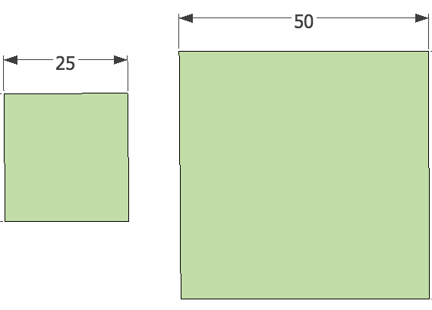

D
C
B
A

1. Measure each dimension of the model of the 20’ shipping container using a ruler. It will be most accurate to measure the model before you cut it out using centimeters as units. Record your measurements in the table below, then write the scale factor as a fraction.

 | Model (cm) | Actual (ft) | Scale Factor: small to large  = Model/Actual | 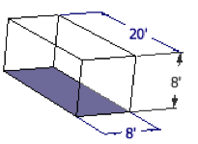
Width: |  | 8 feet
Height |  | 8 feet
Length |  | 20 feet

2. Is the scale factor the same for each of the different measurements?

Objective C: Students will use the scale factor of the model to convert standard window and door dimensions to the appropriate scale size for their model.

The scale of a model can be very useful for designing other features for your model that are the correct scale. You will use the scale factor to make model windows and doors for the container building you will design.

To determine what size to make a model object, you will need the small to large (model/actual) scale factor, and the actual dimensions of the object you are trying to model.

1. Practice using the formula below for calculating scale
actual size = model size
x
SCALE FACTOR

Example: The standard dimensions of a sliding glass door are 6 feet wide and 7 feet high. Calculate each dimension of a model sliding glass door separately. If the scale factor is 1 cm/3 ft:
SCALE FACTOR
actual size = model size
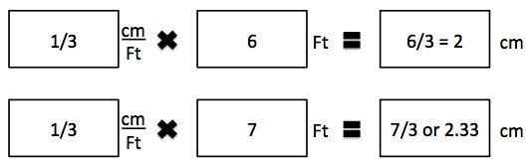
Based on these calculations, if the scale factor was 1/3, our model sliding doors would be 2 cm wide by 2.3 cm tall

2. Use the scale factor of your model to figure out what size to make the doors and windows:
 | Actual Size |  | Multiply by  Scale Factor | Model Size
Item | Width | Height |  | Width | Height
Window | 2 feet | 3 feet
Sliding door: | 6 feet | 7 feet
Standard door: | 3 feet | 6.6 feet

Objective D: Students will use the costs of building materials and labor as well as the size of various shipping containers to calculate the overall cost of their finished building.

Materials and labor costs:
Item | Dimensions | Cost/Item
20’ standard shipping container | 8’ x 8’ x 20’ | $1,500/container
40’ standard shipping container | 8’ x 8’ x 40’ | $2,500/container
Assembly crew | Put together up to 5 containers in two days. | $40,000/5 conts.

Calculate the cost of your building below:
To calculate the building cost, count the number of times a material was used or a job was performed, and multiply that number by the cost of each item.
Example: Material | # of items used | Cost/Item | Total Cost
20’ standard shipping container | 3 | $1,500/container | 3 x $1500  = $4500

Raw Materials:
Material | # items used | Cost/Item | Total Cost
20’ standard shipping container |  | $1,500/container
40’ standard shipping container |  | $2,500/container
 |  | Materials Total

Labor:
Job | # tasks performed | Cost/unit time | Total Cost
Lock together 5 shipping containers |  | $40,000
 |  | Labor Total

Total Building Cost: _____________________________

Objective E: Students will use the formula for area to calculate the final square footage of their model so that they can determine how much flooring to order.
Calculate the square footage of your building:
The square footage of a building is a measurement of the area of the floor space contained within the walls of the building. You will calculate the amount of flooring needed in your container building.

For buildings with square or rectangular rooms, you can calculate the area of each room individually, and then add them together. Use the formula for the area of a rectangle to calculate the square footage of a square or rectangular room: base x height.

1. Using the floor plan below, calculate the square footage of this home:
Room | Base x height = sq ft
Kitchen | 12 x 20 | =
Dining Room | 12 x 20 | =
Living Room | 20 x 12 | =
Bedroom |  | =
Bathroom |  | =
 | TOTAL
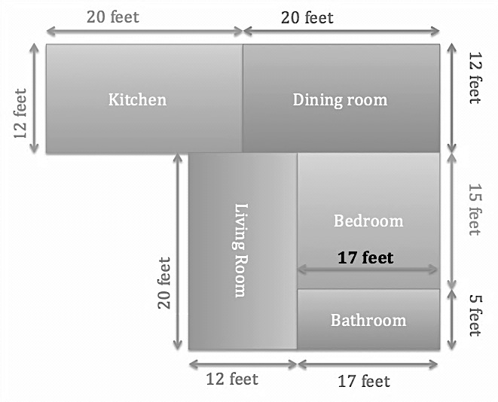

2. Calculate the square footage of each of the standard shipping containers below. Assume that they are lying down sideways, and that the area of the “floor” (dark side) is what needs to be measured.
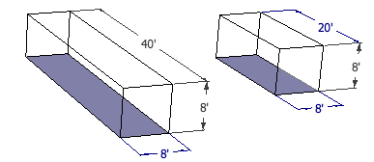

40’ shipping container______________________ 20’ shipping container ___________________

3. Estimate the square footage of your container home based on how many shipping containers you used and the square footage of each type of shipping container. Use the table below to help you with your calculations:

Container Type |  | # Used | sq ft / container | How many square feet?  Multiply
20’ standard shipping container
40’ standard shipping container
TOTAL Estimated Sq ft:
(add them together)

4. You can use four types of flooring in your container home: carpeting, hardwood, tile, and concrete. Outfit your container building with whatever materials or combination of materials you prefer, then calculate the total cost of flooring for your new building by multiplying the cost per square foot (“Cost/sq ft”) by the amount needed in square feet (“Sq ft needed”)

Floor type | Cost/sq ft | x Sq ft needed | = Estimated Cost
Carpeting | $4/sq ft
Hardwood | $7/sq ft
Tile | $6/sq ft
Concrete | $3/sq ft
TOTAL

5. ** Challenge Problem: You decide that you do not like the color that shipping containers come in and would like you to paint the outside of the building after it has been built. One gallon of paint costs $35 and can cover 350 square feet. Estimate the amount of paint you would need by calculating the surface area of each shipping container that would need to be painted. Remember, you won’t need to paint the sides that face the ground!

