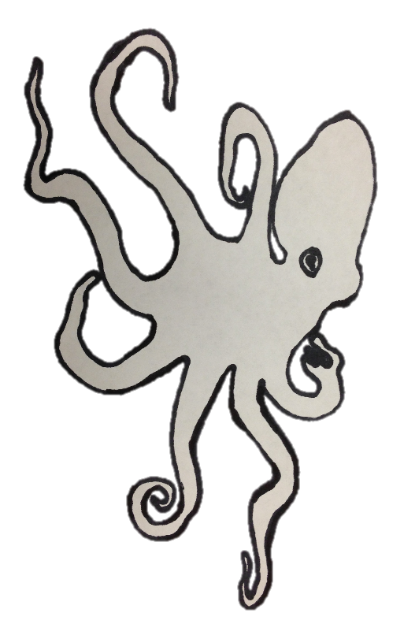
Name___________________________________ Date________________________

My Octopus is…

An octopus can change its shape to look like a rock or seaweed.
An octopus can control its skin texture by wrinkling, smoothing, and curling its skin.
An octopus can change its size by stretching out really wide to appear large, or by tucking itself into a tiny ball so that it looks small.

An octopus can change the color of its skin to match its surroundings.

Name___________________________________ Date________________________

My Octopus is…
ball pancake star square cube

An octopus can change its shape to look like a rock or seaweed. | shaped like a  It is  round flat square
An octopus can control its skin texture by wrinkling, smoothing, and curling its skin. | textured so that it feels  prickly bumpy rough smooth
An octopus can change its size by stretching out really wide to appear large, or by tucking itself into a tiny ball so that it looks small. | bigger than  a quarter my hand my pencil  smaller than  a piece of paper my chair
An octopus can change the color of its skin to match its surroundings. | this color:  the same color as

