AUG. 14, 2014 – www.sciencefriday.com

Secrets of the Sauce (and Other Edible Liquids)

BY ALI BOUZARI
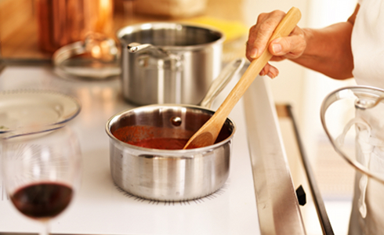
Stirring a small pot of spaghetti sauce on the stove, from Shutterstock

There are only four ways to change the thickness of a sauce. Or a soup. Or any liquid that you want to eat, for that matter. Four. It’s a powerful concept. It means that whether you want to make mayonnaise or mustard, stew or fondue, there are only four basic ideas to master before the dish’s consistency is completely within your control.

Each of the following techniques comes from the fact that the thickness of any liquid depends on how easy it is for water to move around. Make life hard for that water, and the liquid will get thicker. Here are the four methods:

1) Dissolve stuff in it.
When something dissolves, water grabs onto it and has a hard time moving around it. This applies any time you add sugars, proteins, or complex carbs to your food. Examples include the sugar in maple syrup or honey; the gelatin in a rich stew; the starch in gravy; the pectin in applesauce, ketchup, or marmalade; and all of the modern-sounding gums like xanthan, gellan, and locust bean that thicken sauces on avant-garde tasting menus, as well as in simple condiments like Hidden Valley ranch dressing.

2) Put some chunks in it.
Even if they don’t completely dissolve, food particles are also really good at getting in water’s way. Think about blending up a pesto, mole, or salsa—those chunks help to thicken the liquid, and the smaller they get, the more thickening power they have.

3) Make an emulsion.
Emulsions are just droplets of one thing suspended in something else. If you suspend a bunch of droplets of fat in water, those fat bubbles get in the way of the water, making things thick and creamy. This is what’s going on with hollandaise sauces, mayonnaises, and vinaigrettes. Emulsion is also what gives fatty ramen broth its extra body. And the emulsified droplets don't always have to be made of fat; air works too. Think of the thick froth on top of your cappuccino, or the luxurious texture of a chocolate mousse.

4) Change the temperature.
At lower temperatures, everything moves slower, including water. Just lowering the temperature a couple of degrees can thicken virtually any liquid. This is why the Southern saying about ‘being slower than molasses in January’ makes sense.

It’s important to remember that foods are mixtures of all kinds of stuff. Any liquid you run into in the kitchen will rely on a variety of these concepts, so think of them as tools on a utility belt that you can use together to fix almost anything!

About Ali Bouzari
Ali Bouzari began cooking in restaurant kitchens while studying biochemistry as an undergraduate. In 2011, he started teaching at the Culinary Institute of America while pursuing his Ph.D. in Food Biochemistry from the University of California, Davis. For his dissertation, Ali stayed true to his roots as a cook and collaborated with The French Laundry to study a uniquely culinary topic: cooking vegetables sous vide. This interaction jumpstarted his career as a consultant to the culinary industry, allowing him to work closely with some of the most innovative restaurants in the country (Benu, The Restaurant at Meadowood, Eleven Madison Park), including working as Culinary Scientist for the Thomas Keller Restaurant Group. He is currently writing a book that seeks to bring the knowledge and insight that he gained working with great chefs from around the world to the general public. In addition to his restaurant consulting work, Ali worked with a team of scientists and chefs to play an integral role in the development of the Culinary Science bachelor's program at the Culinary Institute of America

