DIY soda bottle - bike pump adapter
Make a soda bottle into a high-pressure chamber

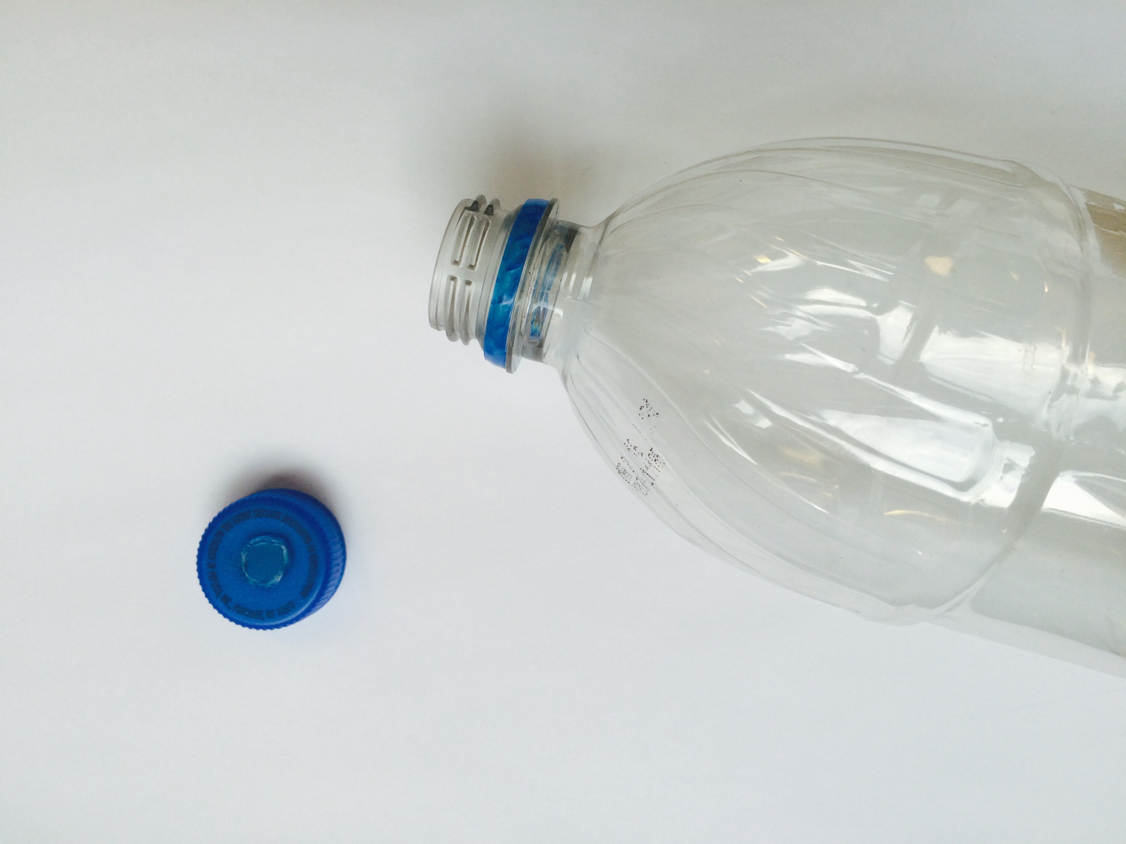 | Remove the lid from a soda bottle and drill or solder a 1/4” hole through the center of the lid.
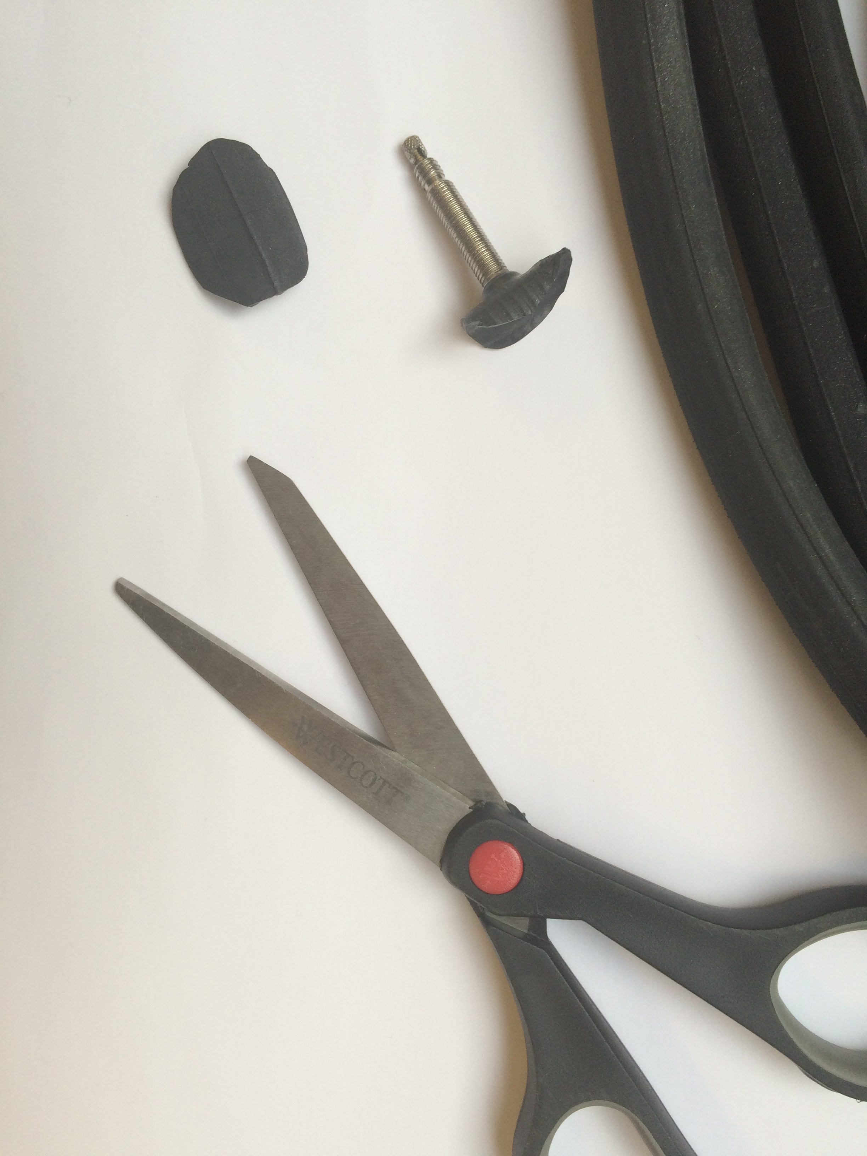 | Cut the valve from a bicycle inner tube, leaving 1/2” of excess tube on all sides of the valve. Any type of valve will work so long as you have a compatible bike pump.
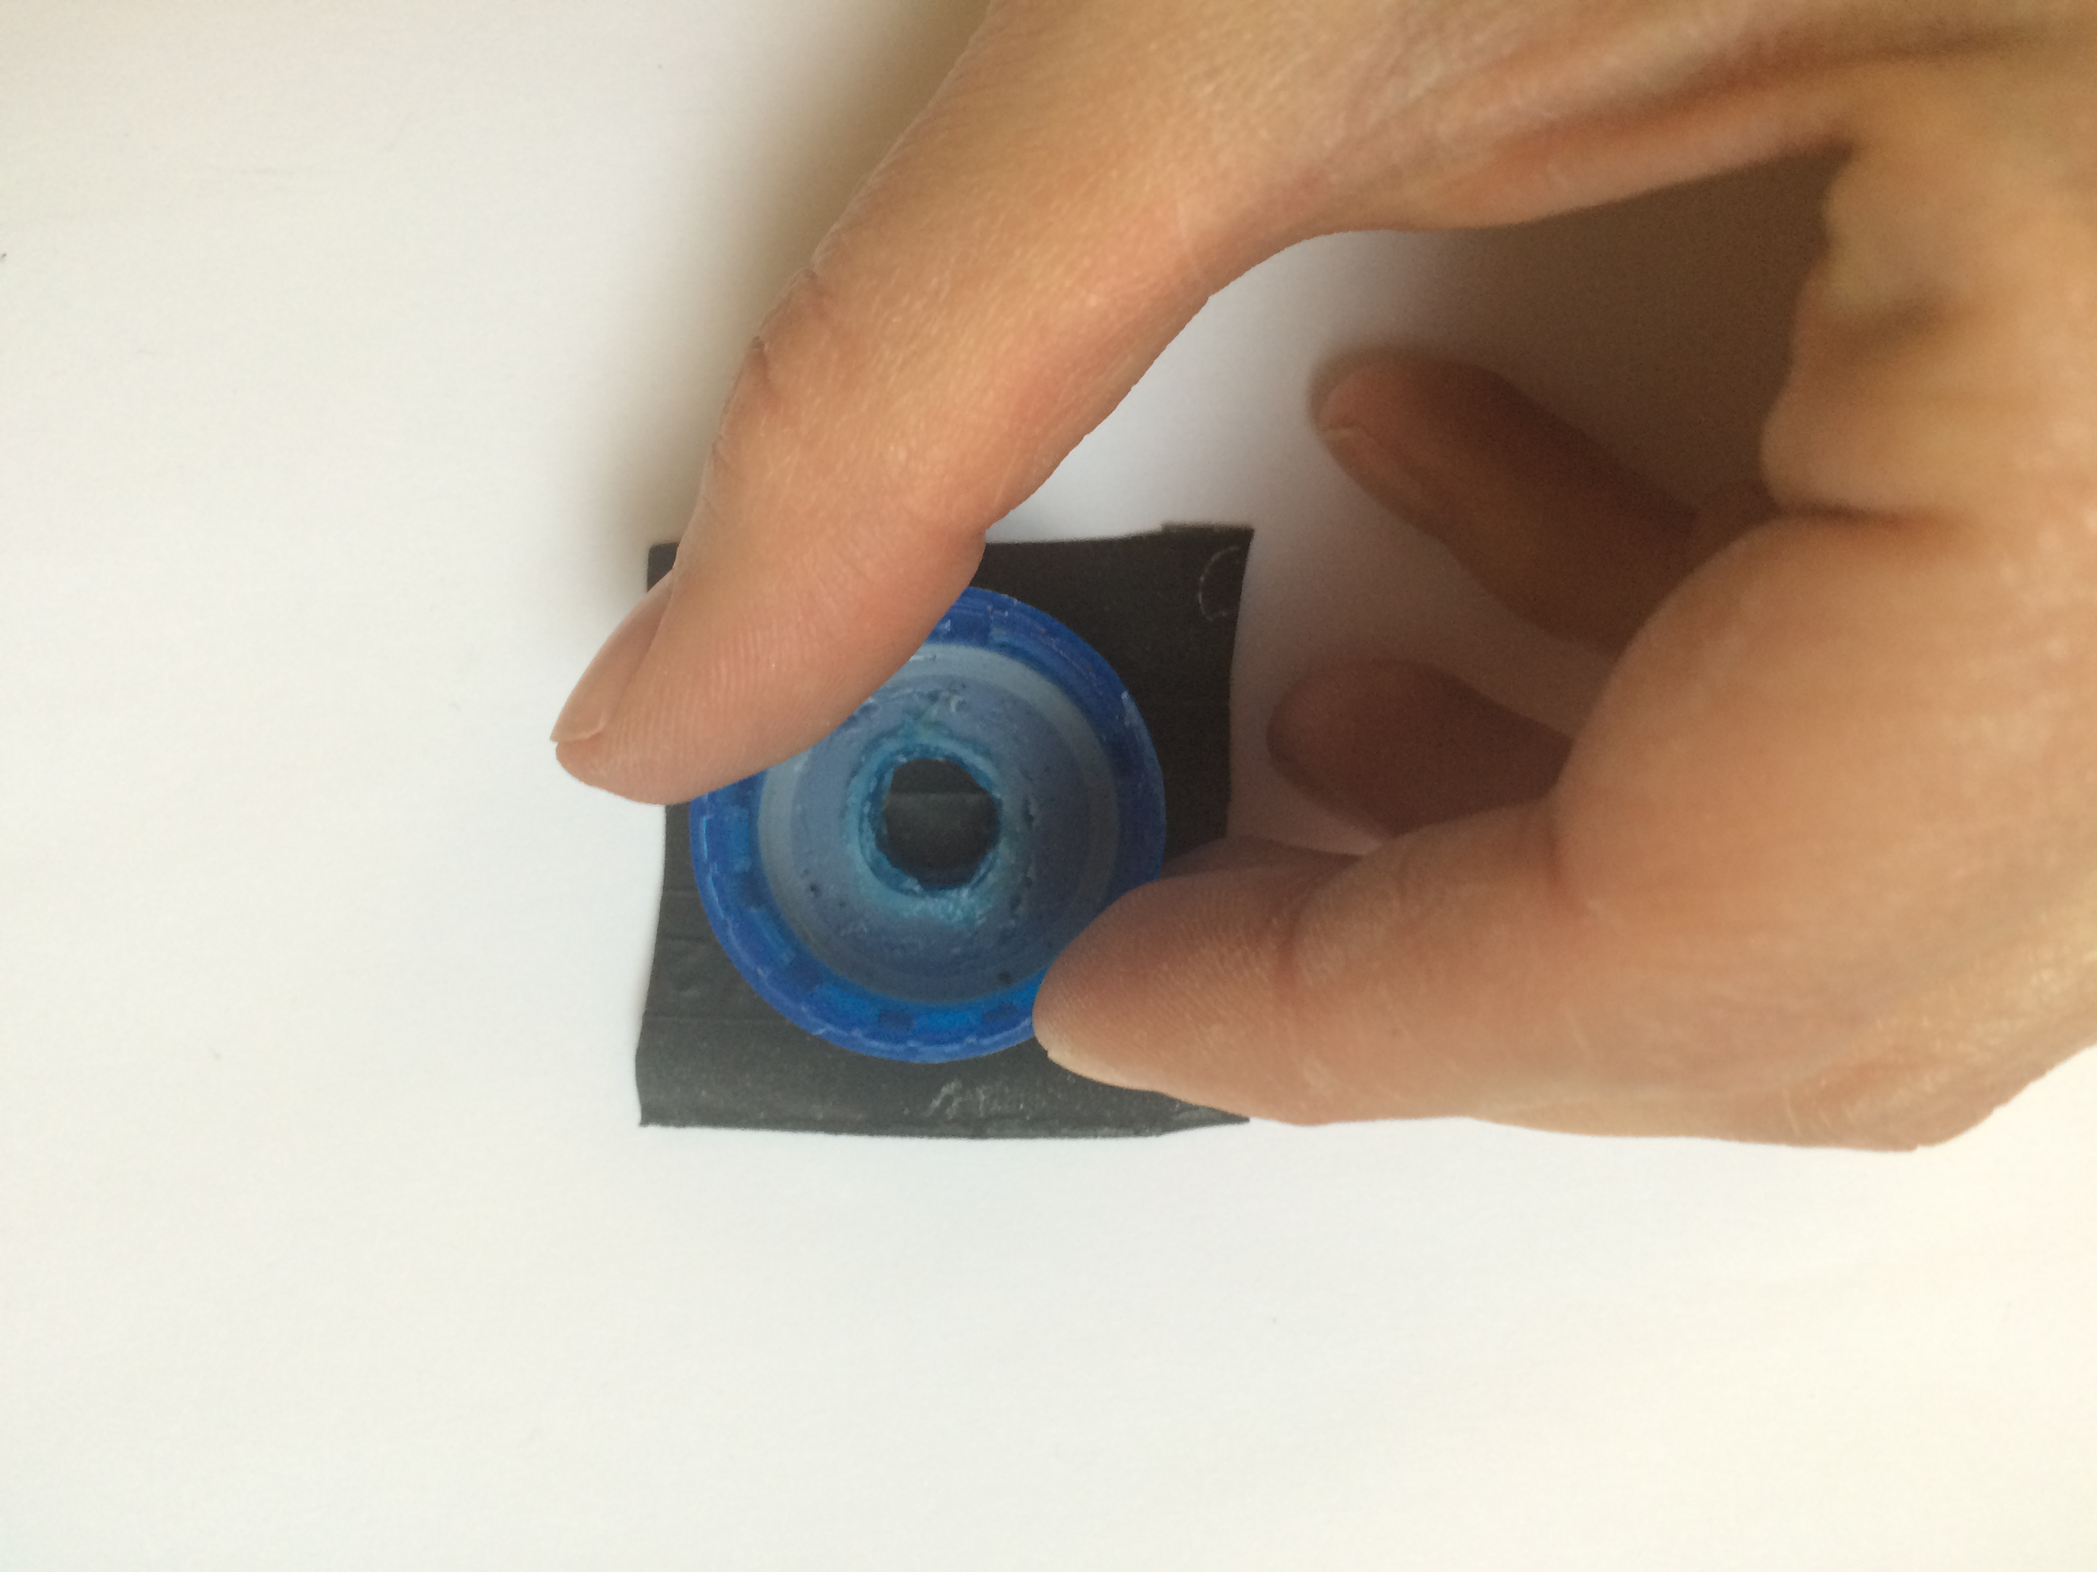 | Cut a separate square from the inner tube. Using the soda bottle lid as a guide, trim the square with scissors to form a circle with the same diameter as the lid.
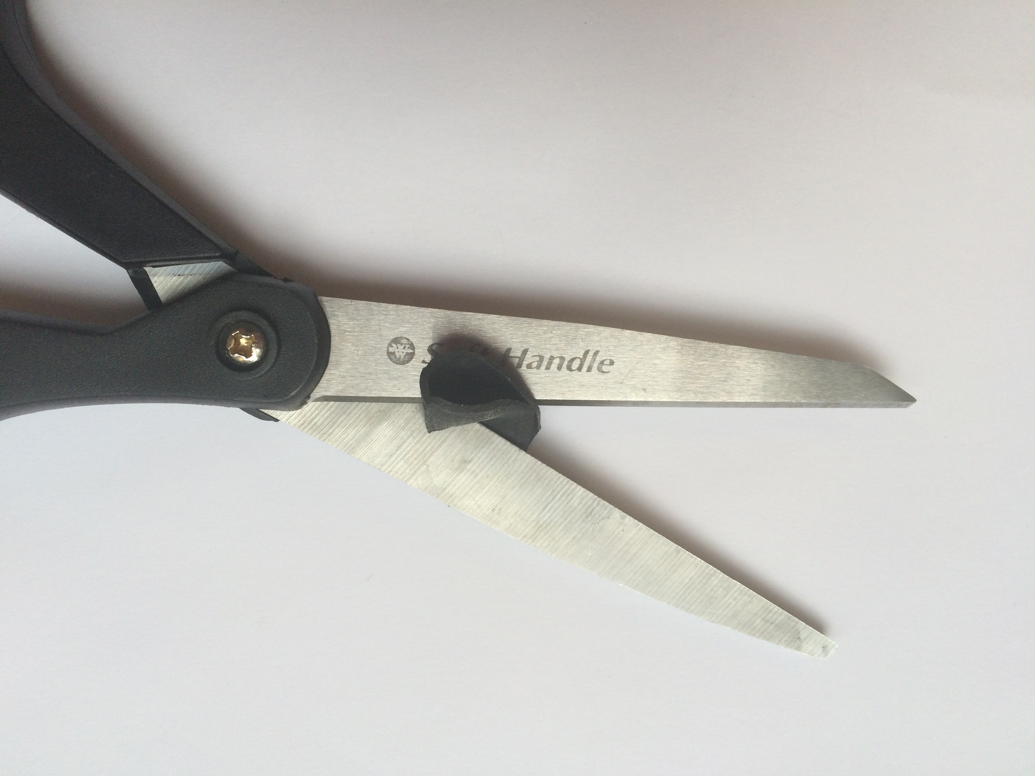 | Fold the circle of inner rube in half, and cut a tiny, 1/16” slit into the center of the circle.
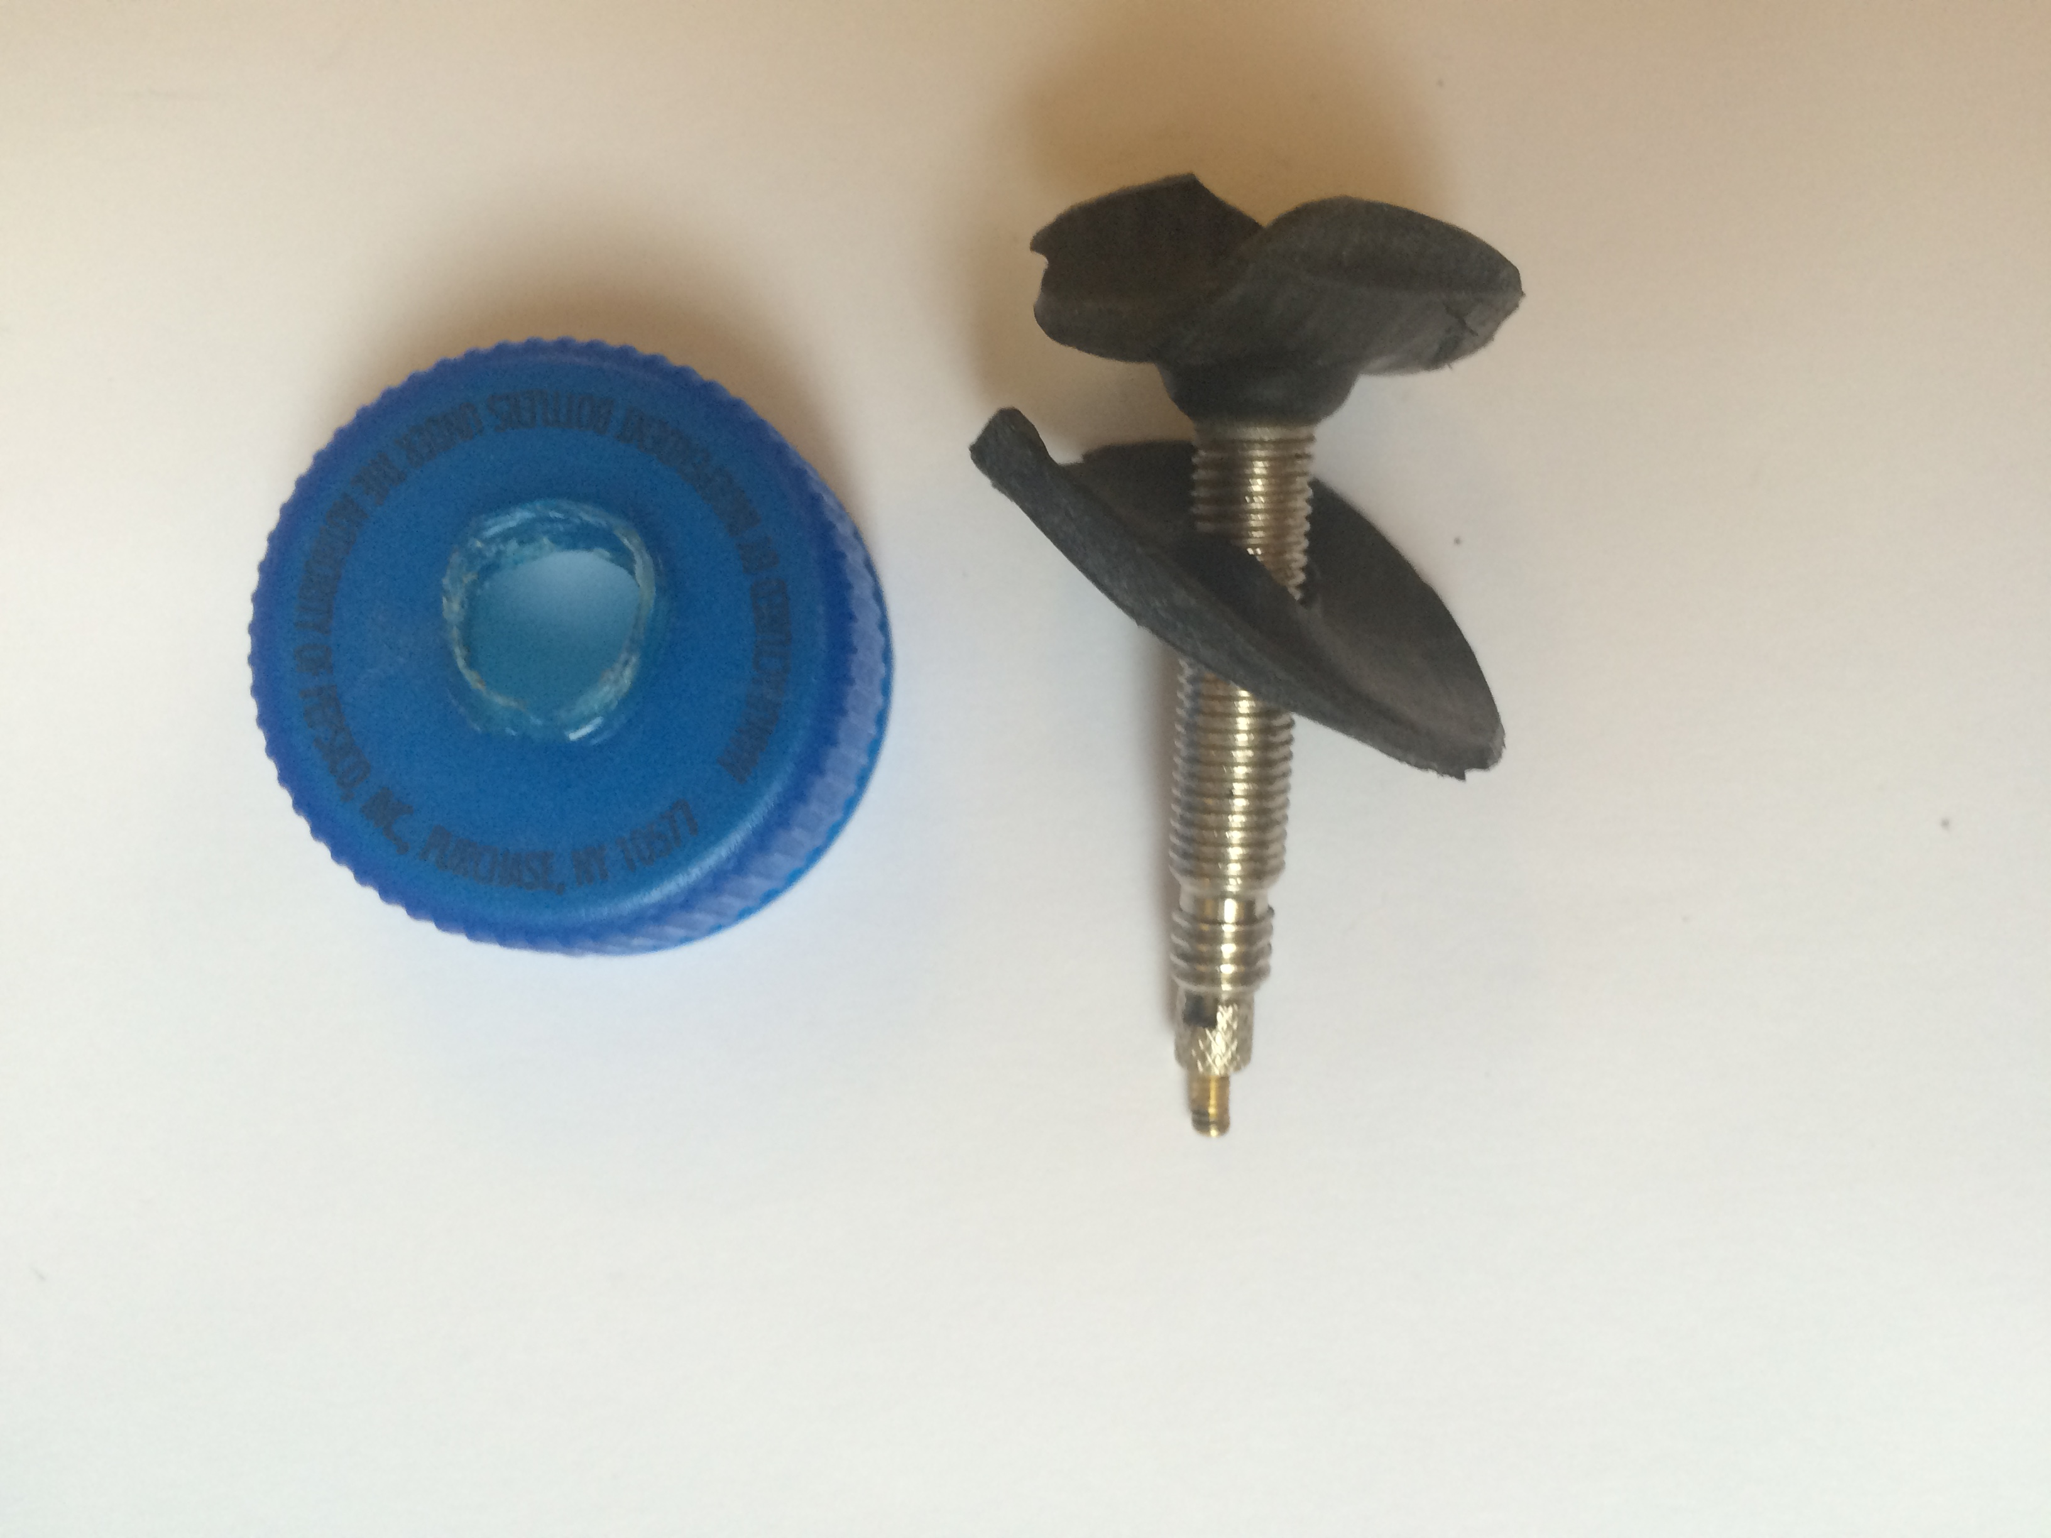 | Push the valve through the tiny slid you cut in the inner tube circle.
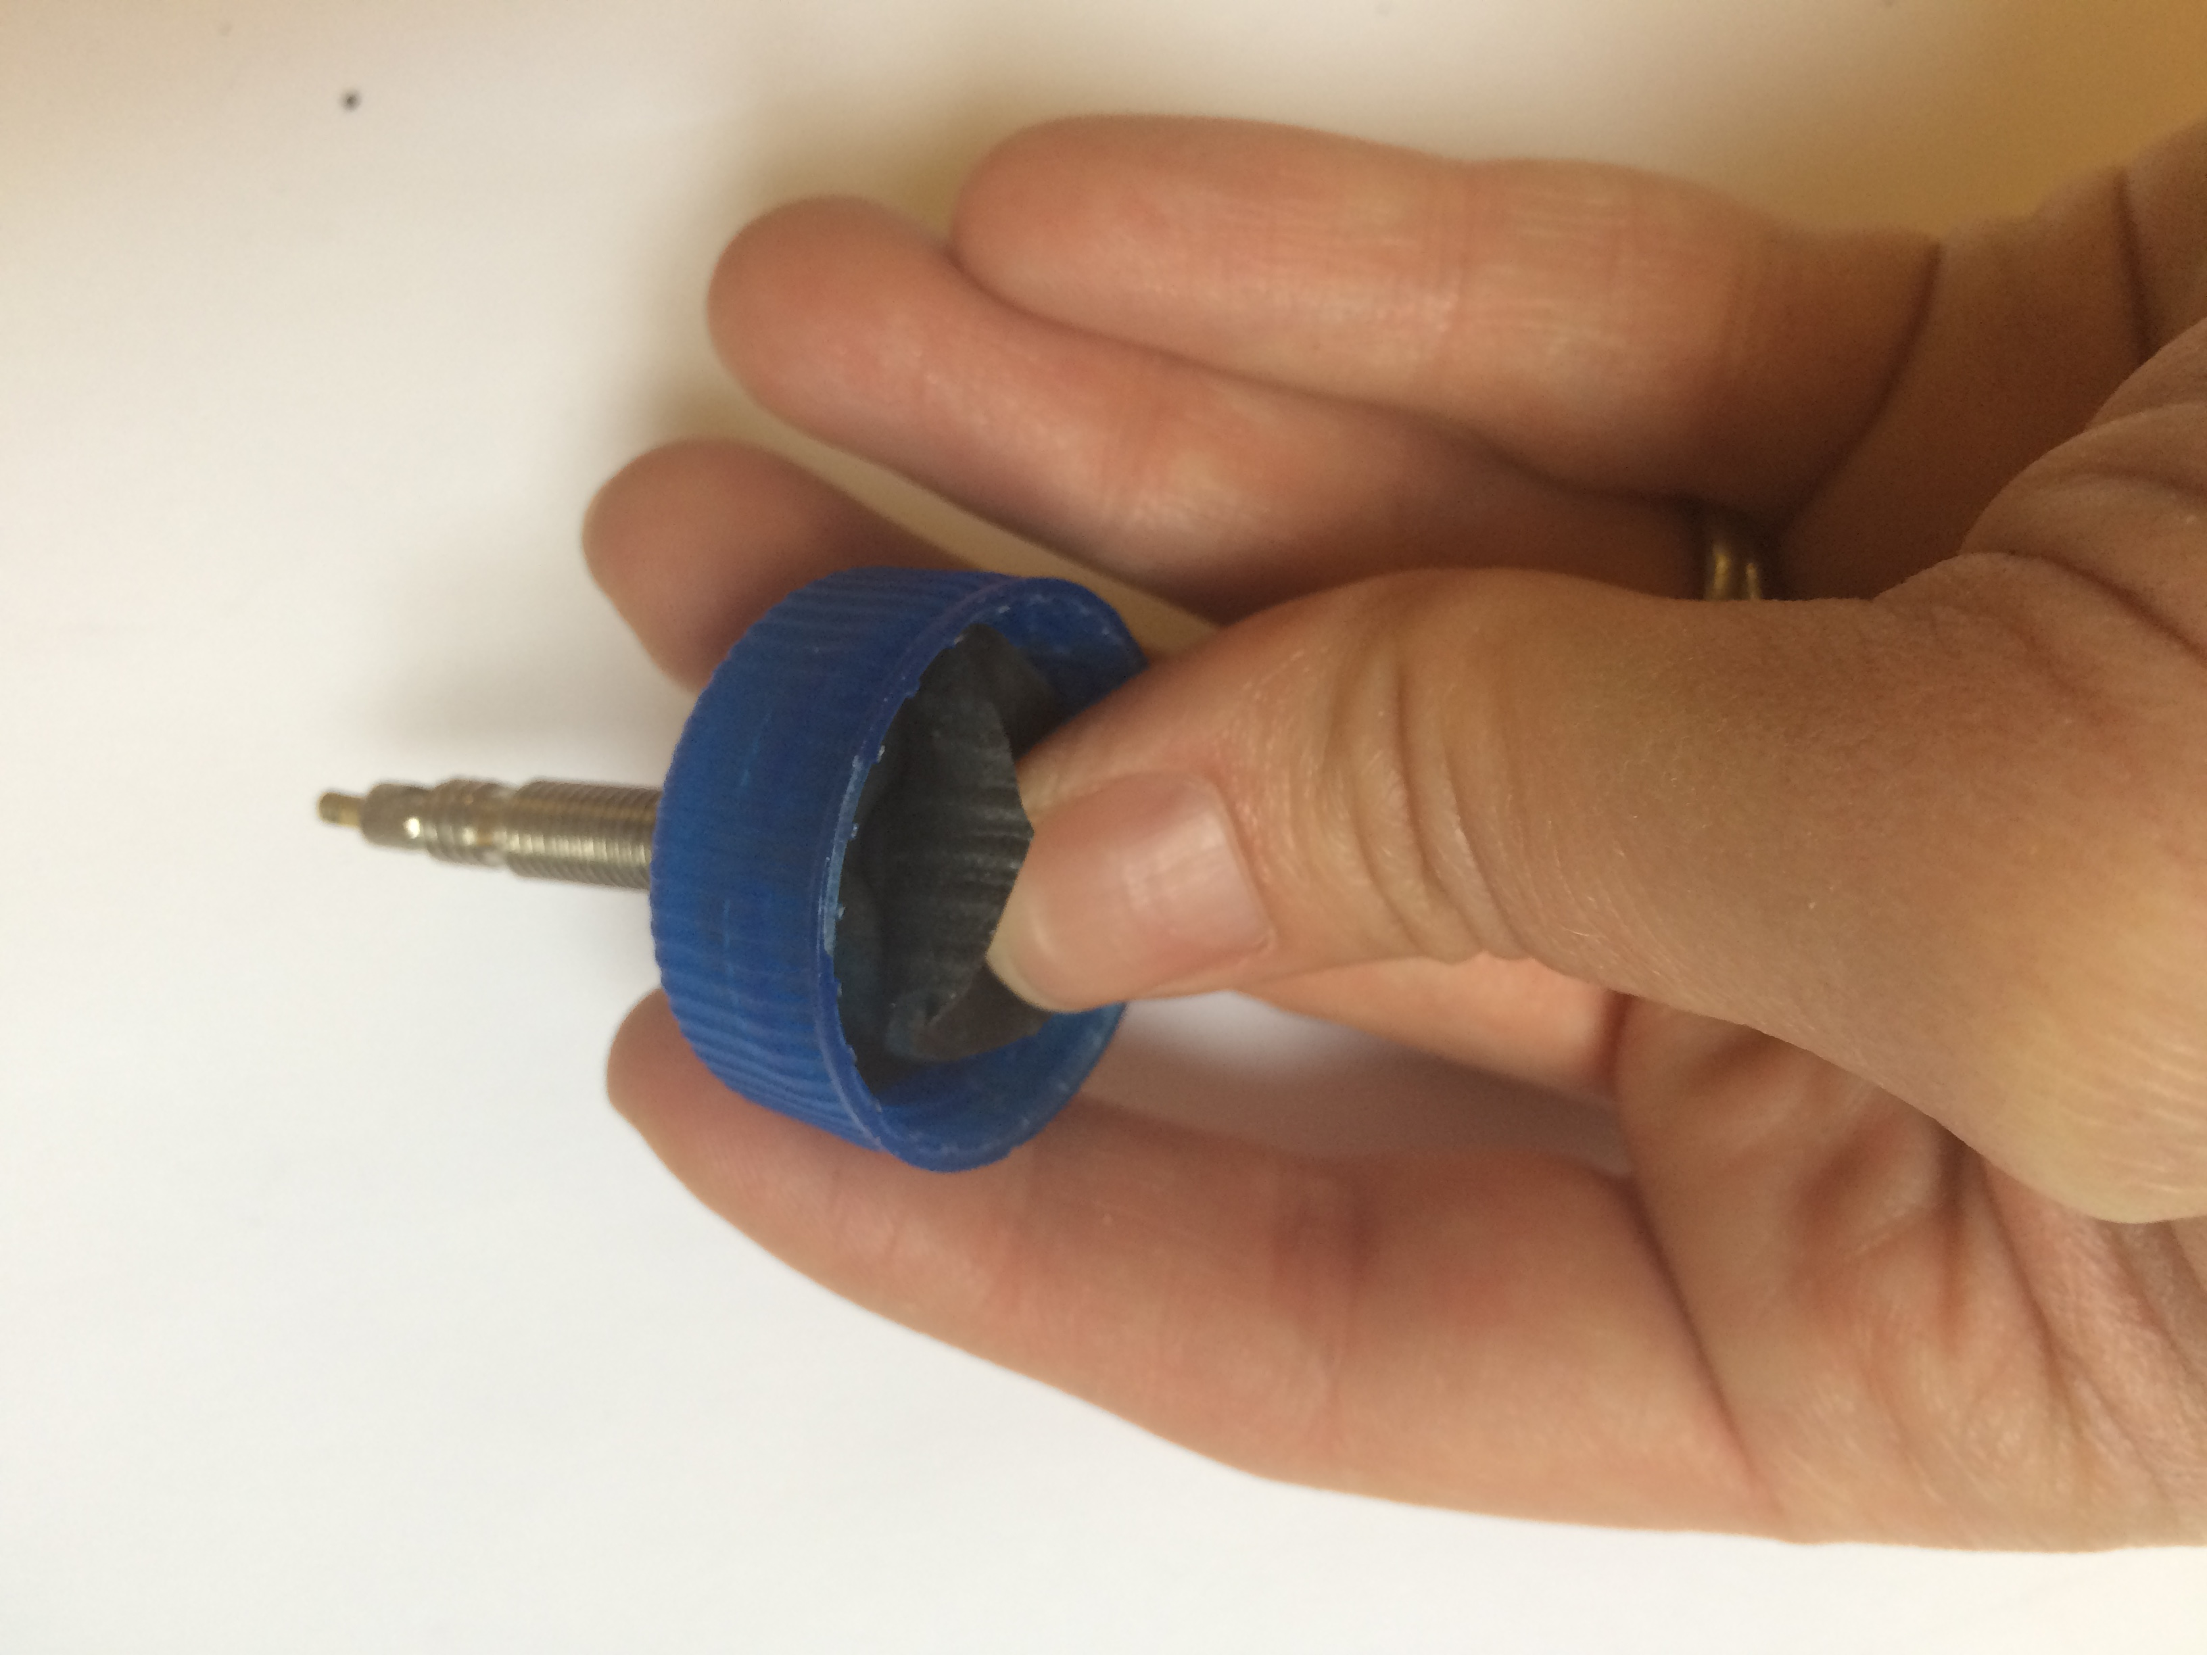 | Place the valve and the circle of inner tube into the lid so that the valve pokes through the hole in the lid. Use the tip of your finger to push the ends of the rubber circle into the very edges of the inside of the lid.
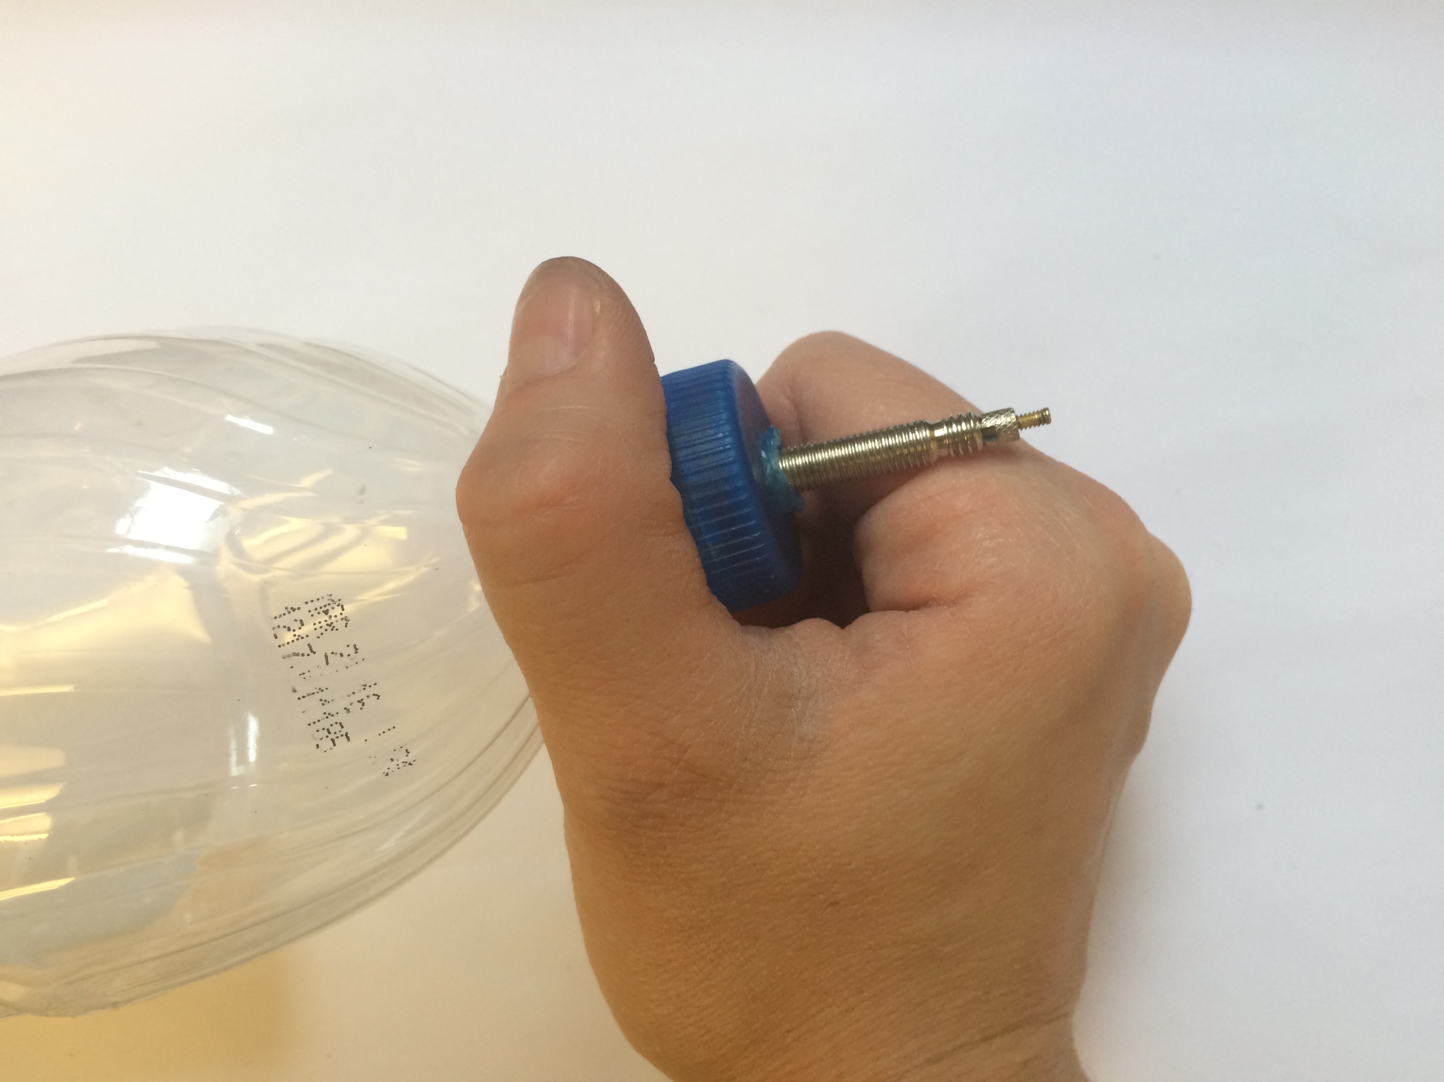 | Firmly screw the lid back onto the bottle as far as you can. You should feel the resistance of the rubber on the lip of the bottle.
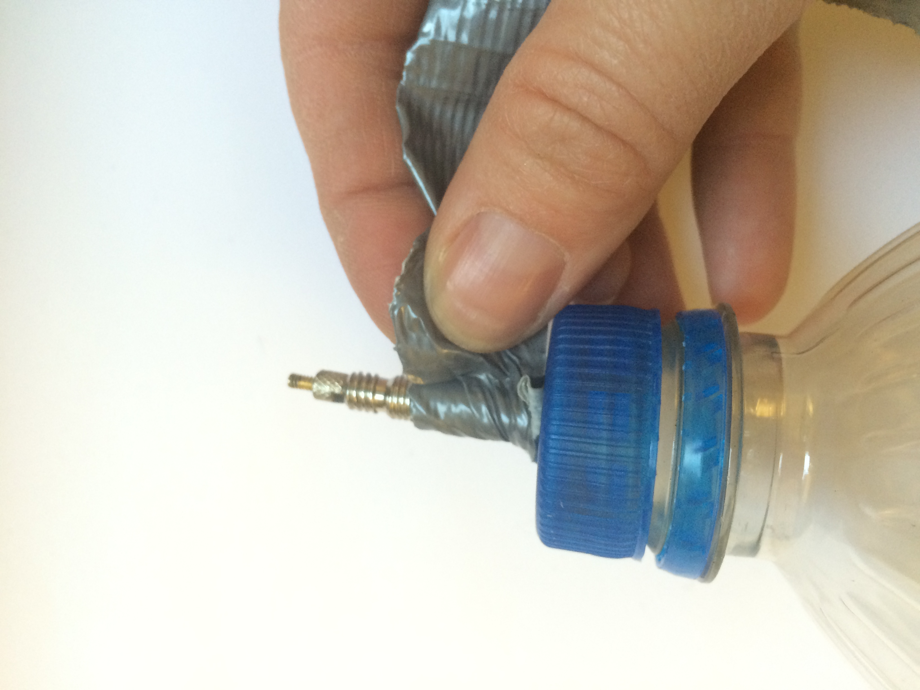 | Use duct tape or electrician’s tape to seal the gap between the valve and the hole in the lid of the bottle. Squeeze the bottle gently and listen for leaks. Seal any additional leaks with tape.

