Heart-Making Instruction Sheet
Here are a few approaches to creating hearts, whether you are drawing your hearts directly on a valentine or sketching them and then cutting them out.

COMPUTE: Use a digital illustration program
- Create a heart shape in a digital illustration program, either by drawing freehand or by using an available heart shape in the program.
- Practice learning how to copy, move, resize, rotate, and recolor the heart shapes you generate.
- Practice moving the hearts consistent distances by using your arrow keys and counting the number of taps in each direction.

SUPER EASY: Draw a line, and then improvise
- Draw a line AB of a certain length x.
- Draw “freehand” the right and left-hand sides of the heart, starting at the top of the line and ending at the bottom. Alternatively, if you’re cutting out hearts, fold your paper along line AB and then draw one side of the heart along the folded line, and cut the folded paper along that line. Your heart will be symmetrical.
- Change the size and orientation of your heart by changing the length and orientation of your starting line. You can also change the width of the two lobes.

EASY: Make a square and two half circles
- Use your ruler to make a square.
- Use a compass to draw a half circle on one side of the square by placing the needle of your compass in the middle of that side and placing the pencil on the corner, then turning.
- Repeat this procedure to draw a half circle on an adjacent side.
- Change the size and orientation of hearts you make by first changing the length and orientation of your square, and then repeating steps 1-4.
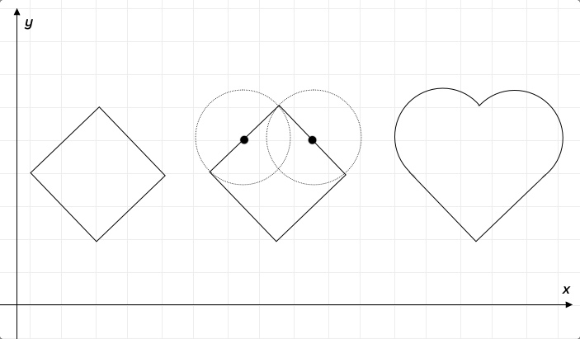

MODERATE: Make two lines and two circles
- Draw a vertical line of length 3x, where x is any unit of length (cm, graph paper squares). Call this line AB, labeling the top point A and the bottom point B.
- Next draw a horizontal line of length 4x and center it on top of line AB so that 2x of the line is on the left side, and 2x of the line is on the right side, forming a “T.” Label this new line CAD, where C is the leftmost point and D is the rightmost point on the line.
- Use your compass to draw a circle on line CAD by placing the needle of your compass in the middle of line CA, and placing the pencil at point C, then turning. Call this circle C.
- Use your compass to draw a circle on line AD by placing the needle of your compass in the middle of line AD, and placing the pencil at point D, then turning. Call this circle D.
- Draw a line from point B to the part of circle C closest to point C so that it touches but doesn’t intersect with the circle. Fun fact: a line that shares a single point with a curve but does not intersect it is called a tangent line.
- Draw a second line from point B to the part of circle D closest to point D, but where it won’t intersect with the circle.
- Change the size and orientation of this kind of heart by changing the length or orientation of lines AB and CAD.
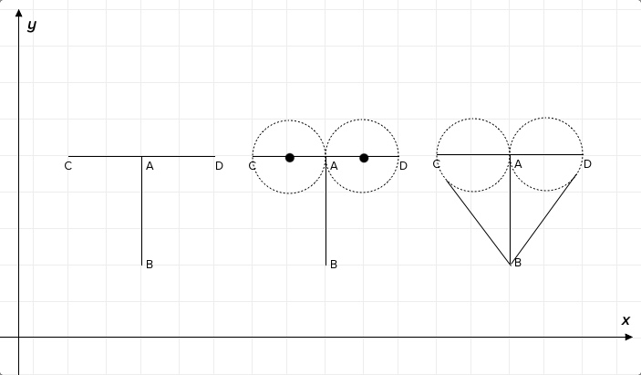

IMPRESSIVE: Graph a cardioid, or “heart-shaped” function with software
- Choose your favorite cardioid function, or try one of these cardioid functions from wolfram-alpha. I like this one because it’s defined in terms of x and y and has a value t that can be used to tweak the function: x=16 sin³t, y=13cost-5cos(2t)-2cos(3t)-cos(4t).
- Using a graphing calculator or graphing software, graph your function. If using the above function, be sure to assign a value for t before you start.
- Change the size of this function by changing variable t.
Bonus: How could you change the orientation of this function?
- Be sure to check out these super impressive cardioid functions plotted by math artist Hamid Naderi Yeganeh.

