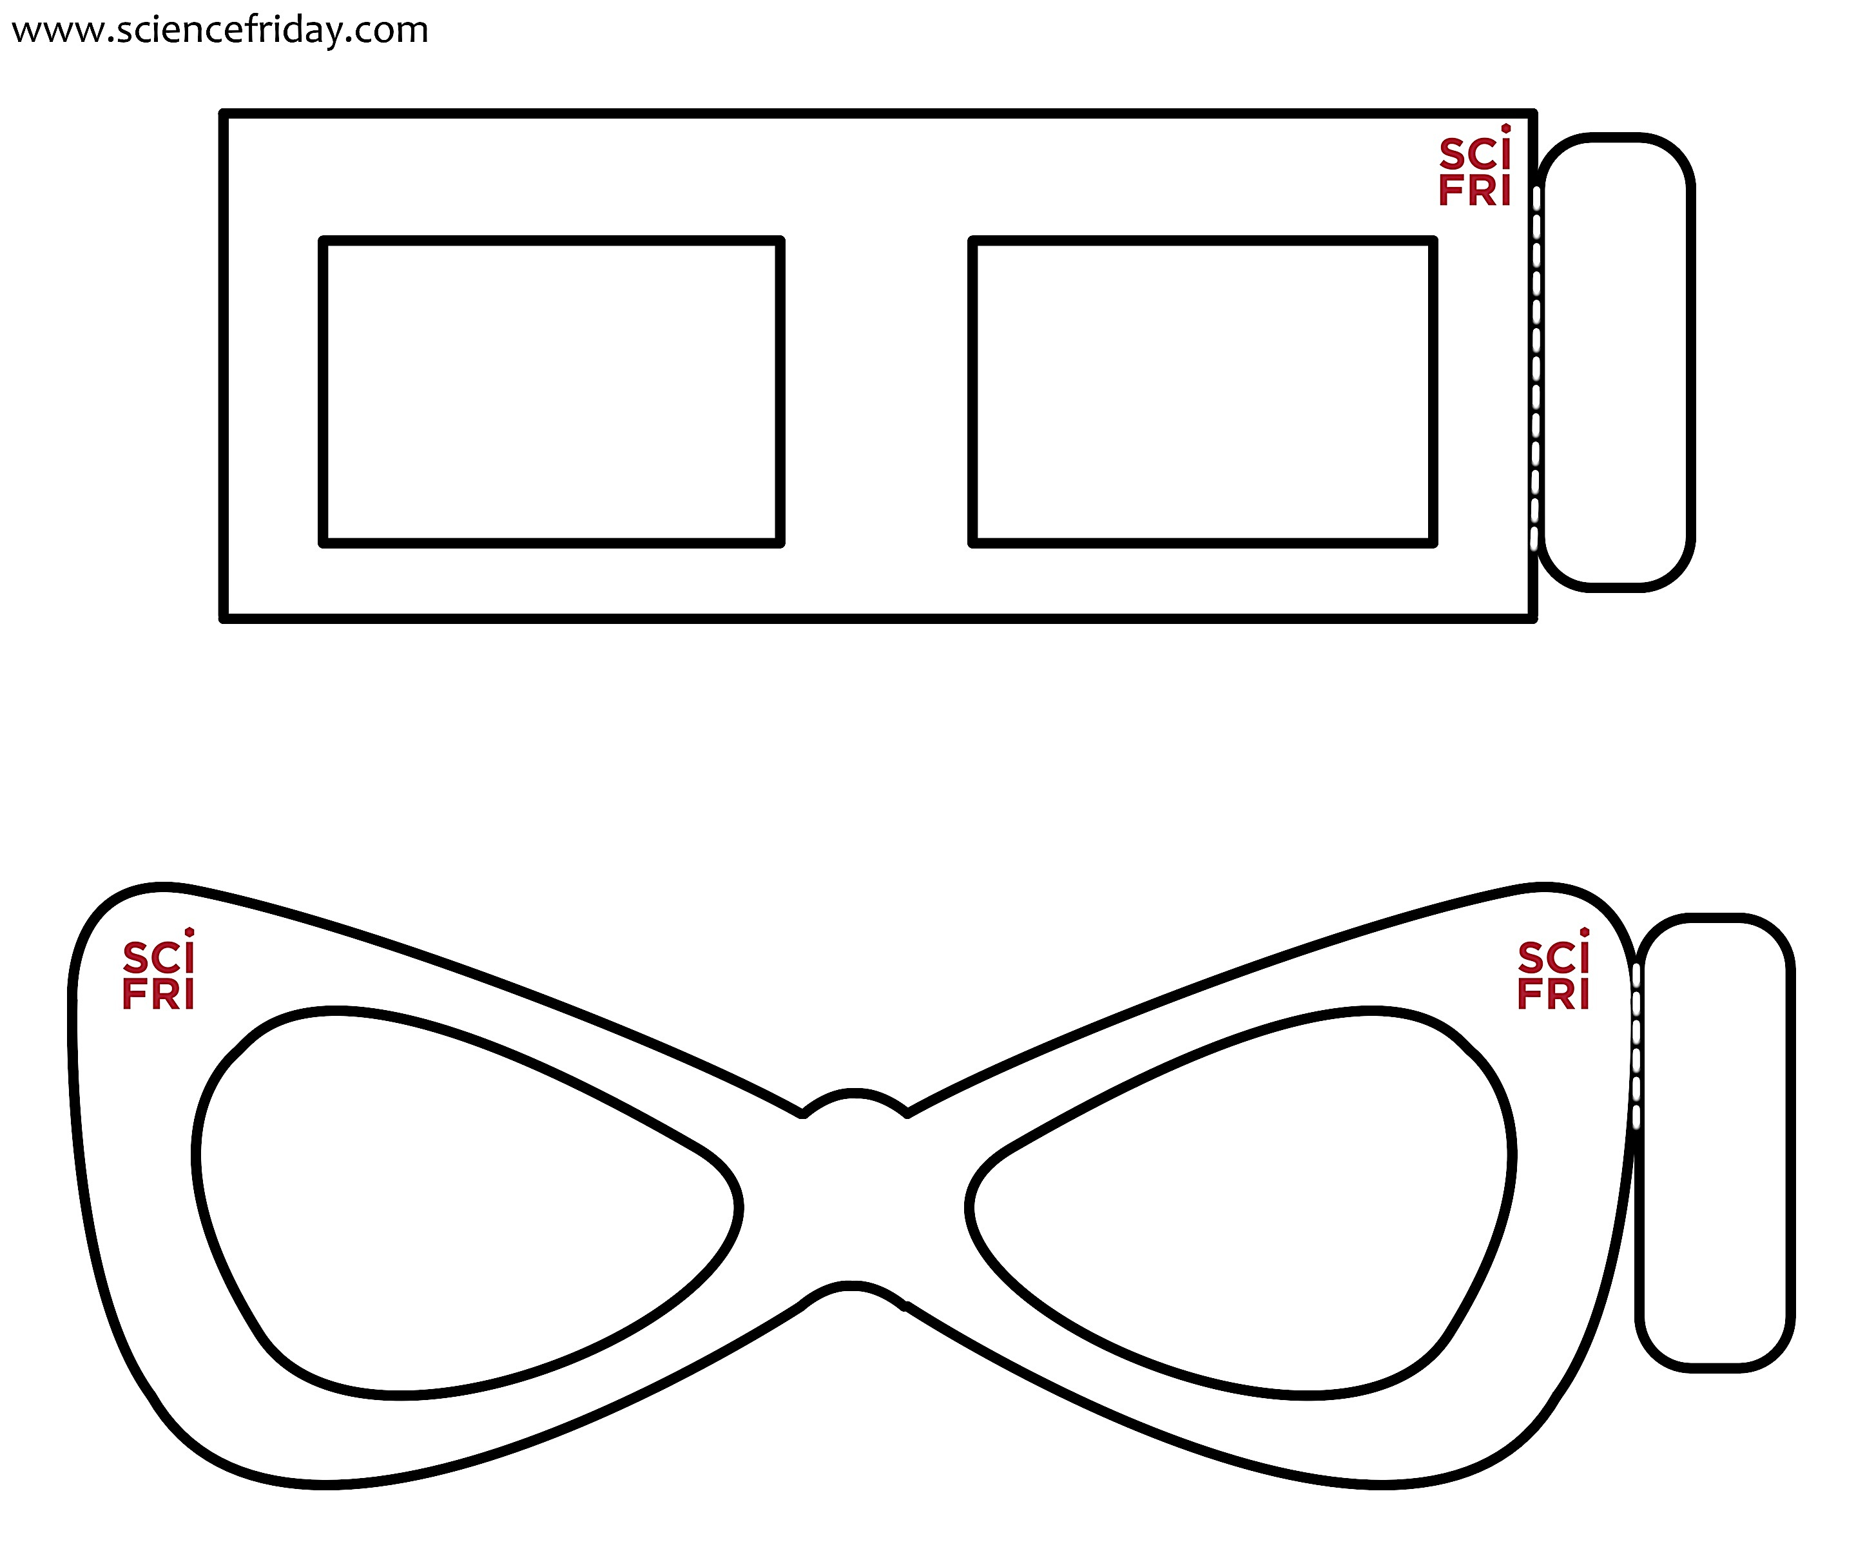

Fold and tape

Fold and tape

Instructions
1. Print out this page on sturdy paper, preferably cardstock.

2. Cut out the frames and eyeholes along the solid lines.

3. Fold and tape the side tab around a straw or wooden stick to form a handle.

4. Cut out new lenses from colored cellophane or colored light filters. Your glasses will work better if you use at least three layers of cellophane or light filters for each lens.

5. Tape the cellophane/light filters into the frames, being careful not to tape over the viewing area.

