Chocolate Prediction Sheet: How will the way you prepare the chocolate affect beta-crystal formation?
Modification | Model | Will this modification help or harm beta-crystal formation? Why?
Seeding –The chunk of tempered chocolate acts as a “seed” crystal to provide a scaffold for new crystals to grow on. | 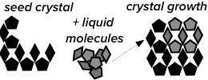
Scorching – Chocolate is heated until all crystals are melted and the molecules within chocolate begin to break down, causing them to separate and, in some cases, evaporate from the molten chocolate. | 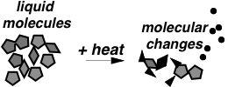
Seizing - Droplets of cold water are sprinkled into the melted chocolate. Keep stirring as it cools. Some of the molecules in the chocolate are water-soluble and will dissolve into the added water, while others are hydrophobic (repelled by water) and will clump together. | 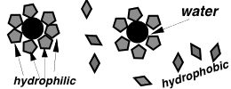
Shocking –The bottom of the bowl is placed in ice water while the chocolate is stirred continuously until it becomes difficult to stir. | 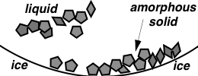
Marble tempering - The liquid chocolate is poured out onto a marble slab to help it cool, then scraped across the surface continuously until it becomes thick and viscous. | 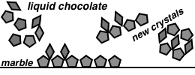
DIY method: Describe how you plan to modify the standard melting procedure:

