Forces and Motion: Graphic Organizer
Trial | Predict which way the cart will move | Explain your prediction
Which way do you think the cart will move in each of the pictures below? Explain your predictions using drawings and words.

- Go to PhET Force and Motion Basics and click “Net Force” to test your predictions using a series of trials. Try new combinations!
- Compare the predictions that you made in the table above to what happens to the cart of candy in each trial. If some of your predictions are not right, use a different color pencil to correct them.

Try more trials using different combinations of people from the red and blue teams. Draw or talk about what you discover. You can use the data table below to keep track of your observations.
Trial | Which way did the cart move? | Explain why
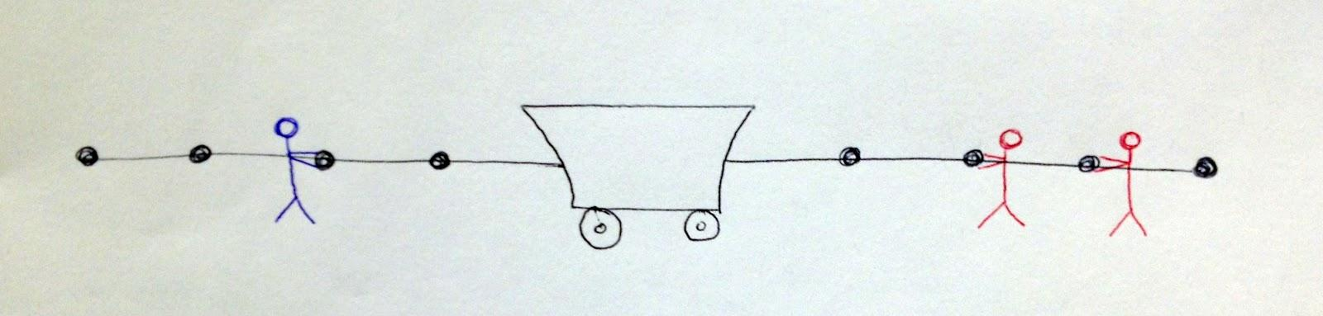

Look at your tables. What are some “rules” that you can use to make predictions about which way the cart will move? You might ask yourself questions like:
  - Does it matter that the people are red or blue? Explain your answer.
  - Does a large person always win each competition? Provide evidence to support your answer.
  - If two people are pulling on opposite sides, does the cart always stay still? Elaborate on your ideas.
  - Does it matter what part of the rope a person holds? Provide evidence to support your answer.
  - How does the “Sum of Forces” help you?

