Air Vortex Cannon Engineering Worksheet

Can you design an air vortex cannon that shoots air even farther?
- Brainstorm ideas for improving the original air vortex cannon design, and record your ideas in the table below.
- Explain why you think each change to the design will make the air cannon shoot air farther.

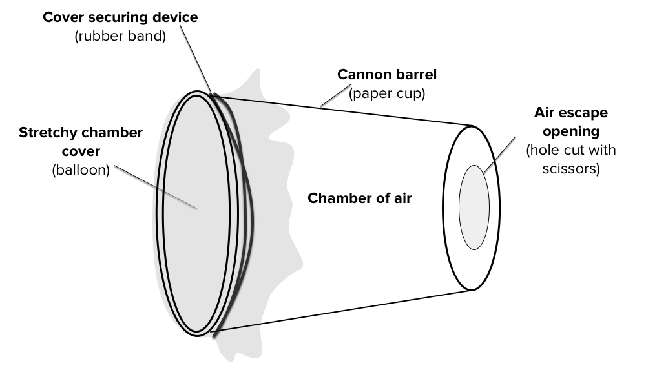

1. Change to air cannon design: | 2. This change will make the air cannon shoot air farther because:
Design a Better Air Cannon
Use this space to sketch a design for an improved air vortex cannon using your brainstorm as a source for ideas.
Make sure to label your design with the materials used for each part of the air vortex cannon

Modify and Test Changes to Your Air Vortex Cannon Design
- Record changes you make to your air vortex cannon design in the table below.
- Test and record the new maximum air travel distance after each design change.
Version  # | Sketch or describe this air vortex cannon design change | Maximum air travel distance
1
2
3
4

