Candy Beetle Data Sheet
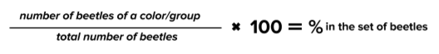
Sample |  | Other Colors | Total # in the Sample
Sample # 1
% Focus Color in the Sample
Sample # 2
Total (1+2)
% Focus Color in the Sample

- Transfer your “Total (1+2)” data from above into the chart below.
- Complete the data table by obtaining data from other members of your group.
Sample |  | Other Colors | Total # in the Sample
Total (1+2)
Total (All Samples)
% Focus Color in the Sample

