Acoustics of Burps Data Sheet

Test Subject | Gender | Height (cm) | Burp Frequency (Hz)
 |  |  | Burp # 1 | Burp #2 | Burp #3 | Burp Average

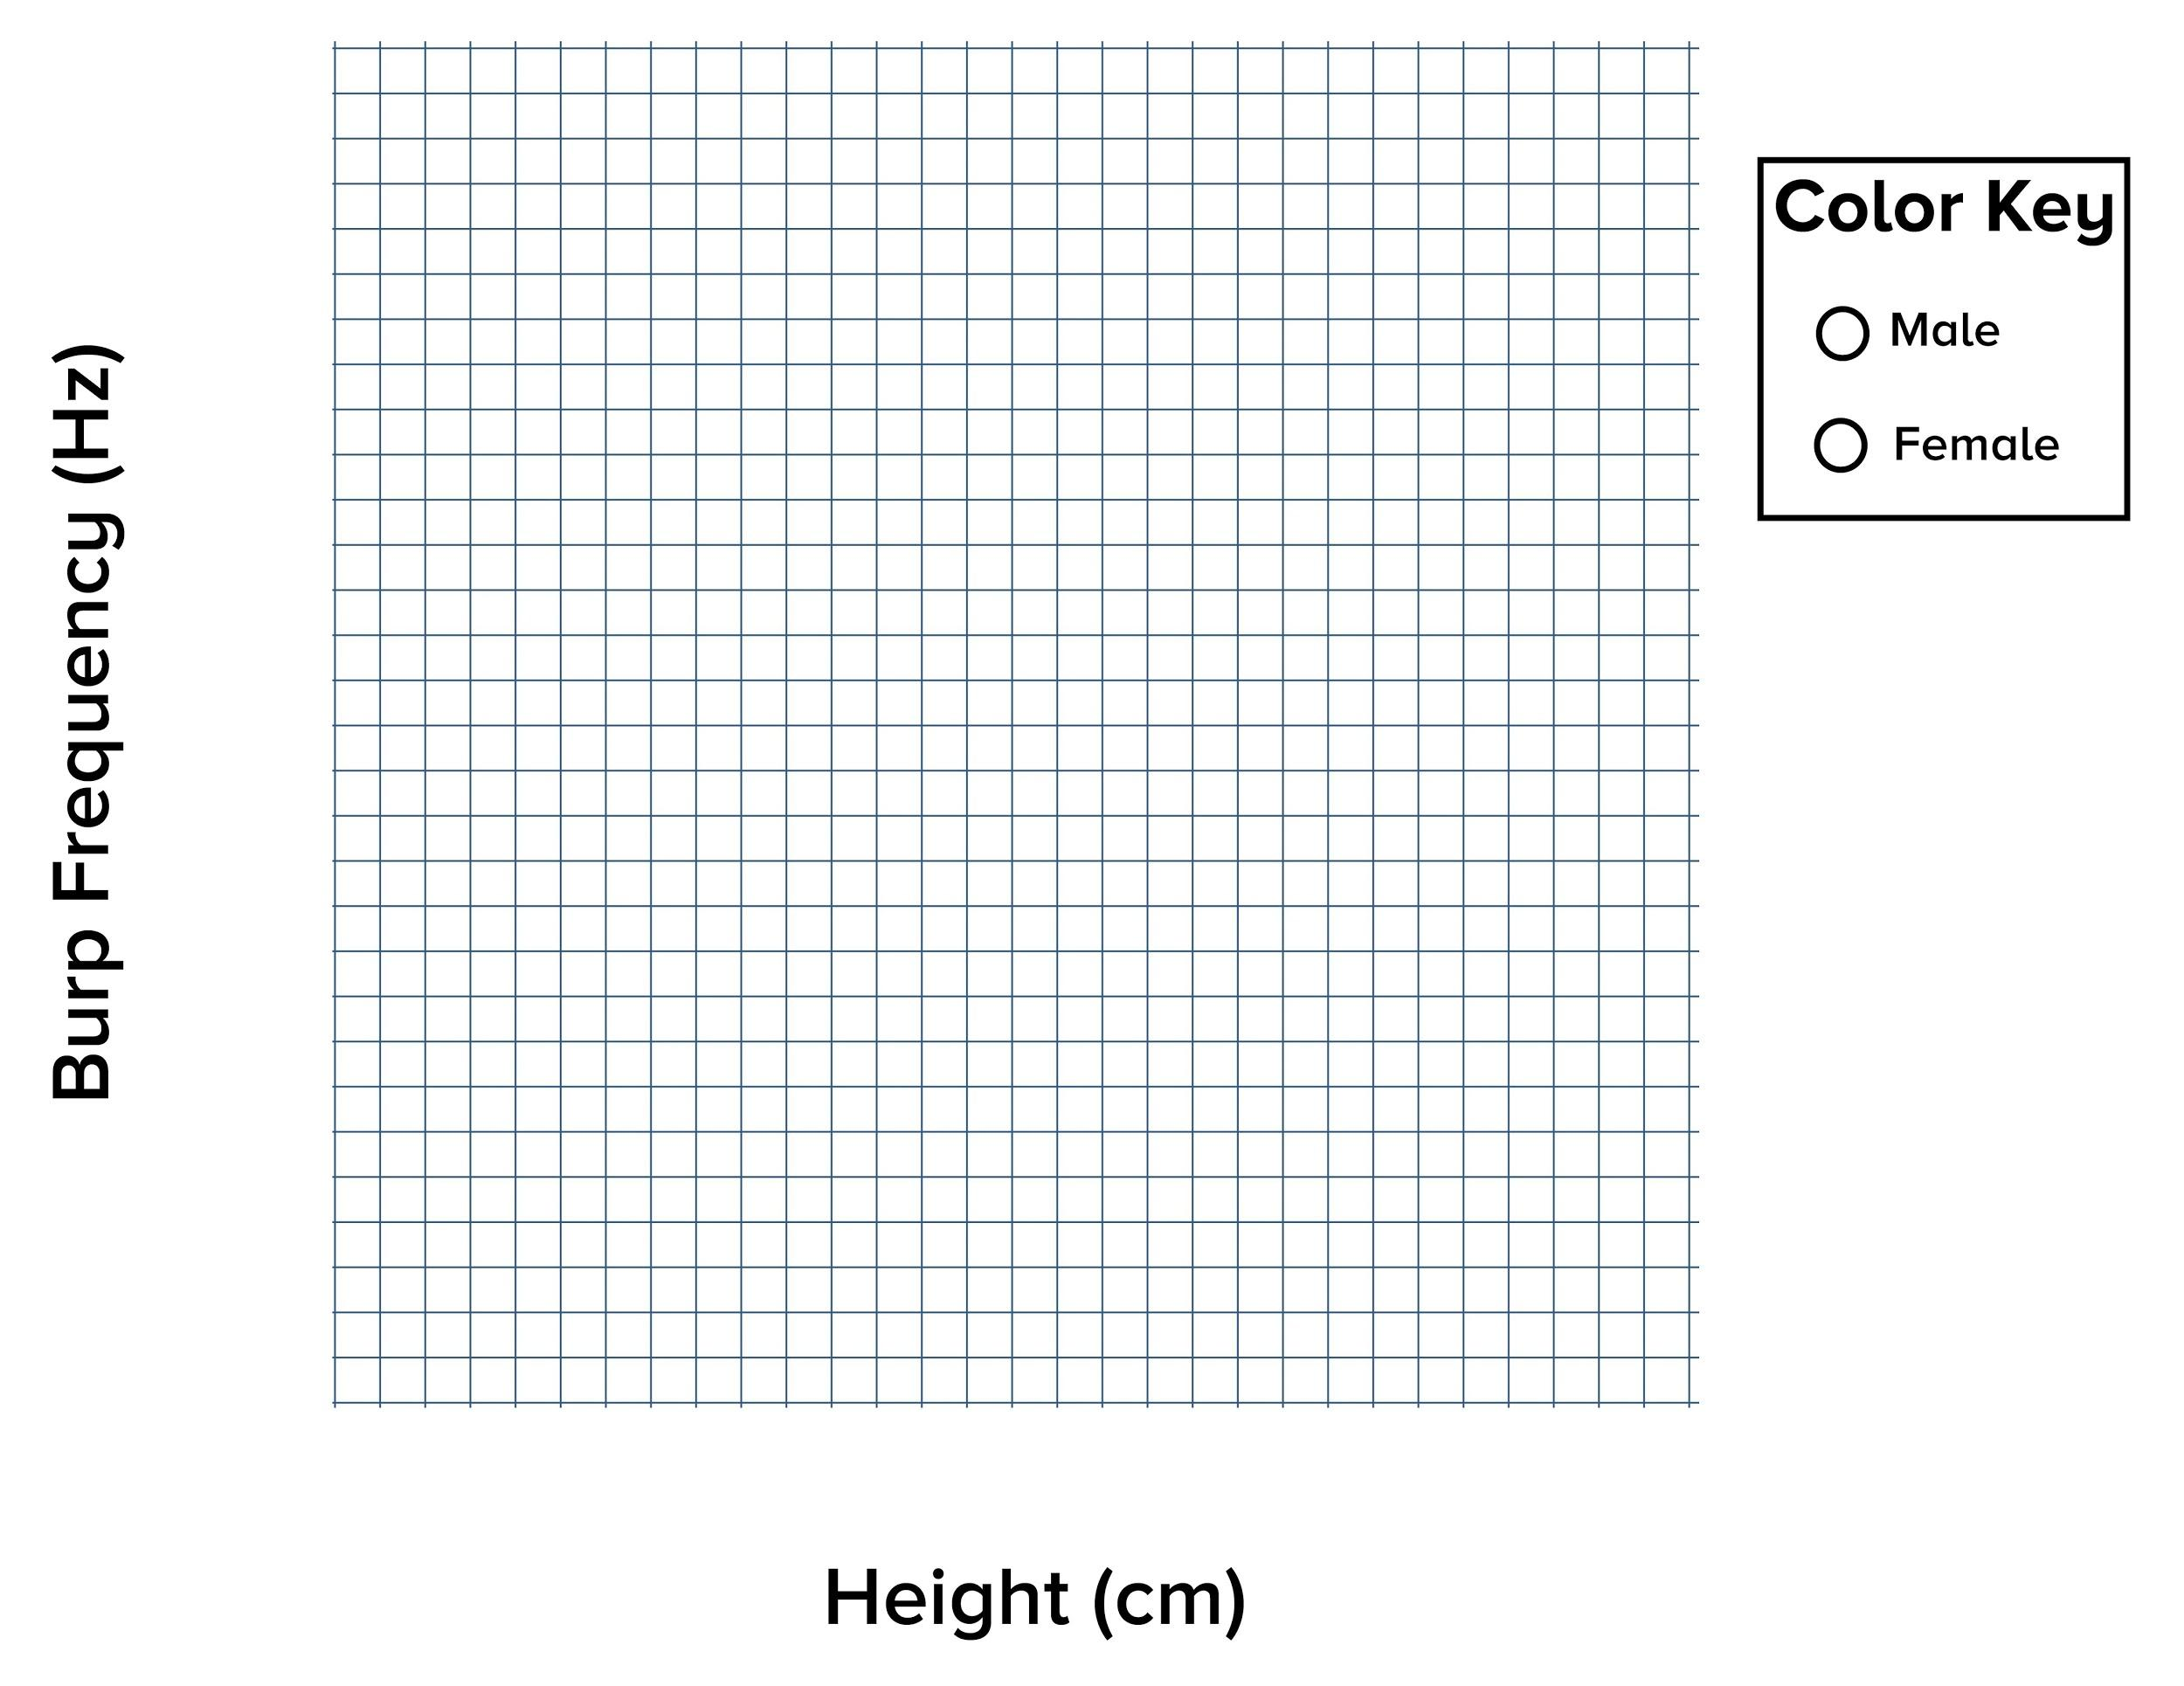
Discussion Questions
Do you notice any trends related to height and burp peak frequency? What about gender and burp peak frequency?

Describe if and how the peak frequency of burps changed depending on height or gender. Why do you think the frequency did or didn’t change?

Think back to the moose and the mouse. Do your results support the concept that body size, in this case height, is inversely proportional to the sound frequency (Hz) found in the animal kingdom?

What other factors do you think might change the peak frequency of a burp?

Say you wanted to burp with a higher pitch. What would you change about your burping style? Why?
Design your own investigation to explore how body size, age, and/or gender relates to human sounds. What other factors could you investigate that may affect the frequency of human sounds? Besides burps, can you think of another sound that humans make that you could study for the sake of comparison? After you have designed your study, collect your data, graph them, and reflect on whether your results support your predictions.

