Multiuse Outdoor Space Design Worksheet

Using your new understanding of albedo and the urban heat island effect, how would you redesign this school's blacktop surface into a multi-use space that stays cool on sunny days?

Design
Use the brainstorming space below to sketch out possible ideas. As you design your solution, consider the following constraints:
- The lot is roughly 90 feet x 100 feet.
- The school currently has space for 36 parking spaces (four rows of nine spaces each), with each parking space measuring about 9 feet x 18 feet.
- The school is willing to sacrifice up to 15 parking spots if it means its students will be able to get more out of their recess.
Brainstorming

Describe how your design aims to reduce the effect of albedo on this multiuse outdoor space.
Final Design Sketch
Include labels for different surface materials and where the necessary parking spaces will go.

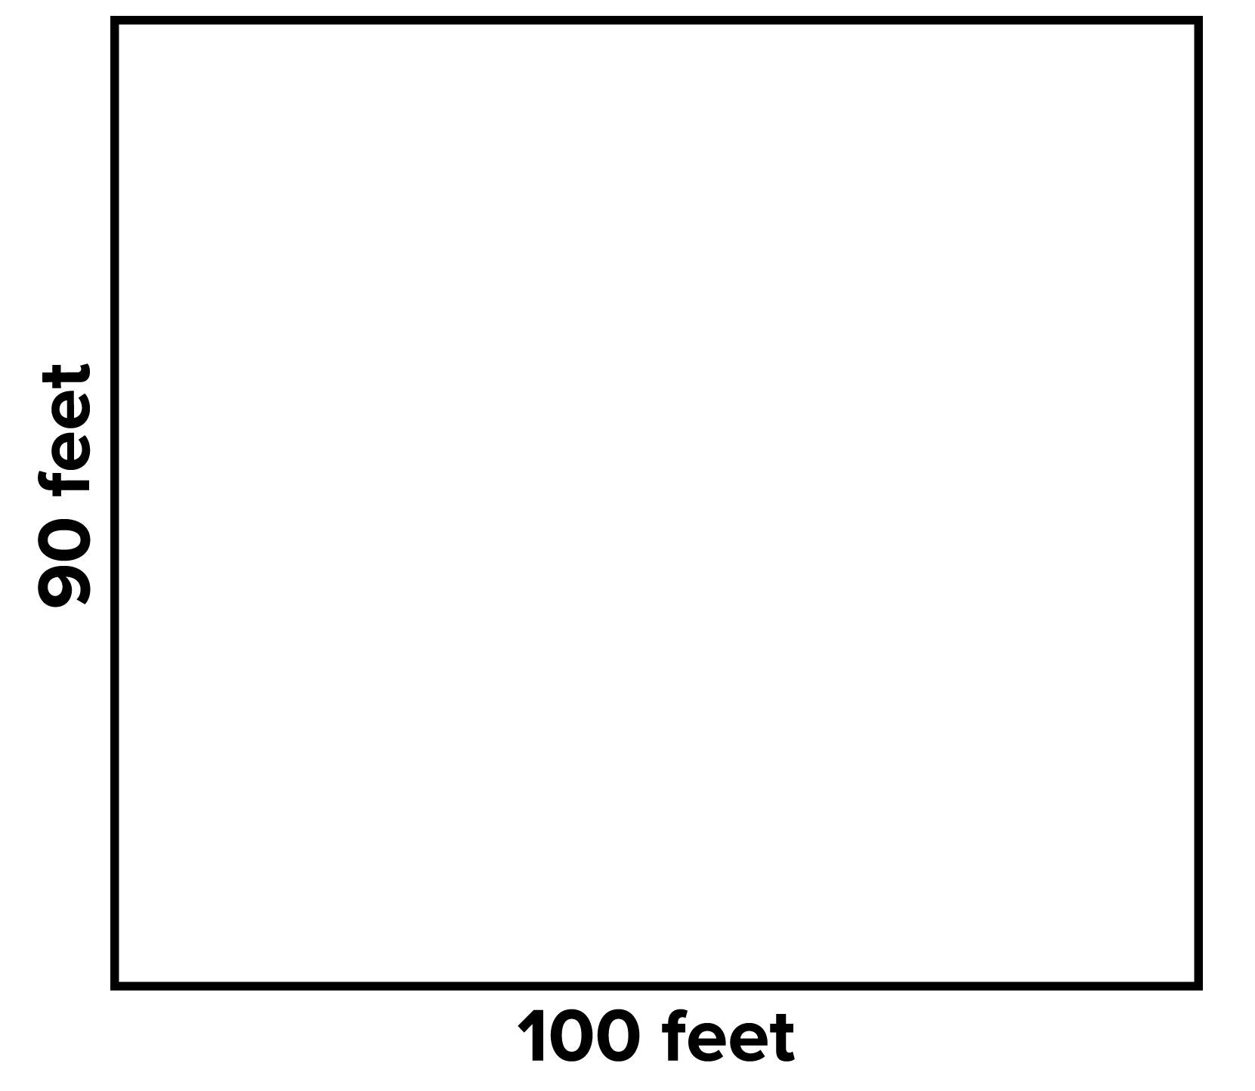

Collect Data
Parking Lot Type | Starting Temperature | Midpoint Temperature | Final Temperature | Change in Temperature (Ending Temp. – Starting Temp.)
Control
Your design
Design Challenge Discussion Questions
- Did your design achieve a lower temperature than the control parking lot?

- How did you preserve the open space for parking?

- Which design elements do you think had the largest impact on the final temperature? Design an experiment to test your conclusion.

- Share your designs. After listening to other people’s ideas, what would you want to try next?

