Climate Change Graphs

This document provides original climate change graphs and planning worksheets to use when creating an illustrated graph. Each title contains a link to the original graph, where you can access the data and a short description.

Graphs contained in this document include:

I. Global Carbon Emissions from Fossil Fuels, 1900-2011

II. Atmospheric CO₂ Levels: 2005-Present (direct measurement)

III. Atmospheric CO₂ Levels During Last Three Glacial Cycles (indirect measurement)

IV. Global Land-Ocean Temperature Index

V. Average September Extent of Arctic Sea Ice, since 1979

VI. Antarctic Ice Mass Variation Since 2002

VII. Greenland Ice Mass Variation Since 2002

VIII. Sea Level Rise: 1993-Present (satellite data)

IX. Sea Level Rise: 1870-2000 (coastal tide gauge data)

X. Global Surface Temperature (top, blue) Vs. Sun's Energy Received
at the Top of Earth's Atmosphere (red, bottom), From 1978 to 2009
Brainstorming Sheet: Global Carbon Emissions from Fossil Fuels, 1900-2011
Access original graph at https://www.epa.gov/ghgemissions/global-greenhouse-gas-emissions-data.

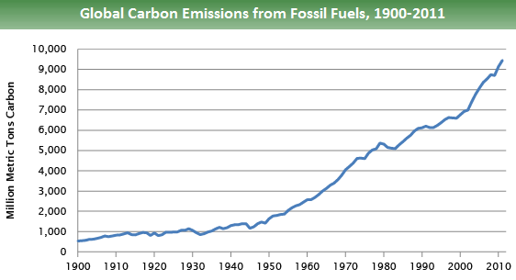
Source: Boden, T.A., Marland, G., and Andres R.J. (2015). Global, Regional, and National Fossil-Fuel CO2 Emissions. Carbon Dioxide Information Analysis Center, Oak Ridge National Laboratory, U.S. Department of Energy, doi 10.3334/CDIAC/00001_V2015

Spaces for thumbnail sketches of ideas for final illustrated graph (blank box for creative positioning/use of graph, if applicable)
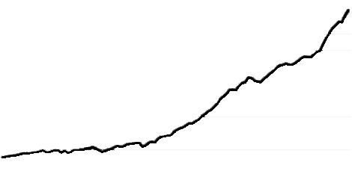

Graph Template
For use when creating full-scale illustrated graph. May be printed and traced or photocopied onto a transparency and cut out for use with watercolor paper, etc.

Brainstorming Sheet: Atmospheric CO₂ Levels: 2005-Present (direct measurement)
Access original graph at http://climate.nasa.gov/vital-signs/carbon-dioxide/.
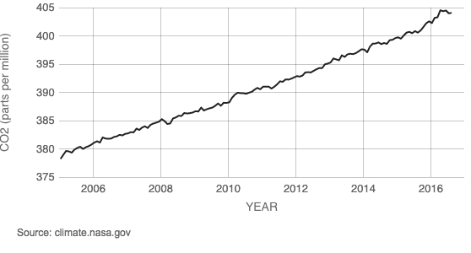
Create thumbnail sketches of ideas for final illustrated graph (blank box for creative positioning/use of graph, if applicable).
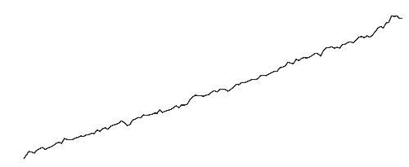

Graph Template
For use when creating full-scale illustrated graph. May be printed and traced or photocopied onto a transparency and cut out for use with watercolor paper, etc.

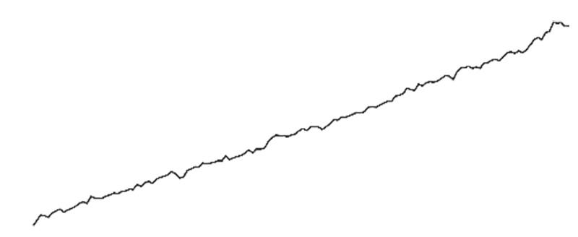

Brainstorming Sheet: Atmospheric CO₂ Levels During Last Three Glacial Cycles (indirect measurement)
Access original graph at http://climate.nasa.gov/vital-signs/carbon-dioxide/.
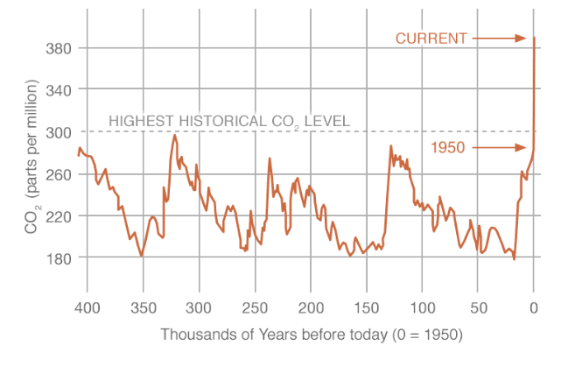
Data source: Reconstruction from ice cores. Credit: NOAA

Create thumbnail sketches of ideas for final illustrated graph (blank box for creative positioning/use of graph, if applicable).
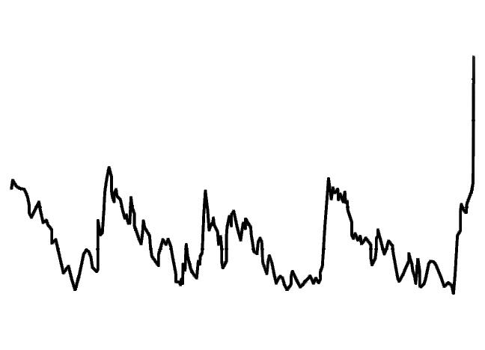
Graph Template
For use when creating full-scale illustrated graph. May be printed and traced or photocopied onto a transparency and cut out for use with watercolor paper, etc.

Brainstorming Sheet: Global Land-Ocean Temperature Index
Access original graph at http://climate.nasa.gov/vital-signs/global-temperature/.
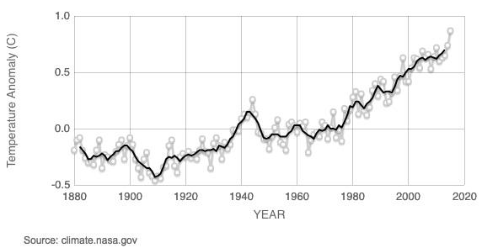
Data source: NASA's Goddard Institute for Space Studies (GISS). Credit: NASA/GISS

Create thumbnail sketches of ideas for final illustrated graph (blank box for creative positioning/use of graph, if applicable).
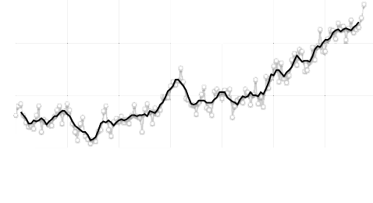

Graph Template
For use when creating full-scale illustrated graph. May be printed and traced or photocopied onto a transparency and cut out for use with watercolor paper, etc.
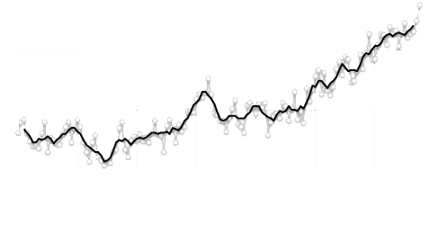

Brainstorming Sheet: Average September Extent of Arctic Sea Ice
Access original graph at http://climate.nasa.gov/vital-signs/arctic-sea-ice/.
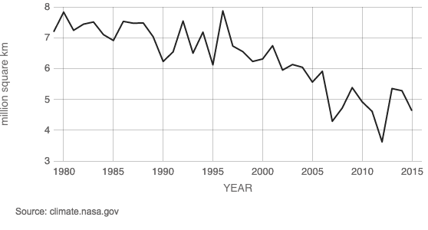
Data Source: Satellite Observations. Credit: NSIDC

Create thumbnail sketches of ideas for final illustrated graph (blank box for creative positioning/use of graph, if applicable).
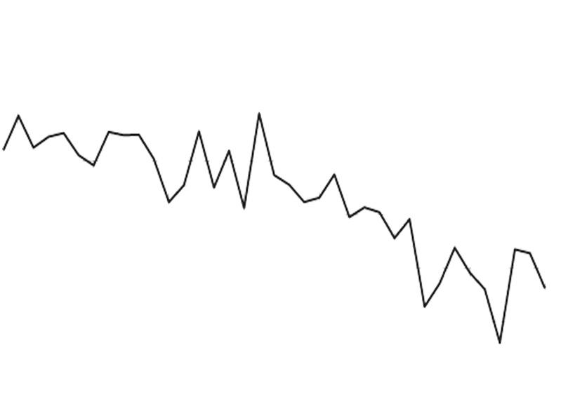

Graph Template
For use when creating full-scale illustrated graph. May be printed and traced or photocopied onto a transparency and cut out for use with watercolor paper, etc.

Brainstorming Sheet: Antarctica Ice Mass Variation, since 2002
Access original graph at http://climate.nasa.gov/vital-signs/land-ice/.
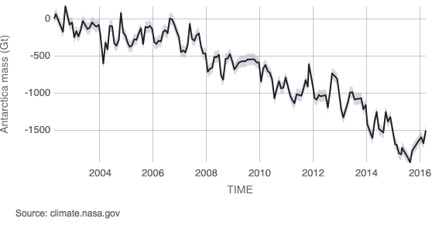
Data source: Ice mass measurement by NASA’s GRACE satellites. Credit: NASA
Create thumbnail sketches of ideas for final illustrated graph (blank box for creative positioning/use of graph, if applicable).
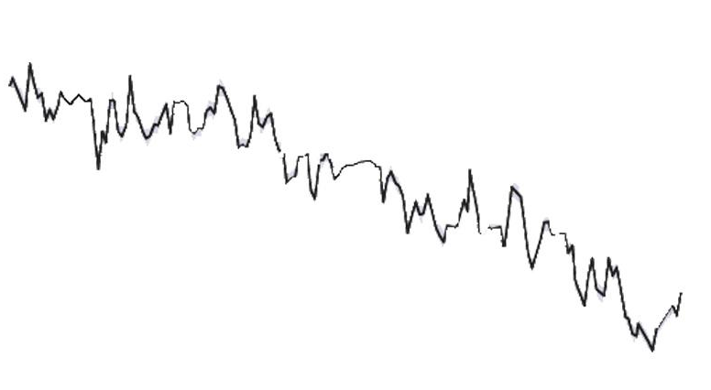
Graph Template
For use when creating full-scale illustrated graph. May be printed and traced or photocopied onto a transparency and cut out for use with watercolor paper, etc.
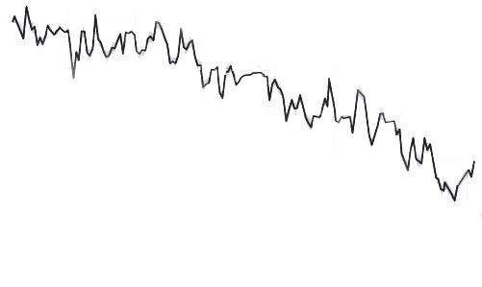

Brainstorming Sheet: Greenland Ice Mass Variation Since 2002
Access original graph at http://climate.nasa.gov/vital-signs/land-ice/.
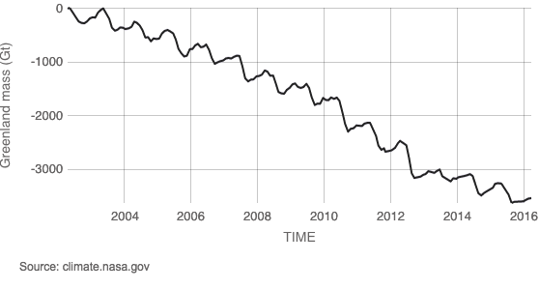
Data source: Ice mass measurement by NASA’s GRACE satellites. Credit: NASA

Create thumbnail sketches of ideas for final illustrated graph (blank box for creative positioning/use of graph, if applicable).
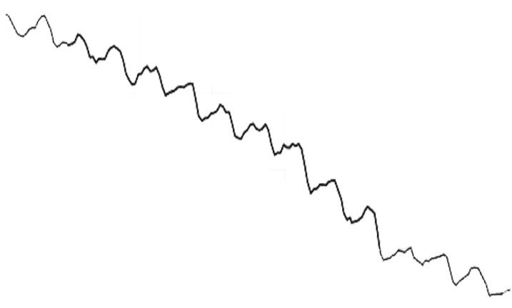
Graph Template
For use when creating full-scale illustrated graph. May be printed and traced or photocopied onto a transparency and cut out for use with watercolor paper, etc.

Brainstorming Sheet: Sea Level Rise Satellite Data (1993-Present)
Access original graph at http://climate.nasa.gov/vital-signs/sea-level/.
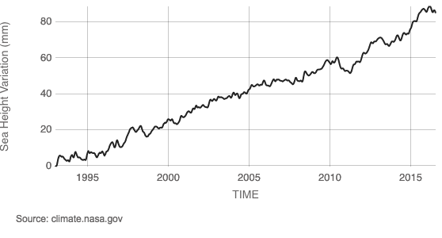
Data source: Satellite sea level observations. Credit: NASA Goddard Space Flight Center

Create thumbnail sketches of ideas for final illustrated graph (blank box for creative positioning/use of graph, if applicable).
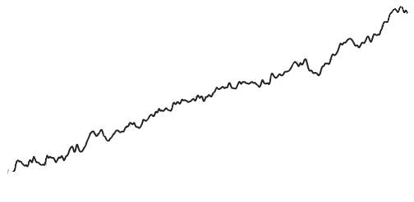

Graph Template
For use when creating full-scale illustrated graph. May be printed and traced or photocopied onto a transparency and cut out for use with watercolor paper, etc.
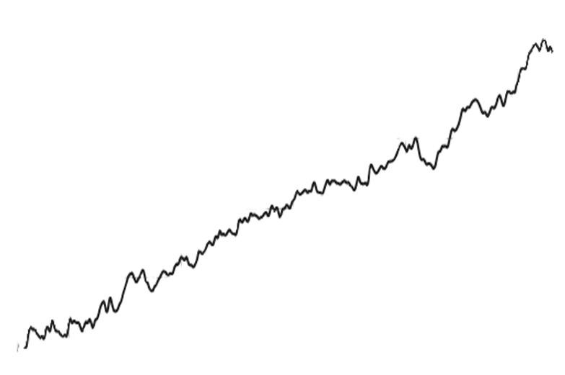

Brainstorming Sheet: Sea Level Rise Ground Data (1870-2000)
Access original graph at http://climate.nasa.gov/vital-signs/sea-level/.
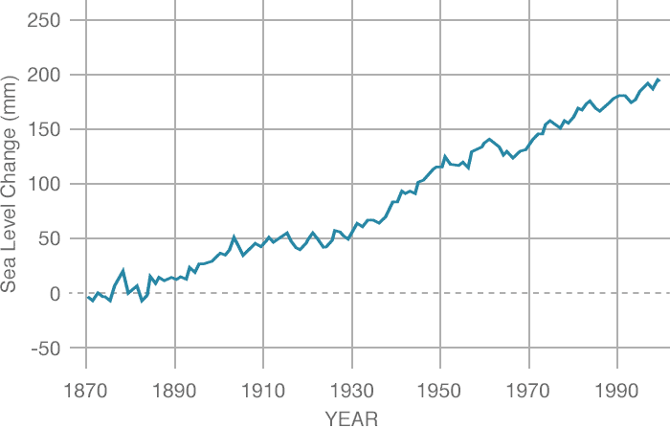
Data source: Coastal tide gauge records. Credit: CSIRO

Create thumbnail sketches of ideas for final illustrated graph (blank box for creative positioning/use of graph, if applicable).
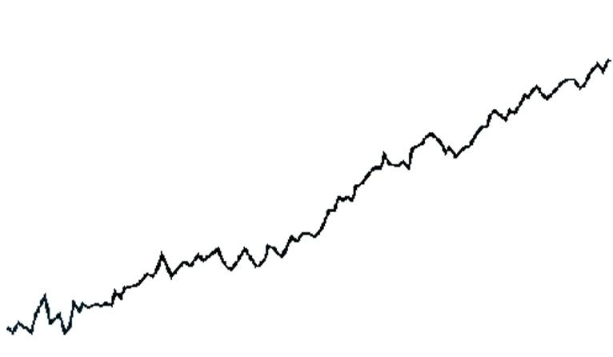
Graph Template
For use when creating full-scale illustrated graph. May be printed and traced or photocopied onto a transparency and cut out for use with watercolor paper, etc.

Brainstorming Sheet: Global surface temperature vs. sun's energy received at the top of Earth's atmosphere, from 1978 to 2009
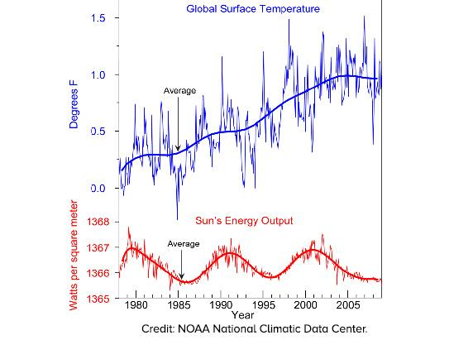
Access original graph at http://climate.nasa.gov/faq/, under the question “Is the sun causing global warming?”.

Create thumbnail sketches of ideas for final illustrated graph. Use detailed, jagged curve(s) or simplify and just use best-fit curve(s).

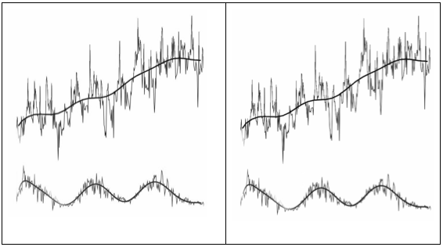

Graph Template
For use when creating full-scale illustrated graph. May be printed and traced or photocopied onto a transparency and cut out for use with watercolor paper, etc.
