Kite Engineering Guide Sheet

Pre-Launch
Create a scaled sketch of your delta kite. Label the sketch with spar and span lengths, and angles.

Use the space below to write down observations during your flight. You might want to note the weather, different movements of your kite, or any breaks or tears in your kite.

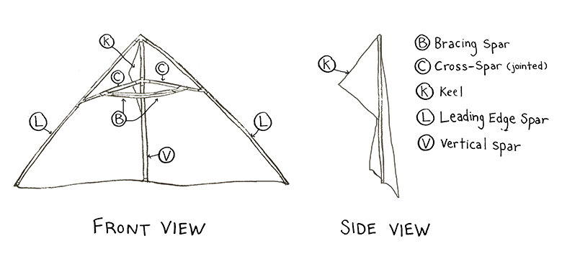
Post Kite Flight
Create a description of the kite’s flight. Be as accurate as possible; use the terms outlined on the kite diagram above (e.g. keel, bracing spars) to help with your description.

What four forces did the kite experience? Are these forces that a ski jumper would encounter? Explain.

Select a problem or issue you encountered during flight that you think could be addressed by redesigning the kite. What is the problem or issue you wish to address?

Plan your redesign
Part of the fun of engineering is the freedom to improve on what has already been built, but redesigning a kite needs to be done thoughtfully. Kites fly upward when the lift is greater than or equal to the weight, and drag and tension are in balance. Since the dynamics that affect kite flight are complex, it’s a good idea to learn which variables (e.g. location of center of pressure and center of gravity, wingspan, point where control line attaches) influence the main forces of flight and make alterations from there.

- How would you like to redesign your kite? Use the space below to brainstorm.
- Explain your final idea, and explain why you think each change to the design will improve the kite’s flight.
- Create a labelled sketch of your redesign.
Brainstorming Area | Sketch your redesign
Explain your redesign

