Name:______________________

Date:_______________________

Circle One: Pre-test / Post-test

What Do Cochlear Implants And Hearing Aids Sound Like?
Directions: Choose the correct answer out of the options provided and write it in the space provided.

- _________ Hearing loss can most commonly be caused by
A) Piercing of the eardrum
B) Head trauma
C) Damage to delicate hair cells within the ear
D) Poor diet during childhood
- _________ The human ear converts sound from ______________ to _________________ that can be interpreted by the brain.
A) mechanical wave energy to protein expression
B) mechanical wave energy to electrical impulses
C) protein expression to mechanical wave energy
D) protein expressions to electrical impulses
E) electrical impulses to mechanical wave energy
F) electrical impulses to protein expression
- _________ Hearing aids can be programmed to filter out certain ________________ to eliminate background noise and make it easier for the user to hear important sounds like the voices of a loved one.
A) amplitudes
B) frequencies
C) mediums
D) energies
- _________ Which of the following describes how cochlear implants function? Cochlear implants...
A) create digital signals that are then filtered and played directly into the ear canal to be processed by the ear.
B) replace a surgically removed cochlea
C) process and filter the sound received into a digital signal that can be sent through electric impulses to nerve fibers in the brain.
D) transmit the unfiltered sounds received from the implant directly to the nerve fibers through electric impulses
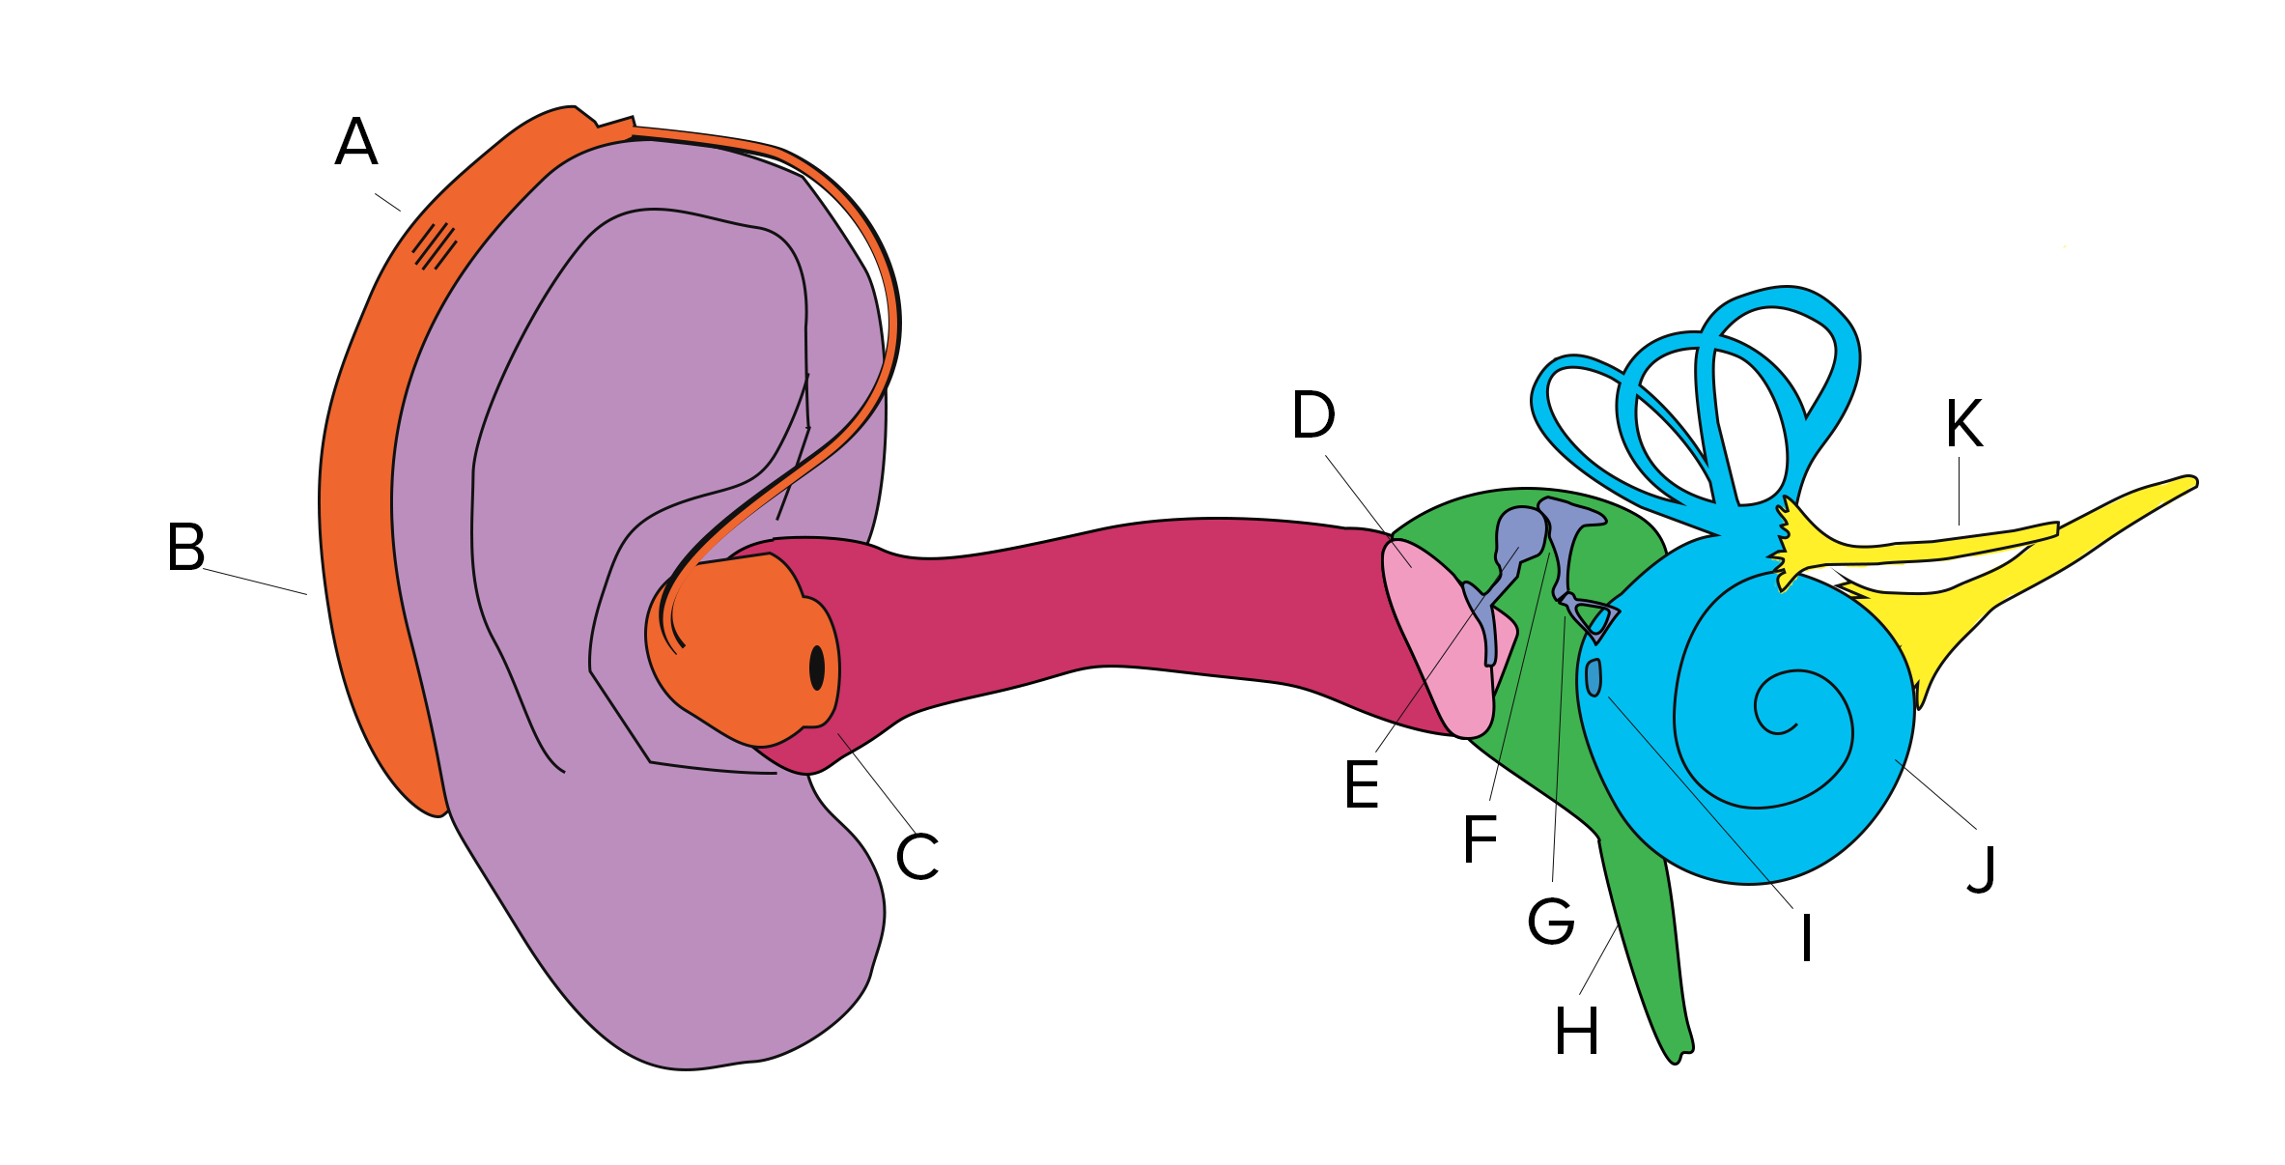
- _________ Which of the following components of the ear is the cochlea?

Answer Key:
1) C
2) B
3) B
4) C
5) J

