CER Worksheet
Claim - Evidence - Reasoning
A scientific claim is an explanation that is supported by evidence and backed by reasoning.
Phenomenon
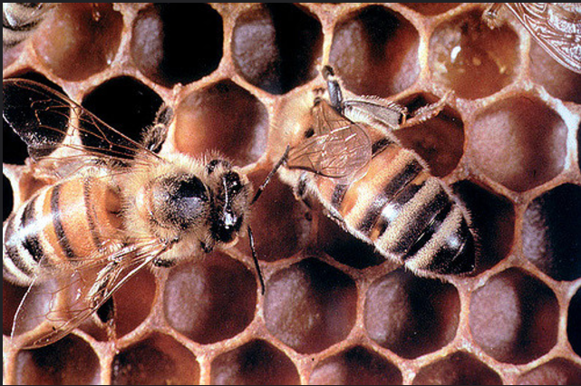

Why do honeybees use hexagonal shapes to construct their honeycombs?

Step 1: Complete the Claim, Evidence, and Reasoning (CER) below, based on your initial observations of honeycomb.
Step 2: After completing several investigations into honeycomb cells, revisit your CER. Add to or edit your claim, evidence, and reasoning based on newly acquired information. Use a different colored pen or pencil to indicate the changes you have made to your CER.

Make a CLAIM. A claim is a statement that explains a phenomenon.

Why do bees use hexagonal shapes to construct their combs?

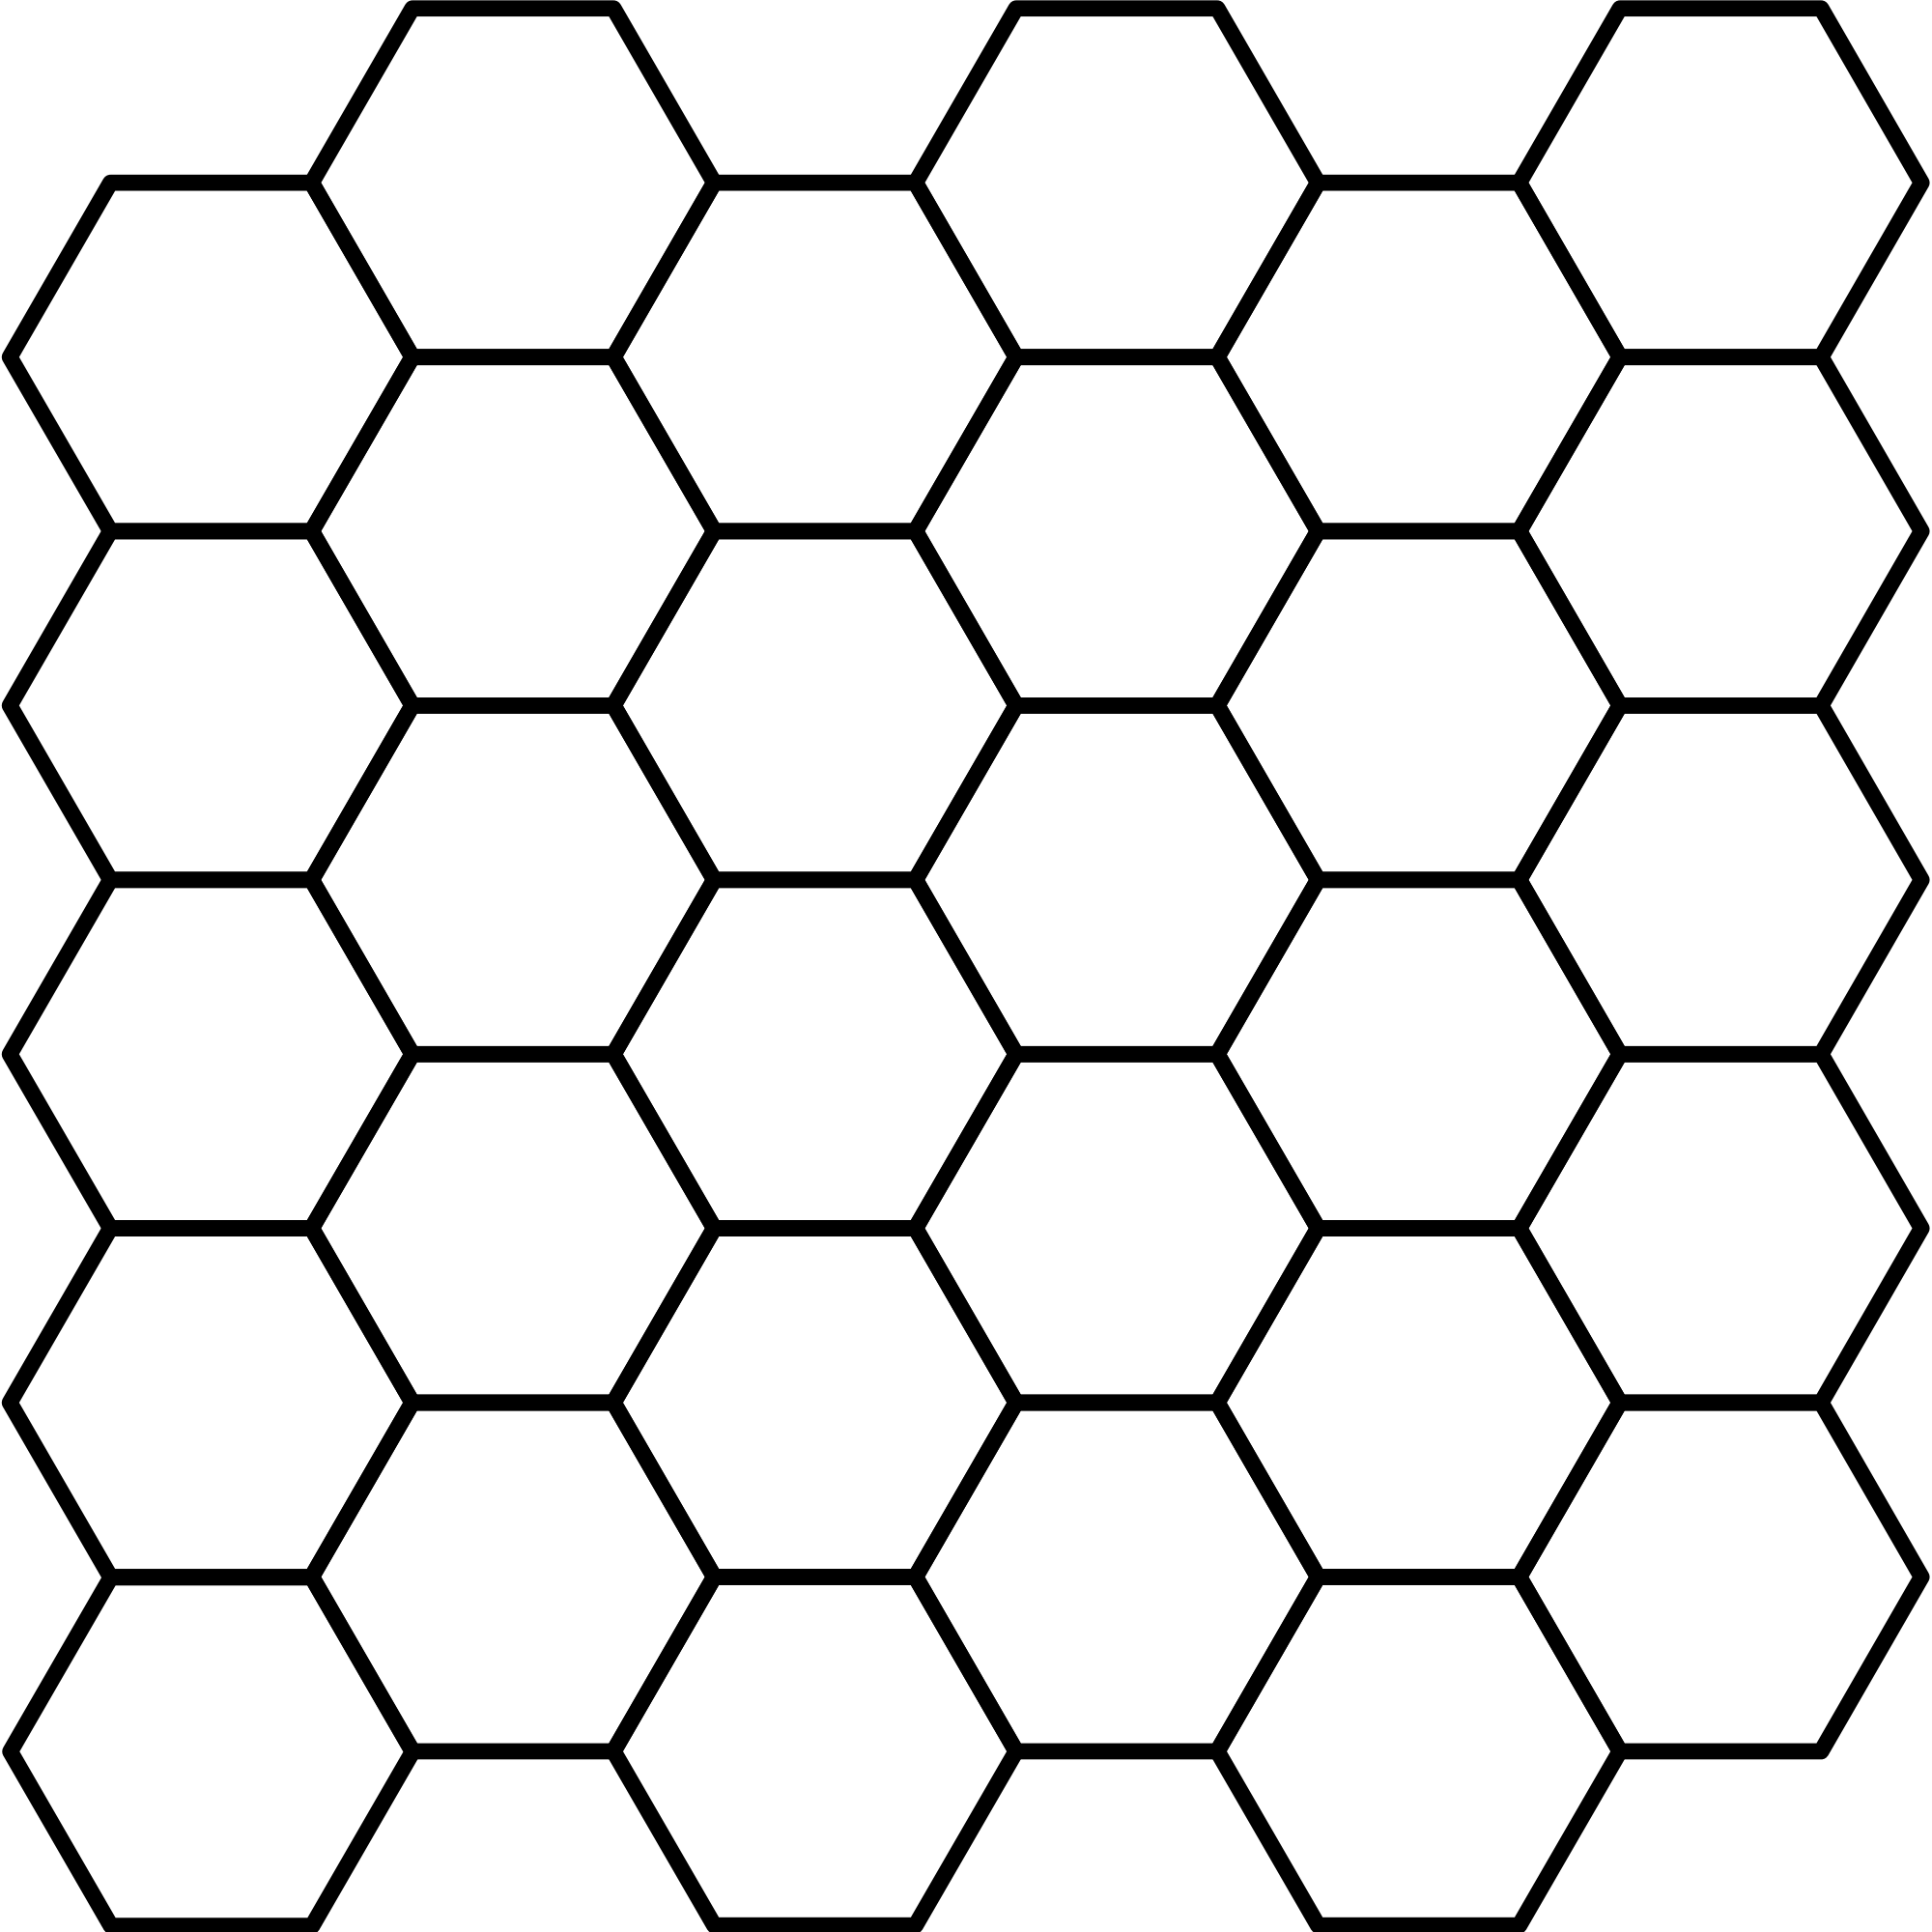

What’s your EVIDENCE? Evidence for the claim can come from investigations, observations, and research.

What is your REASONING for your claim? Reasoning describes how the evidence supports the claim and often draws on scientific theories or principles.

