Macro and Micro Observations of Honeycomb

Observations: Wide Perspective
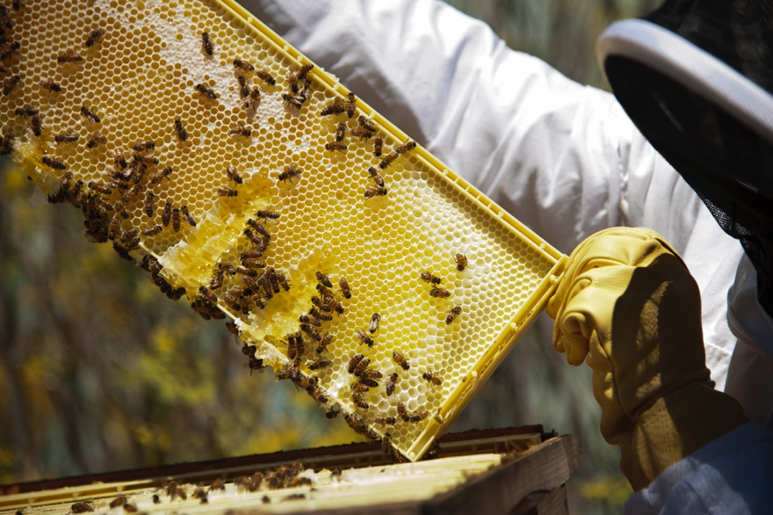
Photo Credit: U.S. Air Force photo/Airman 1st Class Nicole Leidholm
Observations of Honeycomb  What do you notice?  Describe what you see. | What I Wonder  Based on your observations, what do you wonder?  What questions do you have?
Drawings With Labels (Draw and label what you observed.)

Micro Observations: Take a Closer Look
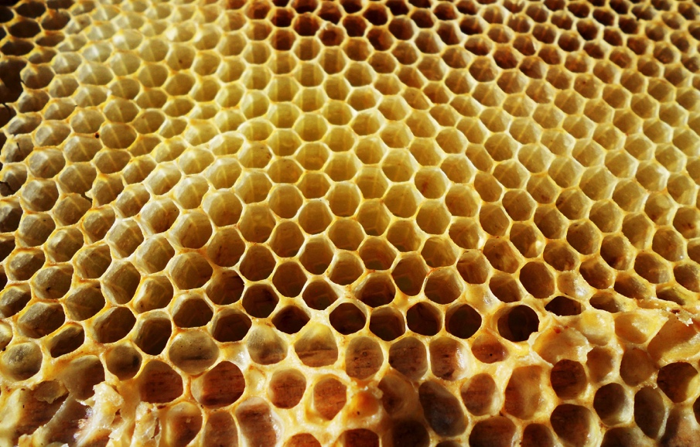
Photo: Shutterstock
Close-Up Observations of Honeycomb  What do you notice?  Describe what you see. | What I Wonder  Based on your new observations, what do you now wonder?
Drawings With Labels (Draw and label what you observed.)

