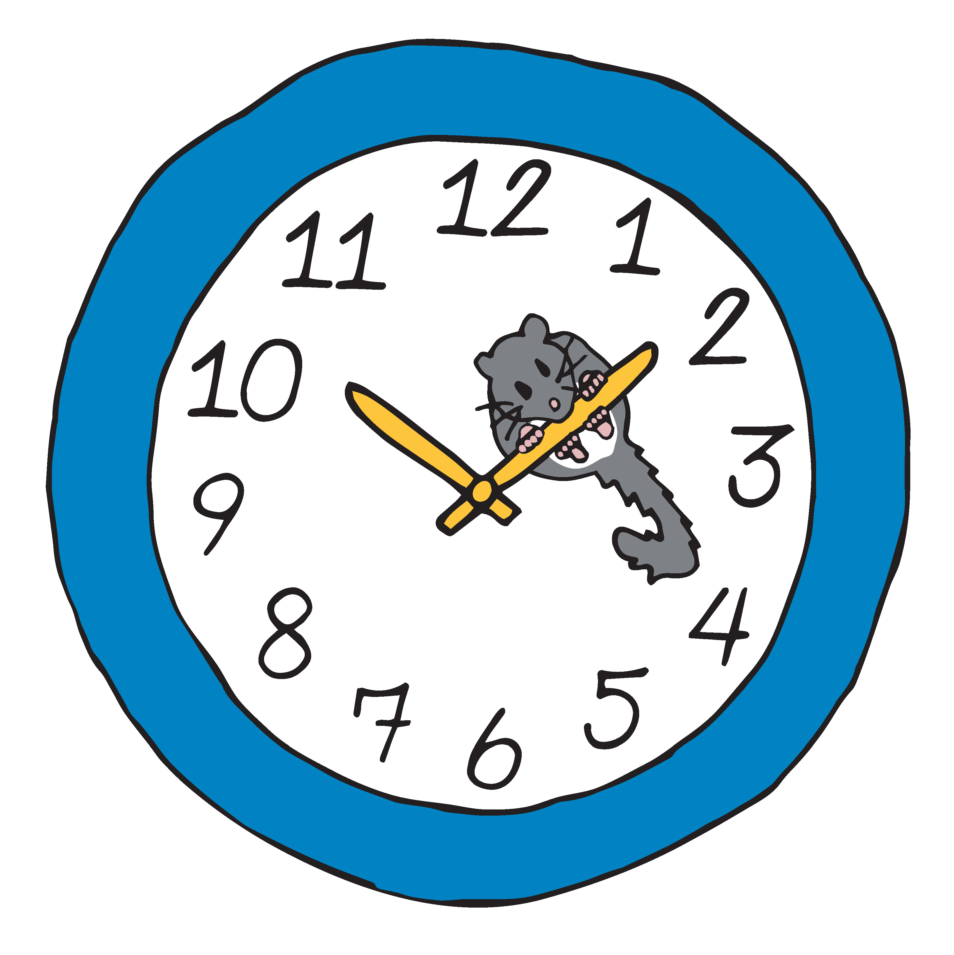

Blood Analysis Worksheet
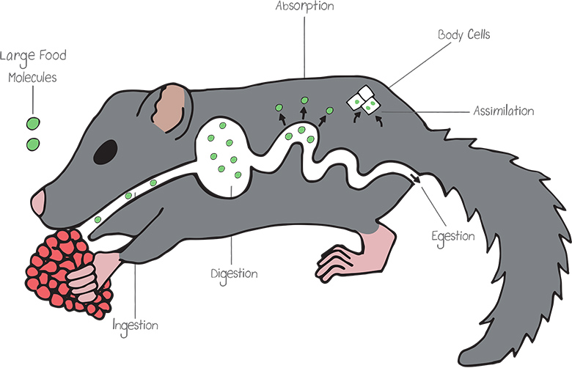
Illustration by Carrie Lapolla
After a dormouse eats a meal rich in complex molecules like carbohydrates and proteins, enzymes in the digestive tract break down those molecules into simpler components such as glucose and amino acids. These smaller molecules are then transported to the bloodstream and delivered to body cells to be used as a source of energy for processes such as growth, movement, reproduction, and metabolism. Chemical tests can be used to analyze the levels of glucose in the bloodstream. If blood glucose levels are monitored frequently, this data can offer insight into the eating habits of an organism.

Task
You’re a molecular biologist researching the potential reasons why telomeres in edible dormice extend as the rodents age. You must first collect blood samples from eight-year-old edible dormice and chemically analyze their blood glucose levels. Then collect DNA samples from the same dormice and measure the telomere lengths. Lastly, compare your findings with those of your team members, and draw a conclusion about the length of the telomeres in dormice based on the blood glucose levels observed.

Procedure and Data Tables

- Obtain a clear vial containing a sample of blood from an edible dormouse and a colored vial that contains the glucose test indicator solution. Using a pipette, add several drops of the glucose test indicator to your vial of blood and note the color change. Compare the color of the vial to the “Blood Glucose Indicator Scale” to determine the amount of glucose in your dormouse’s blood sample. Record the data in the table below.

Dormouse Number | Sex | Color Change | Blood Glucose Level  (mg/dL) | Length of Telomere  (cm)

- DNA was also extracted from a cheek cell from your dormouse, and it includes a telomere at one end. Using a ruler, measure the length of the telomere in centimeters, and record the data in the table provided.

- Working with your group, place the DNA samples and corresponding blood samples for each dormouse in a row to easily see how the lengths of the telomeres and colors of the samples compare.

- Using colored pencils, color the tubes below the color they turned after you added the glucose test indicator solution. Then color the approximate length of each telomere on the DNA molecule next to its corresponding blood sample.

