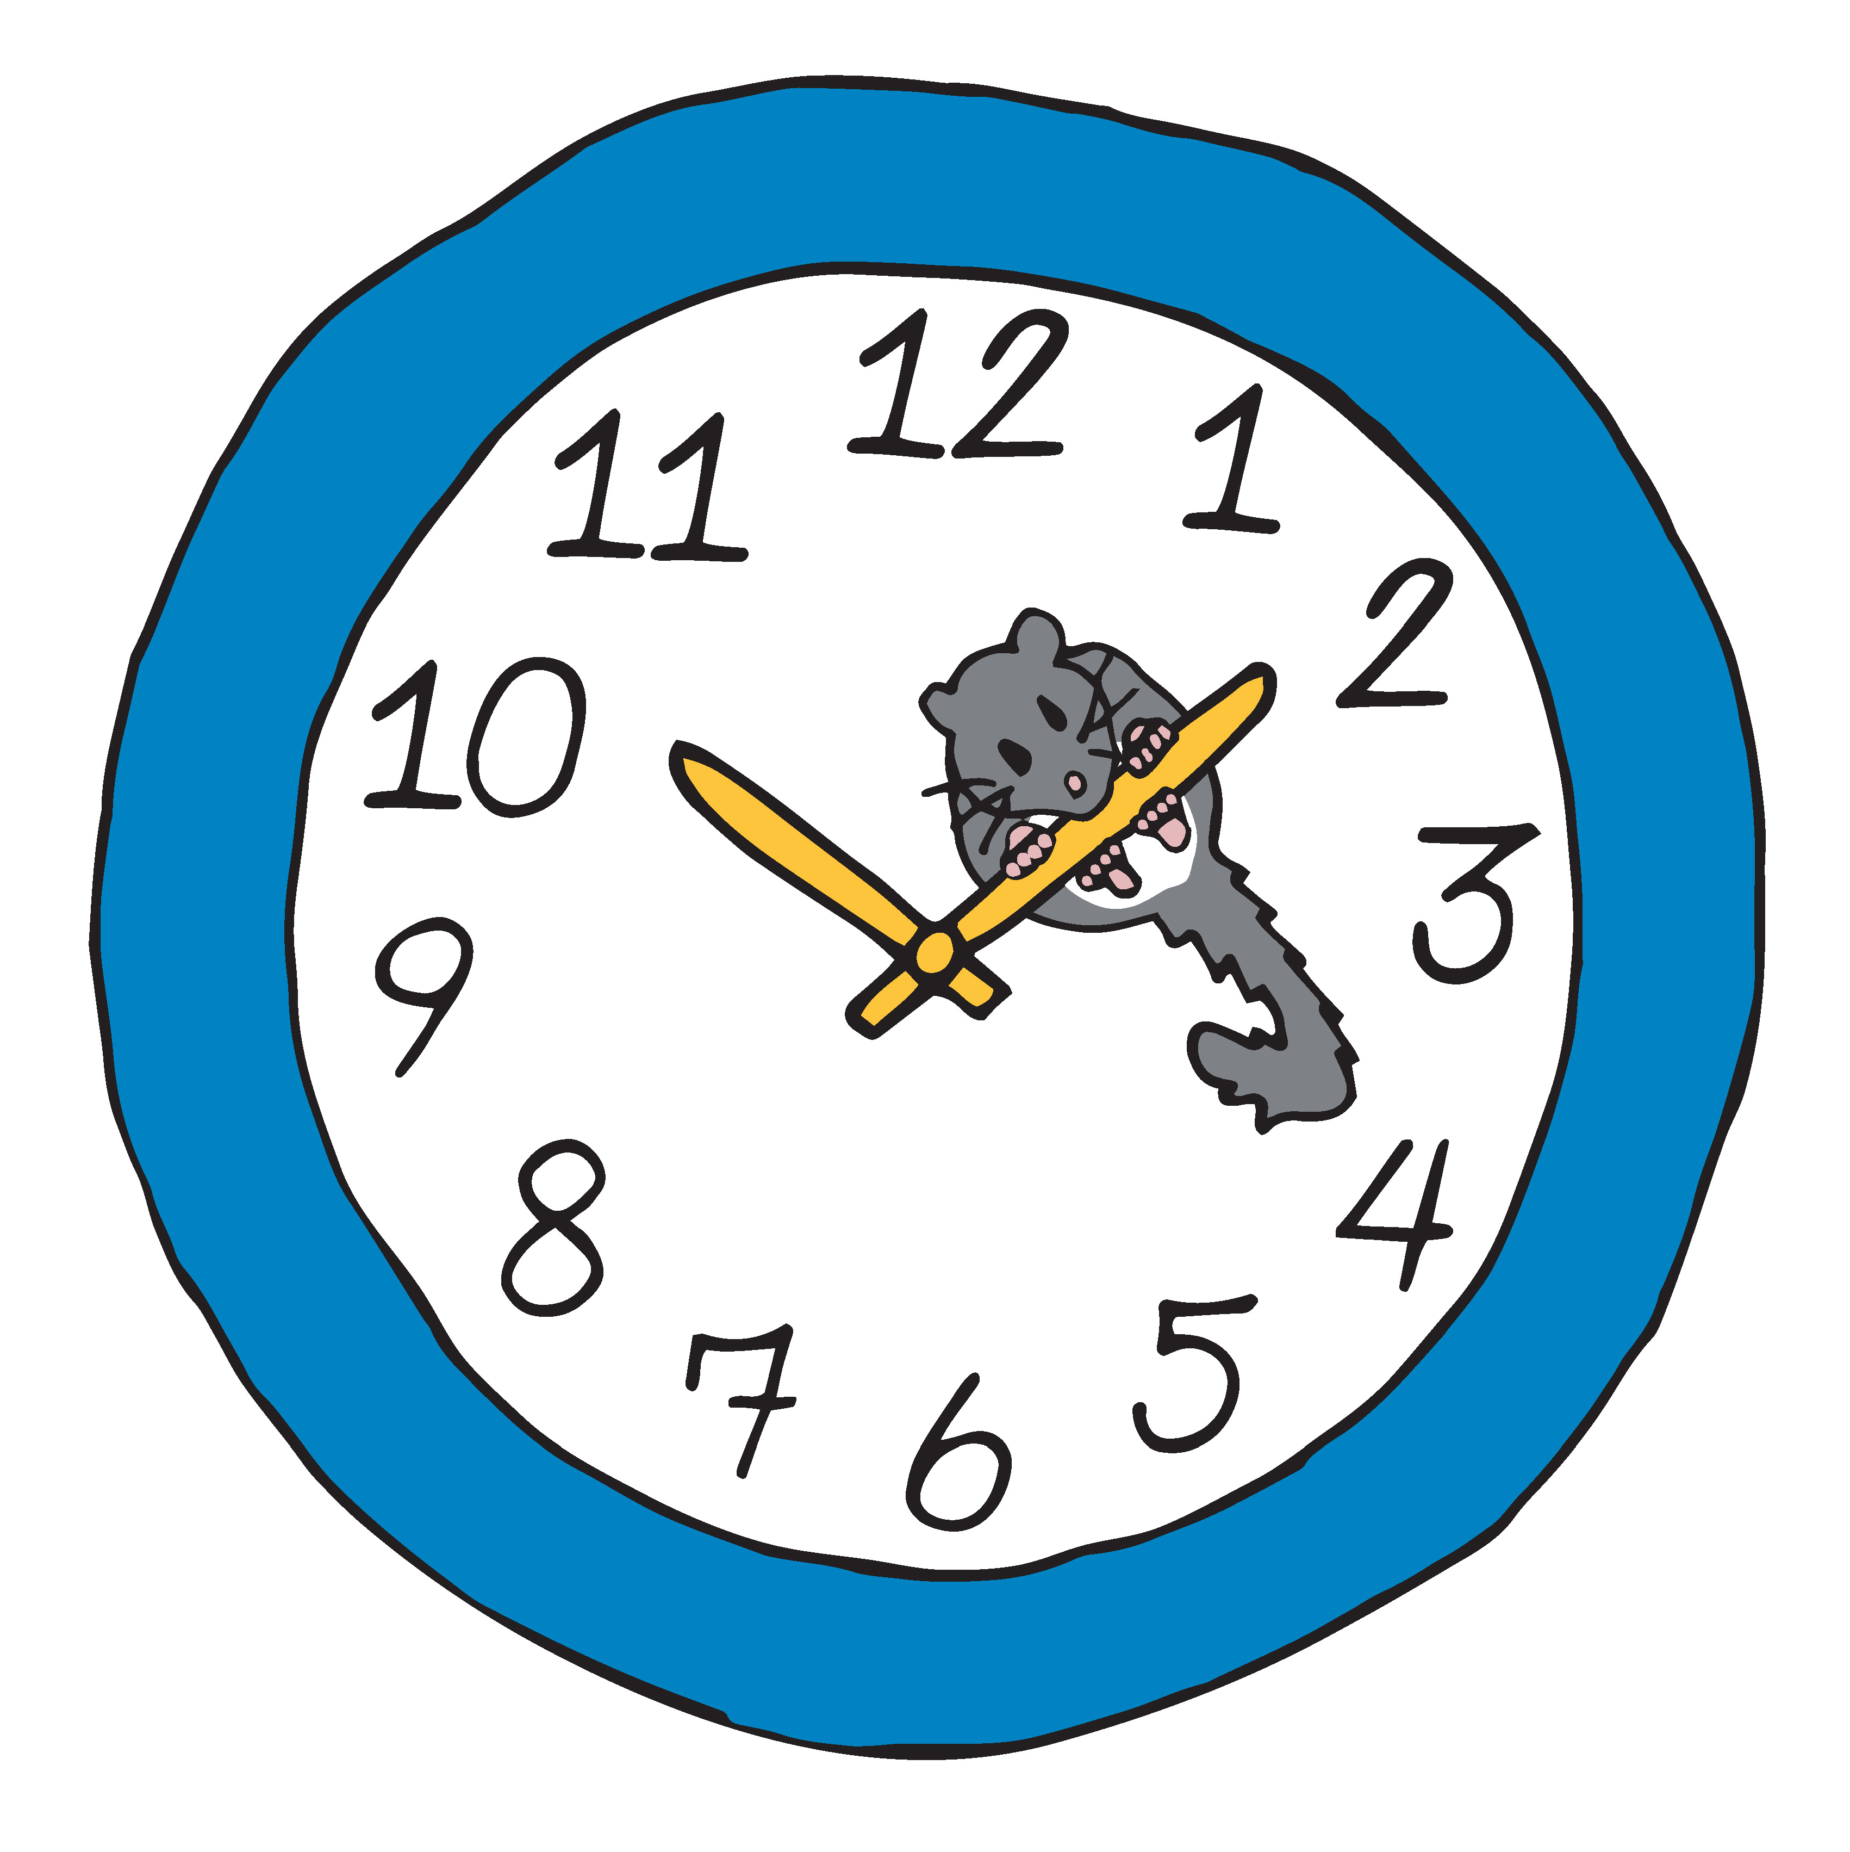

Blood Glucose Indicator Scale
100 mg/dL | 80 mg/dL | 60 mg/dL

Blood Glucose Indicator Scale
100 mg/dL | 80 mg/dL | 60 mg/dL

Blood Glucose Indicator Scale
100 mg/dL | 80 mg/dL | 60 mg/dL

