Accumulated Degree Hour Data Sheet

Equations
Thermal Energy = Hours × Temperature (ºF)

Accumulated Degree Hours (ADH) = Previous Thermal Energy + Current Thermal Energy
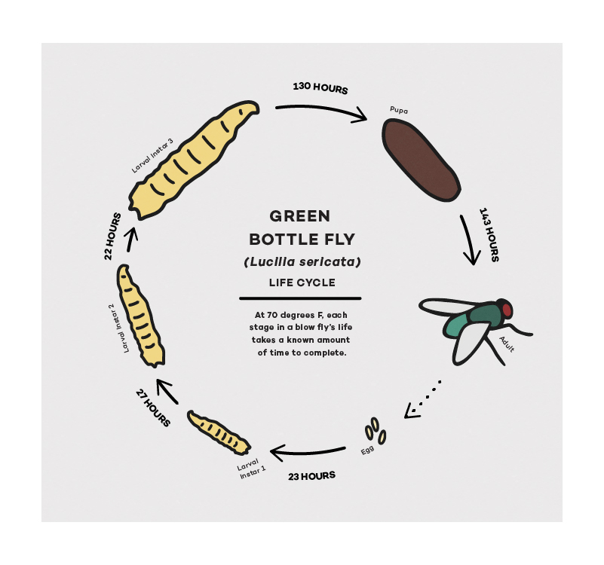
Calculate the ADH of the green bottle fly life cycle at 70 ºF. Refer to the green bottle fly lifecycle above for time spent in stage.
Stage | Time Spent in Stage | Temperature  (ºF) | Thermal Energy | ADH | Total Time Since Eggs Laid
Egg | 23 hours | 70 |  |  | 23 hours
1st instar | 27 hours | 70
2nd Instar | 22 hours | 70
3rd Instar | 130 hours | 70
Pupa | 143 hours | 70

Calculate the ADH of the maggots in your control cup. Compare those values to the data provided for green bottle flies, and estimate the age of your maggots on the last day.

Day Observed | Hours in Day | Local Daily Average Temperature  (ºF) | Thermal Energy | ADH | Estimated Stage
Day 1 | 24*
Day 2 | 24
 | 24
 | 24
 | 24
 | 24
 | 24
*A day has passed since cup was placed outside

Analysis Questions
Based on your calculations, in what stage of development should the maggots in your control cup be on the last day of this experiment?

How precise do you think your calculations are? Why?

Does your calculation of the total ADH match the physical appearance of your maggots on the last day? For example, if your calculation corresponds to the ADH required to reach the 2nd instar, did you observe medium-size maggots?

What factors could have influenced the time the eggs were laid in the cup?

