Building a Dinosaur to Scale

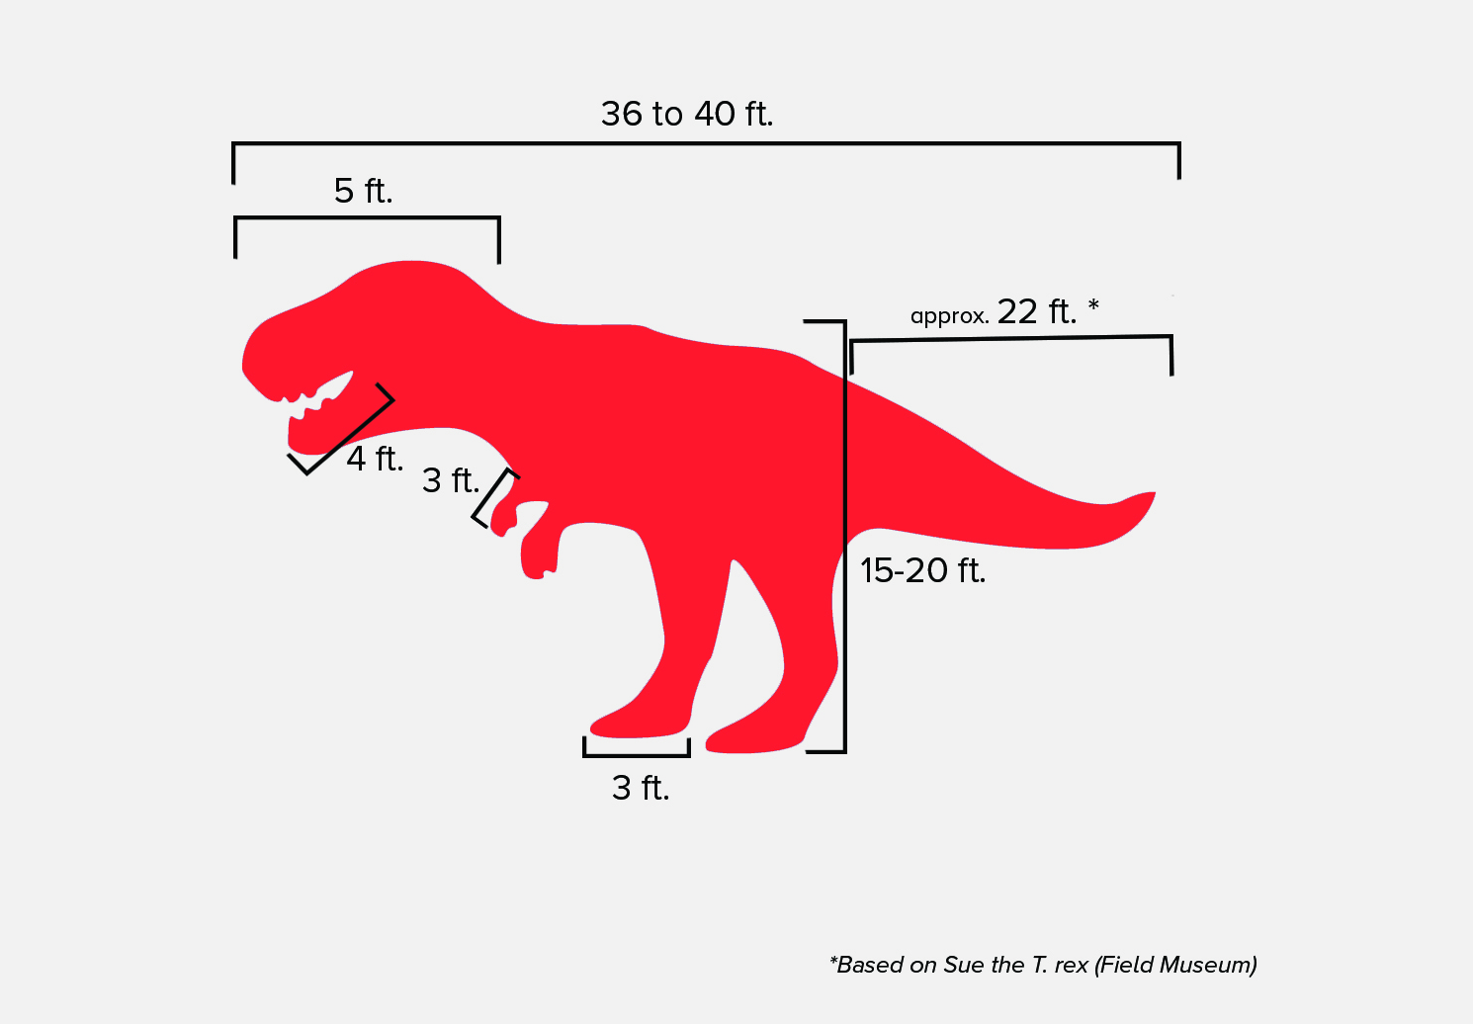
Building a life-size dinosaur would require many resources, but we can still learn a lot by building a scale model of a dinosaur. For our scale, we’re going to use ½ inch = 1 foot. For example, if the dinosaur we’re modeling has a 10-foot tail, we would make sure our model has a 5-inch tail (10 x ½ = 5). Do some background research on the theropod dinosaur you want to model into a puppet. Determine how long various parts of its body were, including the leg, torso, head, arm, and tail (see sample on the right). Convert those lengths to the scale-length of the model, and write the lengths in the table below. Jot down any notes from your research in the corresponding column.

Body Part | Actual Length/Height | Scaled Length/Height | Design Notes
Leg
Torso
Head
Arm
Tail

