**Volume Investigation Templates**

**Cube Cell Template**

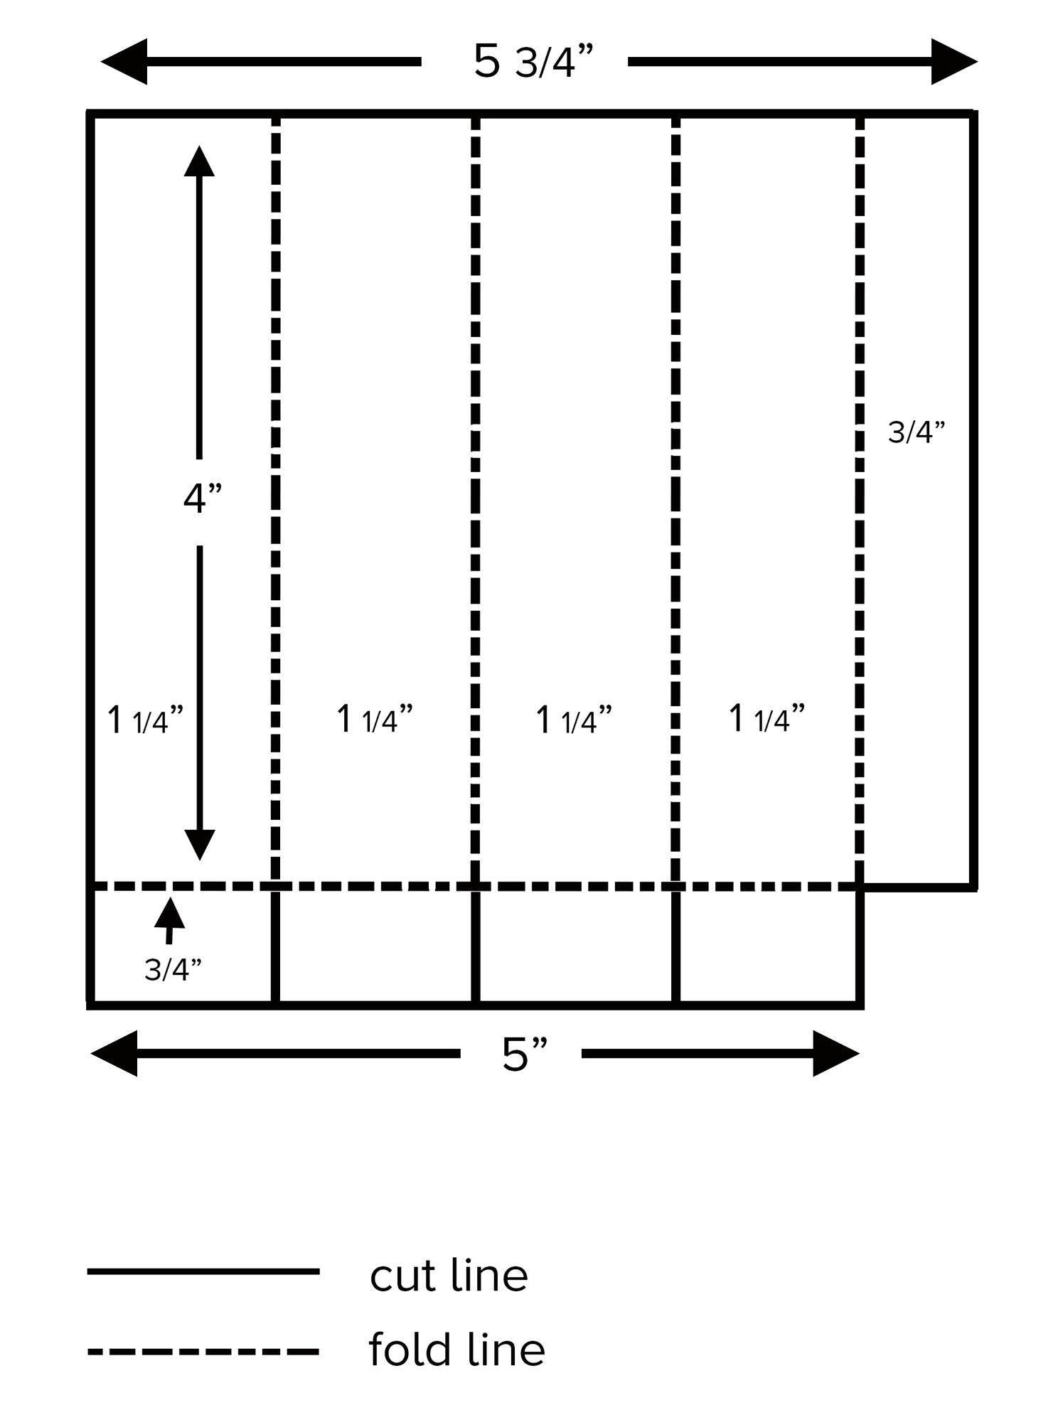

**Blank Cube Cell Template**

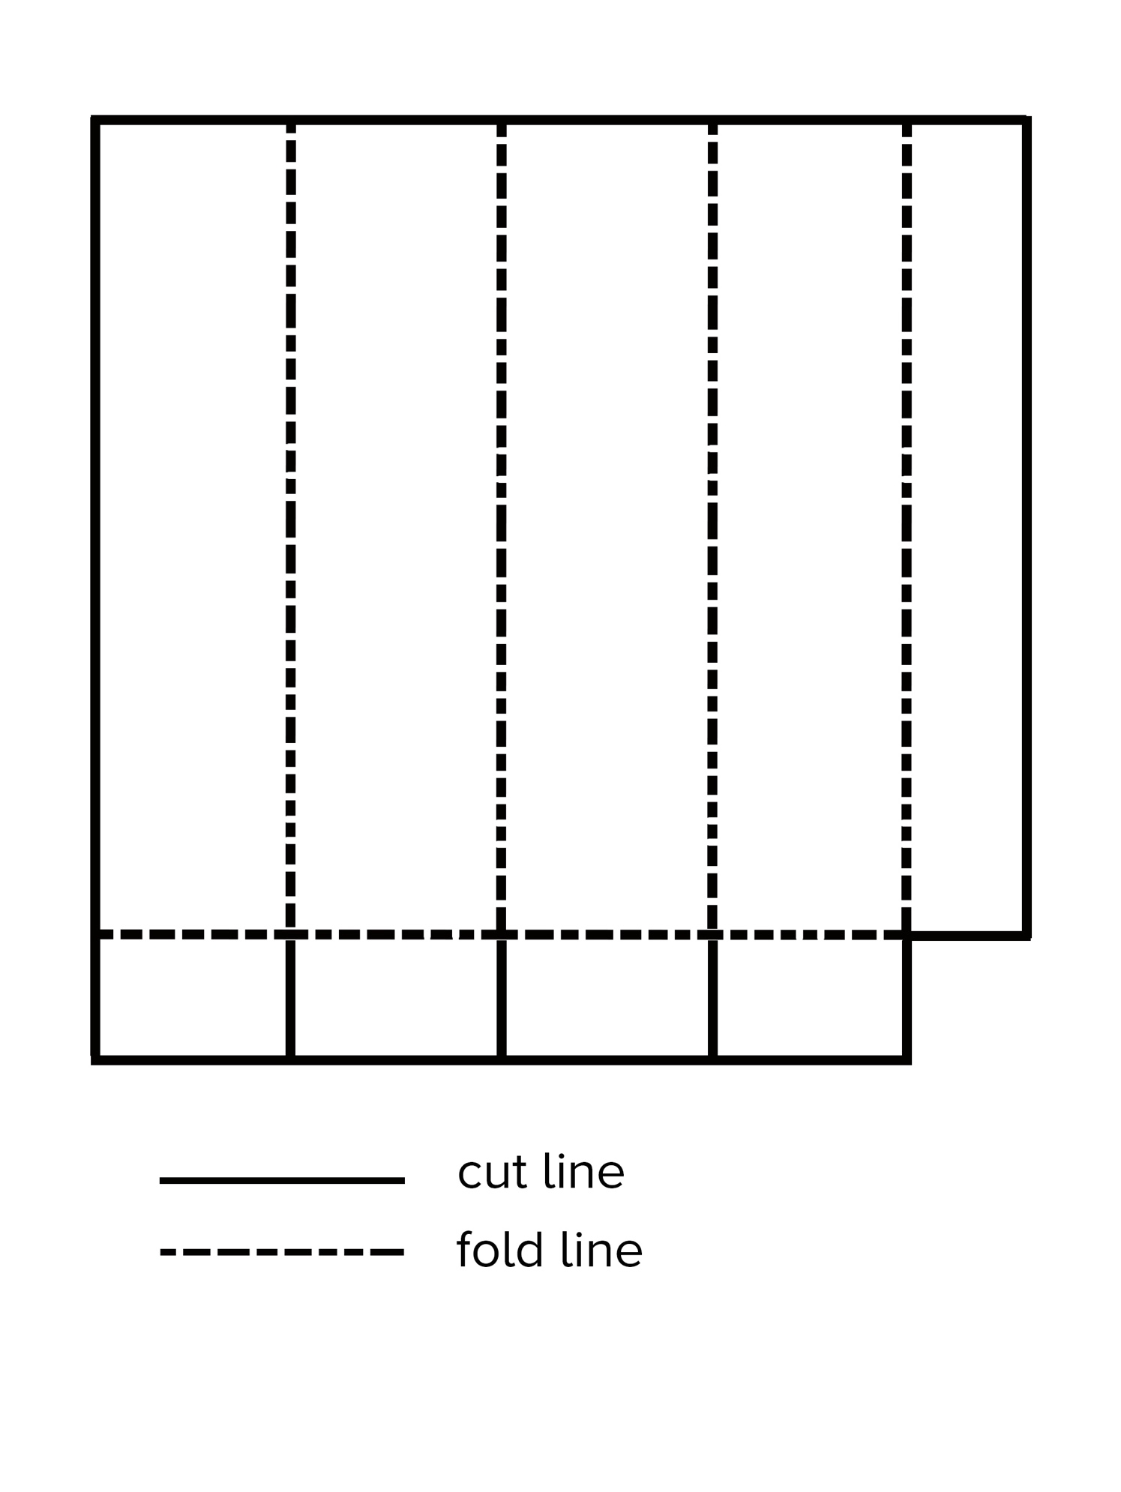

**Triangular Prism Template**

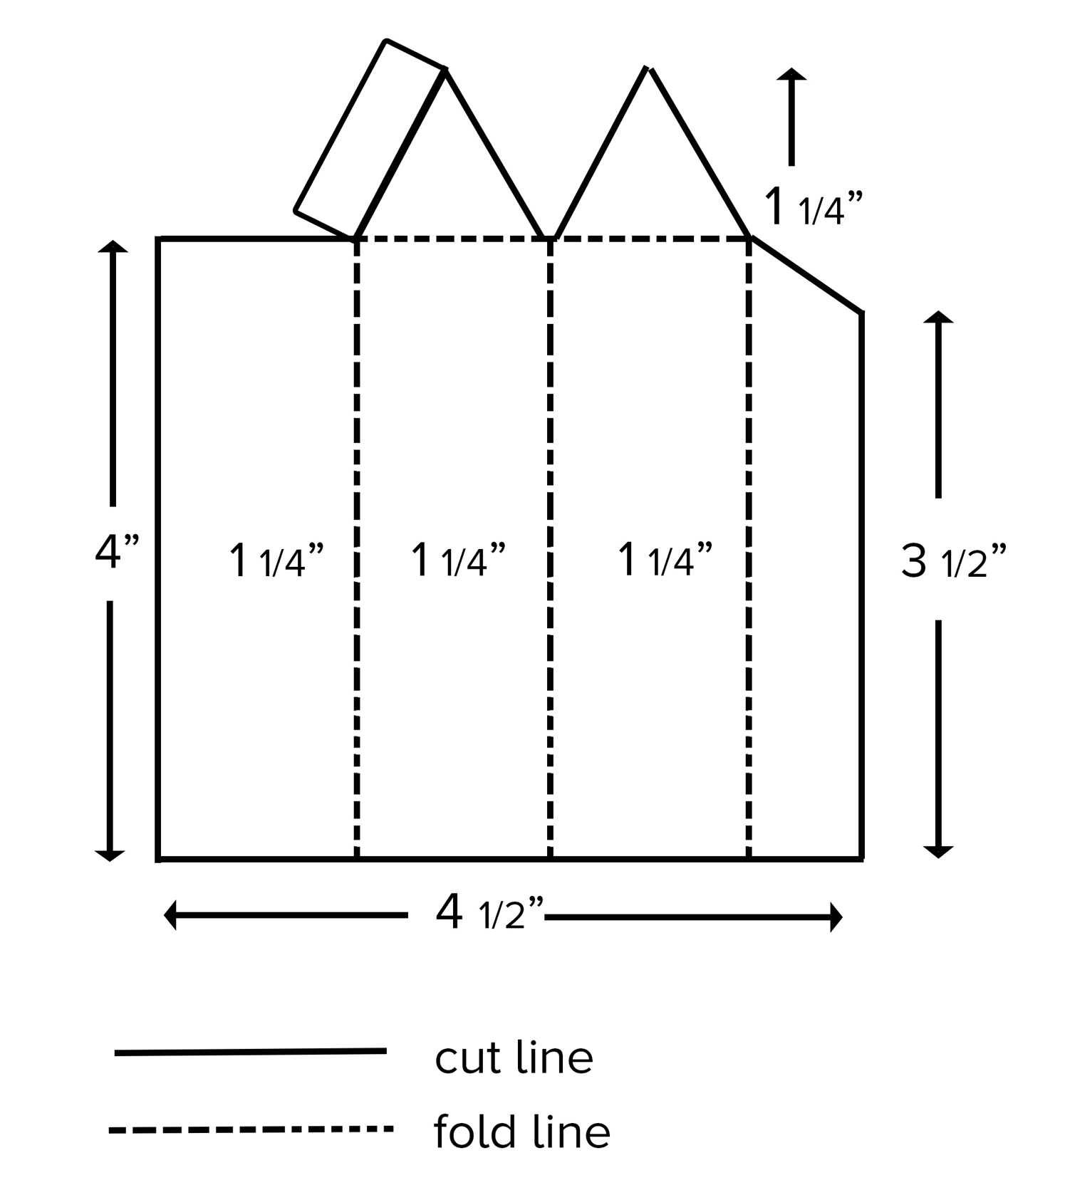

**Blank Triangular Prism Template**

