What’s In Your Chicken Wings?

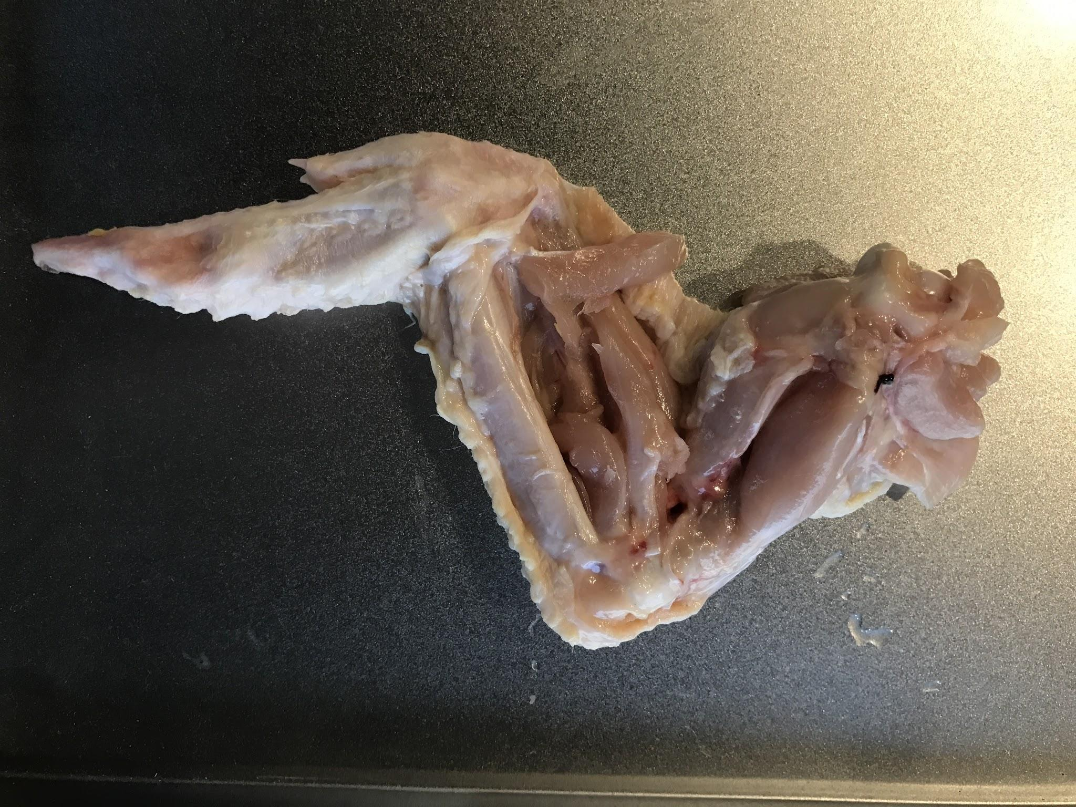

In this activity, you will examine the different types of tissues that make up a chicken wing. You’ll need to look closely at both the outside and the inside of the wing and peel back layers. As you come across different types of tissue, pay particular attention to their texture and how soft or hard they are.

Materials
- Raw chicken wing
- Pencil for recording observations
- Notebook
- Repurposed Styrofoam tray
- Cutting tool (sharp scissors, scalpel, or knife)
- Nitrile gloves

Safety Considerations
Uncooked chicken sometimes carries bacteria like Salmonella, which can make you sick if ingested. Do not consume any of the chicken from this dissection. Please be sure to wear gloves while handling the chicken, and keep your hands away from your mouth at all times. When you remove your gloves, turn them inside out as you pull them off, and wash your hands with soap and warm water after completing your investigation. If you plan on taking notes while dissecting, the best way to avoid potentially contaminating your pencil and notebook is to work with a partner. While one person dissects, the other writes down notes or takes photos. Use sharp cutting tools with adult supervision.

Procedure
- Obtain a raw chicken wing.
- Using a pencil, sketch your chicken wing in your notebook. Then draw a two-column table with the headings “soft tissue” and “hard tissue.” As you come across different tissues, add them to the appropriate column.
- On your diagram, label the skin covering the wing. That’s your first tissue. Is it soft or hard?
- Cut and peel back the skin. Look under the skin flap for blood vessels.
- Identify the muscles (pink and fleshy) and globs of fat (white and soft).
- The tendons are shiny, white, and tough. They connect the muscles to the bones.
- Cut the tendons to expose the bones.
- If you separate the bones, you might also be able to identify the ligaments (stringy tissue connecting bones to bones) and the cartilage (white and rubbery; you can find it between the bones or by the shoulder, where the wing was attached to the rest of the body).

Based on your chicken wing study, answer the following questions.

- What part(s) of the wing’s anatomy is/are considered “hard tissue”? How did you decide?

- If you dropped a chicken wing into an asphalt pit and someone were to find it several thousand years from now, which part of the wing would they most likely recover as a fossil, and why?

