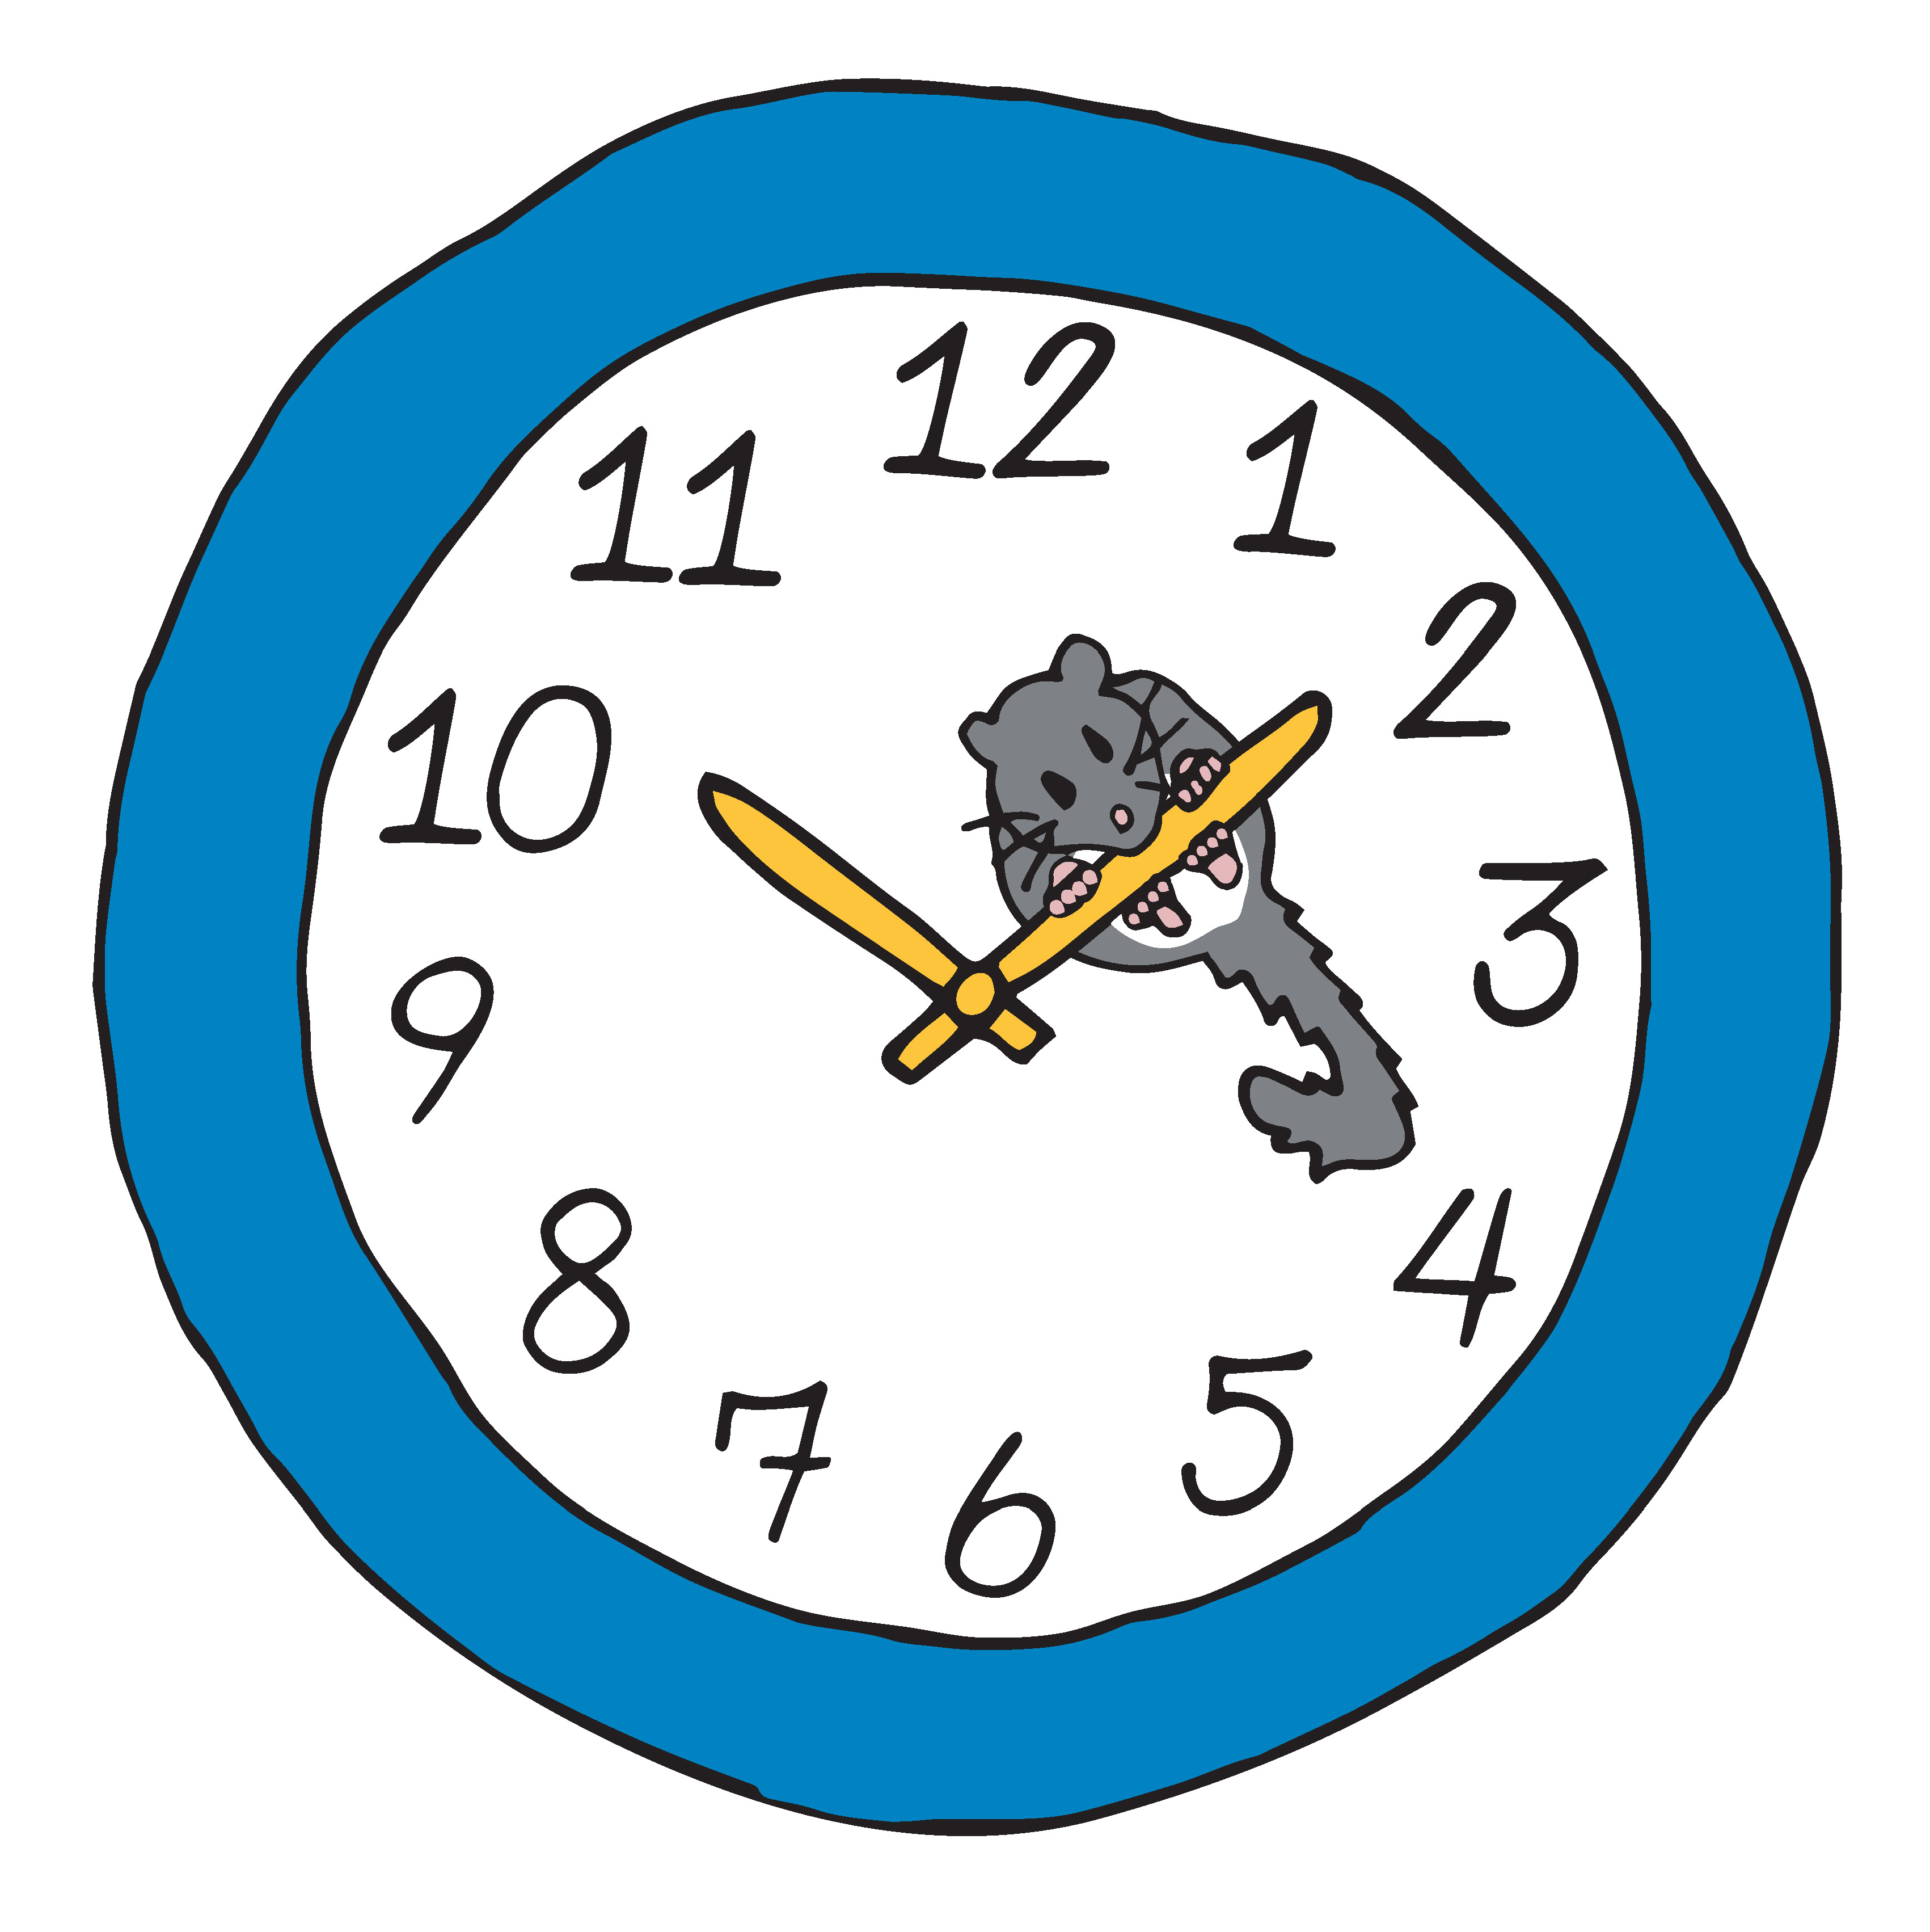

Class DNA Data Sheet

Rodent Type | Age  (Years) | Sex  (♂ or ♀) | Number of Telomere Repeat Sequences (TTAGGG)

