Name:______________________

Date:_______________________

Circle One: Pre-test / Post-test

Do Edible Dormice Hold Secrets To The Fountain Of Youth
Directions: Choose the correct answer out of the options provided and write it in the space provided.

- _________Every time a strand of DNA is replicated the ends of the molecule known as the
________ shorten.
A) telomeres
B) DNA
C) nucleotide
D) chromosomes
- _________ The “molecule of heredity” is another name for __________.
A) Chromosomes
B) DNA
C) RNA
D) Telomeres

- _________The nucleotide sequence “TTAGGG” in DNA will create _______________in a cell.
A) collagen
B) carbohydrates
C) glucose
D) nothing

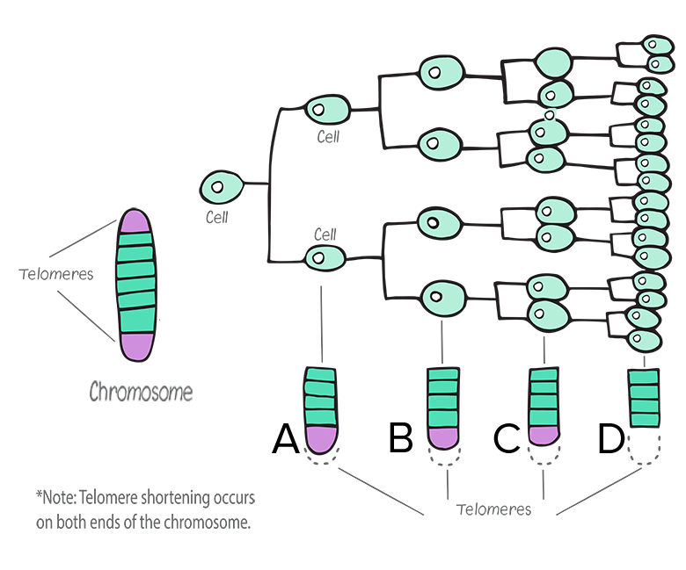
- _________When a cell’s chromosomes reach stage D cellular death also known as _____________ begins.
A) meiosis
B) apoptosis
C) mitosis
D) binary fission
- _________ The length of the “ends” of an organism’s DNA is a trait that is ____________
A) completely random for each individual
B) determined by the climate of the organism’s ecosystem
C) mainly determined by both heredity and diet of an organism
D) inherited from previous generations
Answer Key:
1) A
2) B
3) D
4) B
5) C

