Egg Observation Sheet
Record the mass of each egg in grams. Be sure to include the mass of the clay and Orbeez filling, also in grams. Spin each egg with the same amount of force, and record the time it takes for the egg to fall on its side.
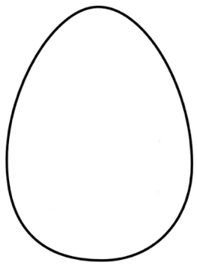
Mass of egg:  Mass of clay:  Mass of Orbeez:  Time: | Mass of egg:  Mass of clay:  Mass of Orbeez:  Time: | Mass of egg:  Mass of clay:  Mass of Orbeez:  Time: | Mass of egg:  Mass of clay:  Mass of Orbeez:  Time:
Mass of egg:  Mass of clay:  Mass of Orbeez:  Time: | Mass of egg:  Mass of clay:  Mass of Orbeez:  Time: | Mass of egg:  Mass of clay:  Mass of Orbeez:  Time: | Mass of egg:  Mass of clay:  Mass of Orbeez:  Time:

Analysis Questions
What did you notice as the amount of Orbeez increased inside the plastic eggs?

How did increasing the amount of clay affect the egg’s rotation?

Which egg do you think had the greatest rotational inertia? The least?

Why do you think the Orbeez beads affect stability so much?

