Fossil Information Sheet
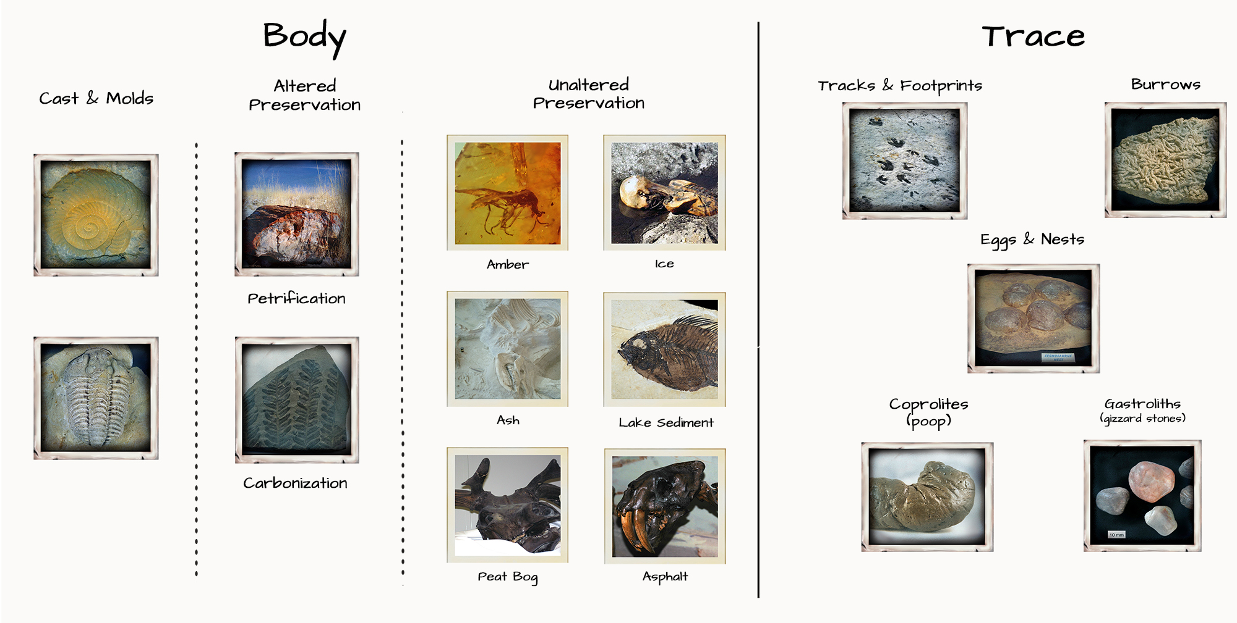

Fossils can be divided into body fossils, which entail whole organisms or body parts, and trace fossils, which reveal evidence of an organism’s activities or behavior. Examples of trace fossils include footprints, nests, eggs, worm burrows, gizzard stones, and even poop!

Sometimes, the remains of an organism are preserved in a virtually unaltered state, meaning that the original composition of the organism is largely intact. Materials such as ice, volcanic ash, amber, asphalt, peat bog, and lake sediment can preserve remains in this way.

Most of the time, however, remains become altered through environmental exposure and decay. There are several types of fossilization processes that can alter an organism’s remains.

In the case of petrification, minerals seep into the remains of an organism and crystallize over long stretches of time, forming a stone version of the original organism.

Carbonization is like making a “carbon copy” of an organism. The carbon contained within the remains of a soft-bodied animal or plant forms a stamp-like impression on the sediment, while the remaining molecules break up.

A mold fossil forms when the remains of an organism leave a mark in sediment that hardens before the organism rots or is washed away. Sediment can then fill in that mold, forming what looks like a sand or clay version of the organism; this is called a cast fossil. (Molds and casts may sound like trace fossils, but they are considered body fossils because they preserve an aspect of an organism’s anatomy rather than its activity.)

