Tar Noir:
Paleoforensics AT LA BREA TAR PITS
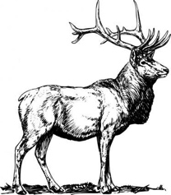
- An old buck dies of natural causes in a forest. What happens to it after it dies? Give as much detail as possible

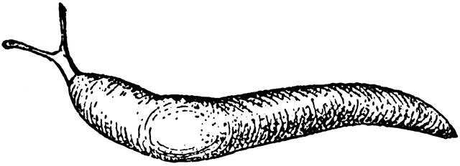
- What if it were a slug instead of a buck? In what ways would the process you wrote about above be the same and different?

- Watch the Science Friday video segment “Tar Noir” found at: https://www.sciencefriday.com/segments/tar-noir/
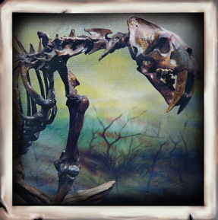
After you watch the video, answer the following question.

Gotta Question?!

You will be doing an internship at Rancho La Brea Tar Pits this summer. Your supervisor wants you to think of a question to explore while you are at La Brea. What are two or three questions that come to mind after watching the Tar Noir videoclip?

_______________________________________________________________________________________________________________________________________________________________________________________________________________________________________________________________________________________________________________________________________

A Closer Look at a Chicken Wing
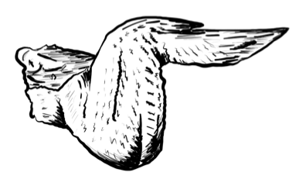

Your Task: To determine the different types of tissues that make up a chicken wing.

Procedure:
- Obtain a chicken wing.
- Note the outside of the chicken wing before your start cutting.
- Take some notes here about what the tissue looks like and feels like.

Using sharp scissors or a scalpel if you have one, dissect the chicken wing to expose as many different tissues that make up a chicken wing as you can. Draw a sketch of the dissected chicken wing and label the tissues.

How many different types of tissues were you able to identify?

What does “hard tissue” mean and which part of the wing’s anatomy is considered hard tissue?

“There’s a Science For That!”: Taphonomy
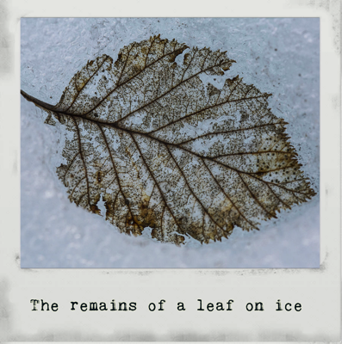
Just like there’s an App for everything, there’s also a science for everything. Did you know that coleopterology studies beetles? What about speleology? That’s the study of caves. If lipids intrigue you, you could go into lipodomics, but if you’re more into hair, you could study trichology. There are even those who are experts in the science of scat-ology. Yep, that’s the study of feces. The science of what happens to an organism from the time it dies to when it becomes a fossil is called taphonomy. Taphonomy includes things like preservation (how the organism changes after death), burial (e.g. in sediment, ice, volcanic ash) and removal from the ground.

- Two processes that determine how long an organism sticks around after death are: decay and fossilization. Explain what these are.

- For a fossil to form, there must be rapid burial before decay. What factors affect how fast an organism decays?

- Do you think the rate of decay varies between soft and hard tissue? Why?

What Factors affect the Rate of Decay of a Chicken Wing?

Your internship supervisor at Rancho La Brea Tar Pits has sent you an assignment as a “warm up” for when you get there in the summer. They want you to design and carry out an experiment to investigate the factors affecting the preservation of chicken wings by varying the sediment in which they are buried. You will be working with a team of other scientists from your class to investigate this. After you complete your experiment, you will share your findings with other teams to get a more complete idea of the factors affecting chicken wing decay.

- In the natural environment, what factors affect the rate at which an organism decays?

Your chicken wing decay investigation is limited to the following materials:
- raw chicken wing tips
- repurposed plastic soda bottles to create the microenvironments
- fishing line to hold and pull up the wing tips
- repurposed fruit mesh or window screen to cover the microenvironments
- disposable gloves
- common, non-toxic household substrates (i.e. liquids and powders water, salt, oil, jello, sand, lemon juice, baking soda)

2. Based on the materials you are allowed to use, and given their properties, which factor from Question #1 will your group focus on, and which substrate will you use?

We will be investigating the effect of ____________________ (factor) on chicken wing decay. The substrate we will use in this investigation is _____________________. .

3. You are only allowed ONE type of substrate. Explain how you will control your independent factor to create the treatment. What levels will you set up? (e.g. No, low, mid, high radioactivity; or 0.5M, 1M, 1.5M, 2M concentration)

4. What is the dependent variable you will measure? _______________________________

What type of data will you collect?

What will be the control for your experiment? (The control would be the baseline, the “no treatment” set up. For example in the radioactivity investigation, it would be the sand with no radioactivity)

Do you think the rate of decay will vary between soft and hard tissue? Why or why not?

Explain Yourself!
What Factors Affect the Rate of Decay of a Chicken Wing?

Create a scientific explanation about the degree to which the factor you picked affects chicken wing preservation using evidence from your investigation to support your claim.

Claim:

Evidence: | Reasoning:

Conclusion: (Remember to use your claim, evidence and reasoning to construct the scientific explanation.)

What’s your Type?

Read the description of the fossils and determine the type they are based on the way they were formed (cast, mold, preserved, petrified, carbonized or trace)
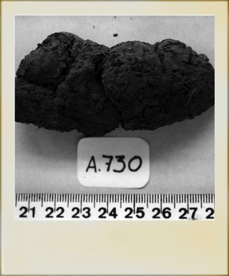
- Coprolites estimated to be 14,000 years old were found inside a cave in Oregon. DNA analysis confirms that they were produced by early humans. These feces are among the earliest human remains found in the Western Hemisphere. What type of fossils are coprolites?

__________________________________
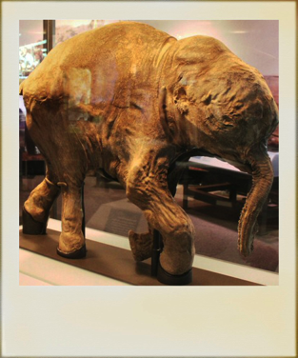

B. A mummified wooly mammoth calf was found in the permafrost in Siberia. The fossil specimen even has skin tissue and fur. What type of fossil is it?

______________________________
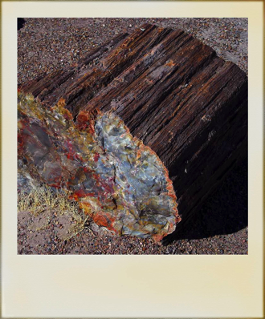

C. A big, very colorful rock thought to be tree fossil has been found in a national park in Colorado. Geochemical analysis has determined that the rock is made almost entirely of quartz and that the different colors are caused by metal impurities mixed in with the quartz. What type of fossil is this?

_____________________________

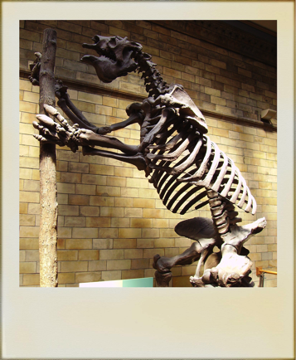

D. The skeleton of a ground sloth have been found in La Brea tar pits in California. The asphalt lakes have yielded fossils of many Ice Age mammals. What type of fossils are these?

_______________________________

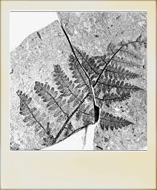
E. Fossils of ferns are often preserved in a way that resembles carbon film. The only thing that remains from their decomposition is the carbon they contained, which leaves behind a black or white mark on the rock like a stamp.

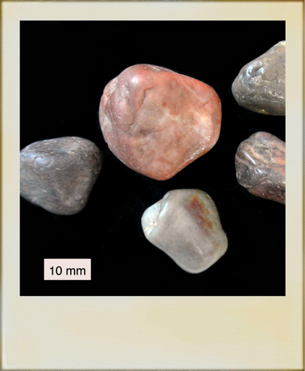
__________________________________

F. Gastroliths (also called gizzard stones) from the Jurassic period have been found near Starr Springs in Utah. These stones help reptiles and birds digest food. What type of fossils are they?

___________________________________

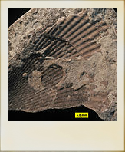

G. A fossil with a brachiopod imprint was found in Aurora, NC. It seems the brachiopod itself must have decomposed after settling on the soft sediment. What type of fossil is this?

_______________________________
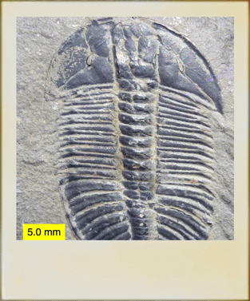

H. Geochemical analysis has shown that a trilobite fossil is made completely of rock and has no organic matter. What type of fossil could this be?

_________________________________________
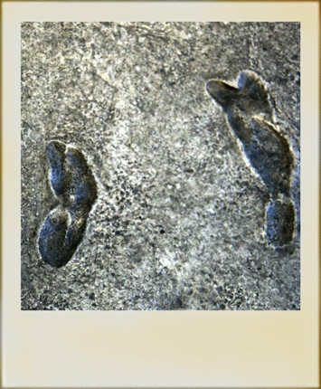

I. Dr. Cynthia Liutkus-Pierce has been studying footprints of early human ancestors in Tanzania. These footprints have been preserved in volcanic sediment for 3.8 million years. What type of fossil are these footprints?
_____________________________

