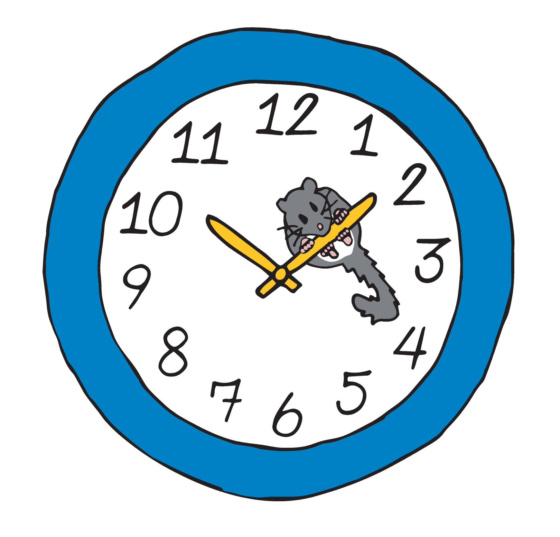
See—Think—Wonder Worksheet

Describe what you see, think, and wonder about the scene depicted below.
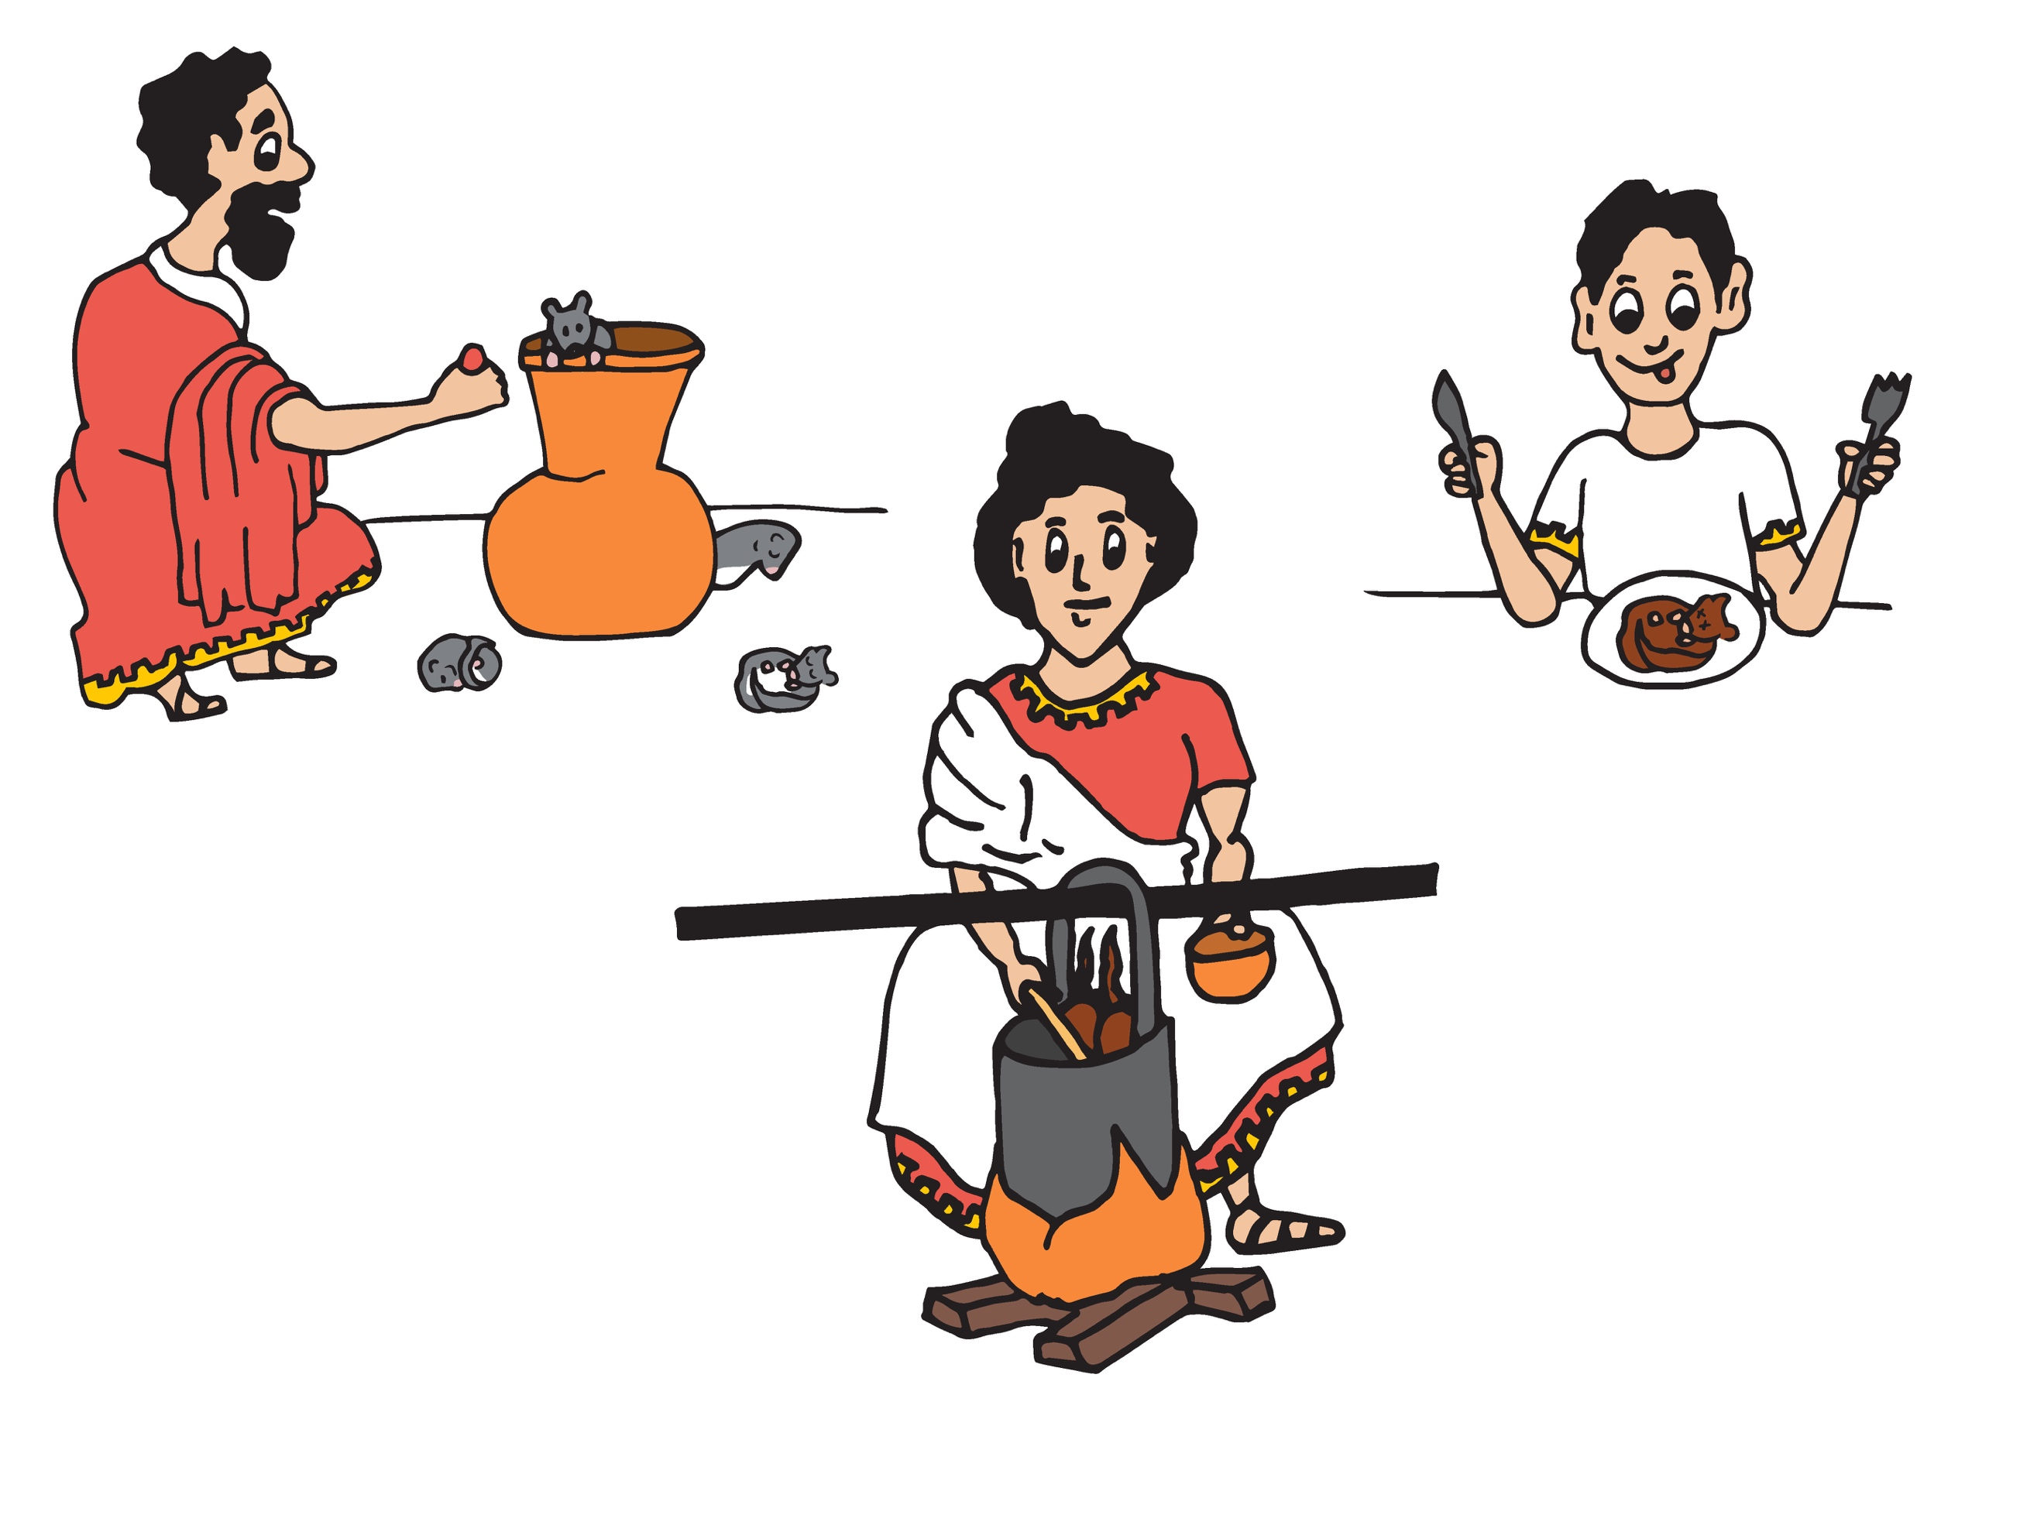
Illustration by Carrie Lapolla
Describe what you see.

What do you think is happening?
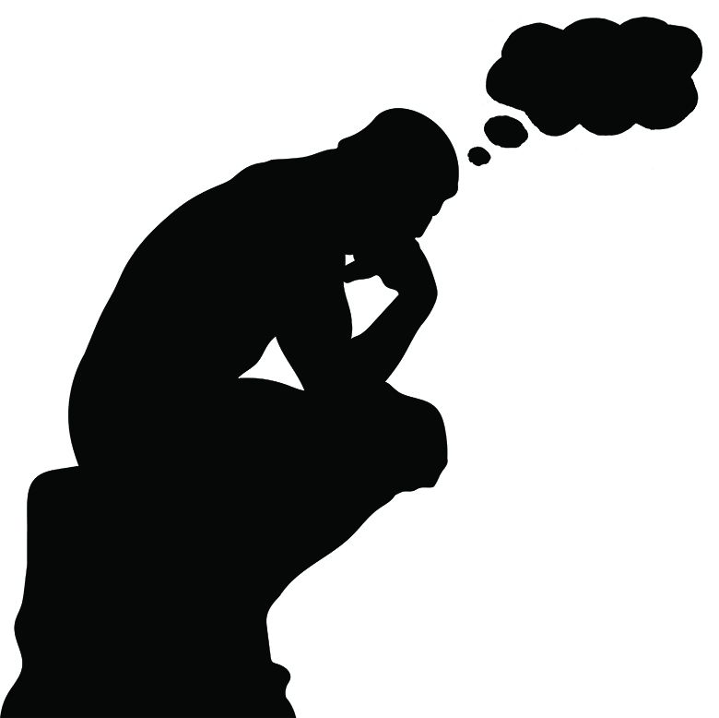

What do you wonder about this image?

