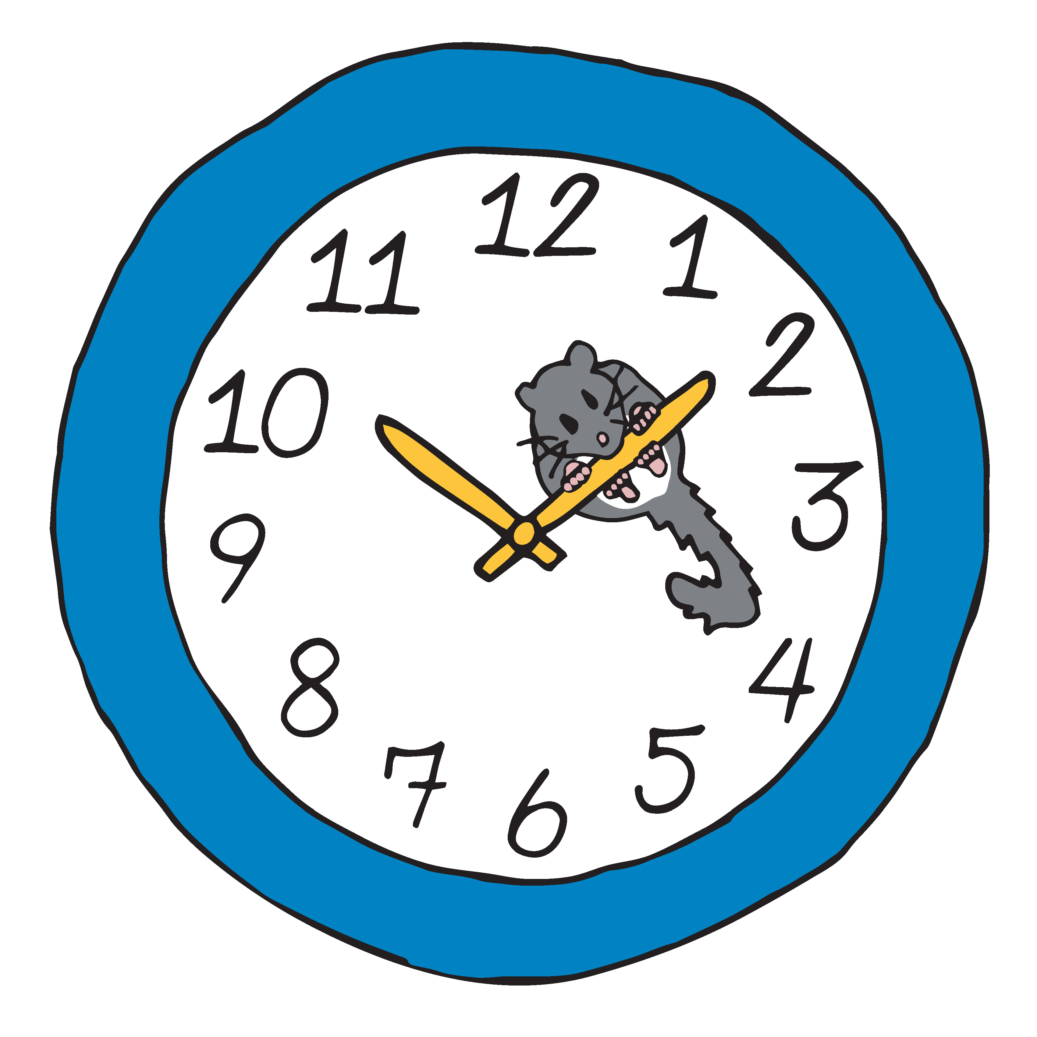

Telomere Analysis Worksheet

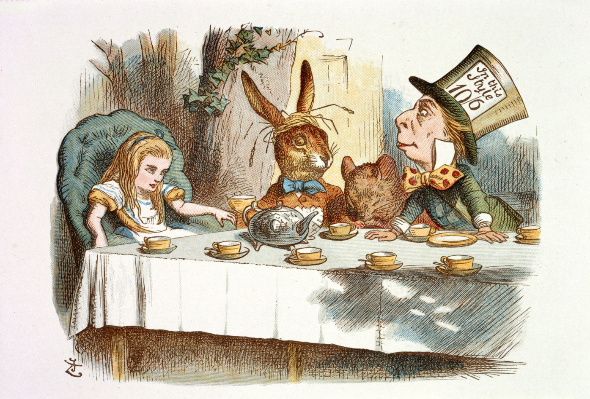
A Mad Tea-Party. Illustrated by John Tenniel [public domain], via Wikimedia Commons

You may recall a scene from “Alice’s Adventures in Wonderland,” featuring a sleepy rodent at the Mad Hatter’s tea party. That rodent is called an edible dormouse. Ancient Romans considered the edible dormouse a delicacy, and ate it as an appetizer or dessert drizzled in honey and poppy seeds. Today these rodents are found across Europe and are known for their unusual sleeping habits; they hibernate up to 11 months each year!

Your Task
As a molecular biologist, you need to collect cheek swabs from edible dormice and related rodents and isolate DNA from the cheek cells. Then you’ll analyze the ends of the DNA, which are segments called telomeres. Telomeres don’t contain genes and thus don’t code for proteins. Instead, telomeres serve to protect the genes from being broken down during replication, like how aglets protect shoelaces from fraying.

Before you begin your analysis, generate a driving question to focus your understanding.
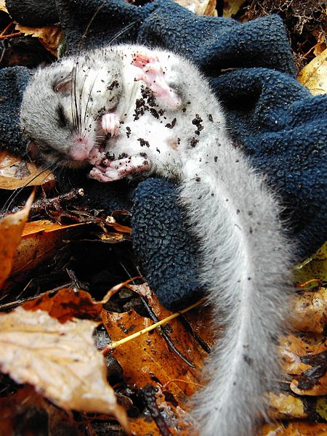

Student Procedure and Data Sheet

1. Obtain one paper strip of DNA from your teacher. This strip represents DNA collected from a cheek swab of a rodent. For simplicity, only one end of the DNA molecule with repeating telomere sequences is shown.

2. Record data about your rodent by completing the table below. Count the number of times the nucleotide sequence TTAGGG appears on the top strand of your telomere.

Rodent Type | Age  (Years) | Sex  (♂ or ♀) | Number of Telomere Repeat Sequences (TTAGGG)

3. Share the data you collected from your rodent with the other molecular biologists in the room by filling out the “Class Data Sheet.”

4. Create a line graph on a large piece of paper, a whiteboard, or graph paper, and label the X-axis “Age (years)” and the Y-axis “Number of Telomere Repeats.” For each rodent analyzed, plot the age and corresponding number of telomere repeats. Use one color for the edible dormice data, and one color for the related rodent data, and create a key indicating which rodent corresponds to which color. Be sure to also provide a title for the graph that incorporates both the independent and dependent variables.

5. Describe in detail what trends you notice in the graph for each rodent type. ________________________________________________________________________________________________________________________________________________________________________________________________________________________________________________________________________________________________________________________________________________________________________________________________________________

6. In the boxes below, draw the trends you observed in dormouse telomere length over time.
Ages 0-2 | Ages 3-5 | Ages 6-13

