Name:______________________

Date:_______________________
Circle One: Pre-test / Post-test

Interpret The Impacts Of Rising Ocean Temperatures On Ecosystems
Directions: Choose the correct answer out of the options provided and write it in the space provided.

- _________ Over the past 40 years ocean surface temperatures in the northern Atlantic ocean have mostly ______
A) increased
B) decreased
C) remained the same
- _________ Populations of the Black Sea Bass off the Atlantic coast of North America...
A) are positively impacted by the temperature change in the ocean
B) are negatively impacted by the temperature change in the ocean
C) are not impacted by the temperature change in the ocean
- _________ All marine species are negatively impacted by the warming of the ocean. Is this statement true or false?
A) True
B) False
- _________ Changes in ocean temperature can cause organisms to no longer be able to survive in their native range. Is this statement true or false?
A) True
B) False
- _________ In a town on the coast of the northern Atlantic ocean, the local fishing industry has noticed an increase in average ocean temperature from 7 degrees Celsius to 9 degrees Celsius. Based on the information in the figures below, a reasonable prediction could be...

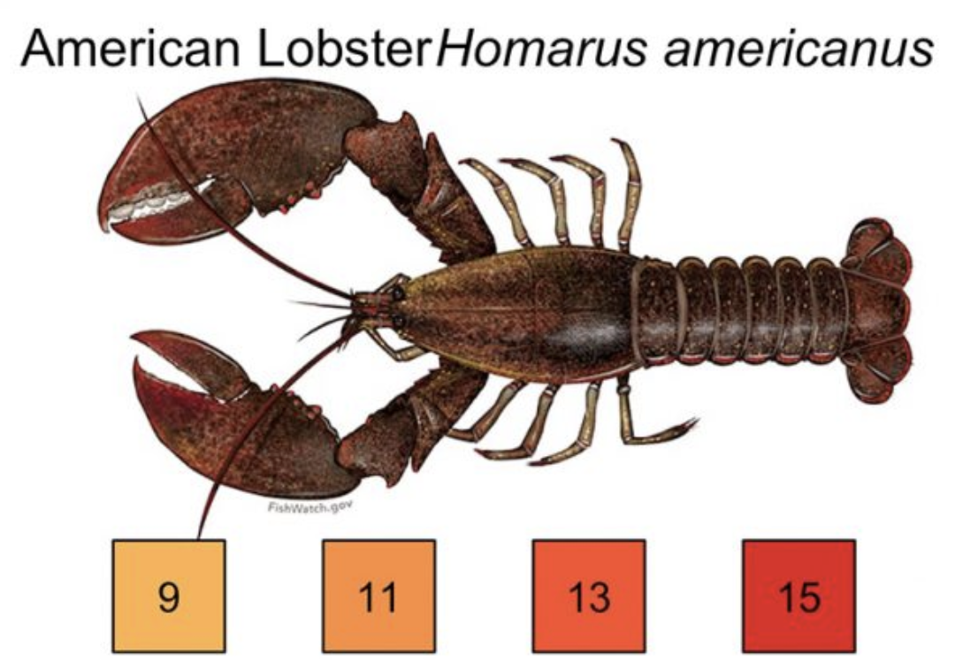
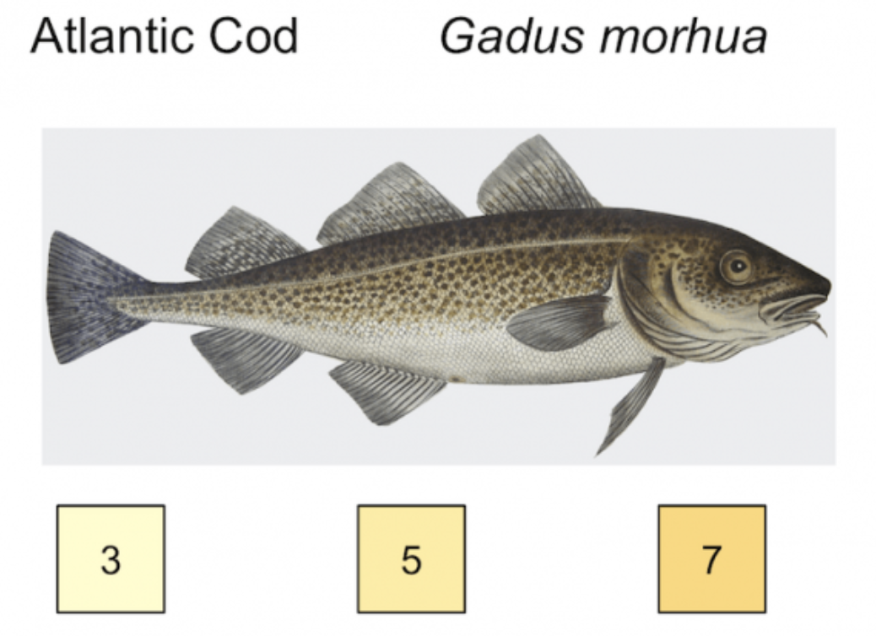
A) the population of American Lobster should decrease as the temperature rises
B) the population of American Lobster should increase as the temperature rises
C) the population of American Lobster and Atlantic Cod should decrease as the temperature rises
D) the population of American Lobster and Atlantic Cod should increase as the temperature rises

Answer Key:
1) A
2) A
3) B
4) A
5) B

