Analyzing the Forelimbs of Animals
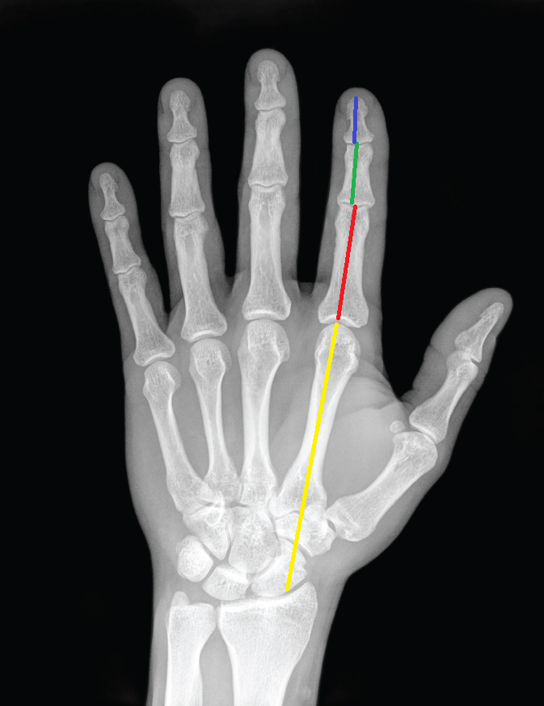
A homologous structure analysis
In this activity you are going to get a hands-on experience collecting data on a variety of forelimb homologous structures. You need to determine if the organism’s hand would be good enough to grasp objects based on your knowledge of the Fibonacci sequence.

For each image use a ruler and measure the carpal/metacarpal distance, 1st phalanx, 2nd phalanx, 3rd phalanx for the 4 different species you have been randomly assigned. Complete this task only for the finger you think is the easiest to get accurate measurements (avoid thumbs).
X-ray of Hand by OpenStax via Wikimedia Commons

You will get X-rays of both primates and non primates assigned to you from your teacher.
You can practice measuring on this human hand first. Try it as a class to ensure everyone is getting around the same measurement.

In the picture of the human hand above, the yellow line represents where you would measure an X-ray in order to measure the length of the carpal/metacarpal bones. In this image the red line represents the proximal phalanx, the green line represents the intermediate phalanx, and the blue line represents the distal phalanx. The same pattern is used throughout this activity.
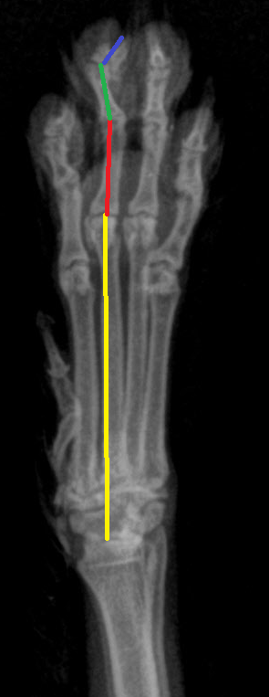
Image Courtesy of Red River Zoo, Fargo, ND
Here is an X-ray taken from a gray fox. Notice how we find the end of the long bone of the forearm and then begin our measurement of the carpal and metacarpal. The paw of the gray fox follows the same homologous pattern of the human hand (proximal phalanx, intermediate phalanx, distal phalanx). You don’t have to measure based on the “index finger”, just use your best judgement to pick a “finger” that has the best view. In the gray fox example above we chose the middle finger. Be advised that results will vary based on which finger you choose.
For each hand, measure the length of each of the bones of the index finger or a finger that is clear enough to measure (3 total) and the metacarpal/carpal combo (4th measurement) for each species hand.
Students, as you measure, analyze if you think that the x ray of the given organism’s hand would be a good grasping hand. If you don’t think that animal’s hand would be a good grasping hand think about what you think that hand could be used for.

Want to measure X-rays digitally? Try a free measurement program like ImageJ (and check out our the ImageJ guide in this resource)
Record your data in the data table below

Species =

Finger bone number | Length of bone
Metacarpal/carpal
Proximal Phalanx
Intermediate Phalanx
Distal Phalanx
Species =

Metacarpal/carpal
Proximal Phalanx
Intermediate Phalanx
Distal Phalanx

Species =

Metacarpal/carpal
Proximal Phalanx
Intermediate Phalanx
Distal Phalanx
Species =

Metacarpal/carpal
Proximal Phalanx
Intermediate Phalanx
Distal Phalanx

Now that you have recorded the bone lengths from multiple different animals you need to graph your data in a similar fashion to how you graphed your finger model from the previous activity. Put the length of the bones on the y axis and then the x axis should be the bone names. This is to say, the first digit (labeled 1 on the x-axis) is the biggest bone (metacarpal/carpal unit), the second is the proximal phalanx (labeled 2), etc. After you plot the points connect each dot sequentially with a straight line. Do not do a best fit curve.

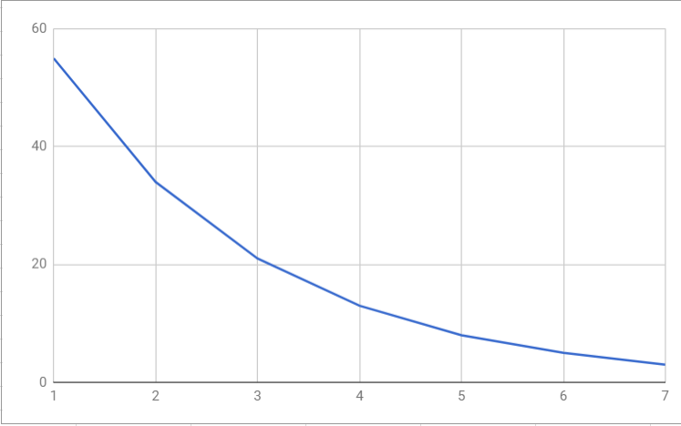
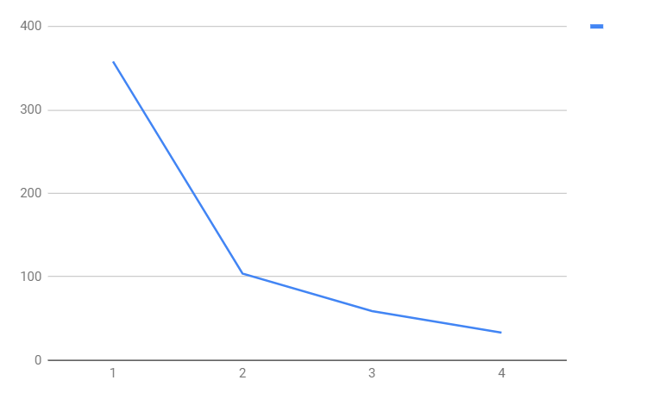

Image Credit Jeff Grant Image Credit Jeff Grant
Graph of the Fibonacci curve Graph of the Gray Fox
NOTE: The above graphs do not have labels for the X and Y axis. Make sure you have labels on your graphs in your final product.

The closer your measurements fit this Fibonacci curve the better the “hand” will curl in on itself. The gray fox example above does a decent job of following the curve with the phalanx but the carpal/metacarpal measurements throw the curve way off. How well do the gray fox measurements follow the curve?

Share your results with other lab groups in the class. See what animals have the hands that are made up of bones in ratios closest to the Fibonacci sequence. *Human hands don’t match up to the Fibonacci sequence perfectly, but as evolution states, natural selection will yield results that are good enough for survival and reproduction.

Analysis questions

- Look up what the common name is for these animals and research how they use their forelimbs. List your answers below.
- Did all of your animals match up to the Fibonacci curve? Which ones did or didn’t? What do you know about each of your animals and their ability to grasp? Do their curves match what you know to be their ability to grasp?
- Look at individual number 125 in the diagram below. Make a claim (a definitive statement) as to what this “hand” could be used for based on the size and orientation of the bones. Give evidence (observations and facts from your previous encounters) and reasoning (your conclusion as to why the evidence supports the claim) to your claim.
Claim, one sentence that clearly states your conclusion:

Evidence, cite at least two pieces of information from the activity that directly support your claim:

Evidence #1:
Evidence #2:

Reasoning, explain how each of the previously cited piece of evidence supports your claim in at least two to three sentences for each piece of evidence:
Reasoning for evidence #1:

Reasoning for evidence #2

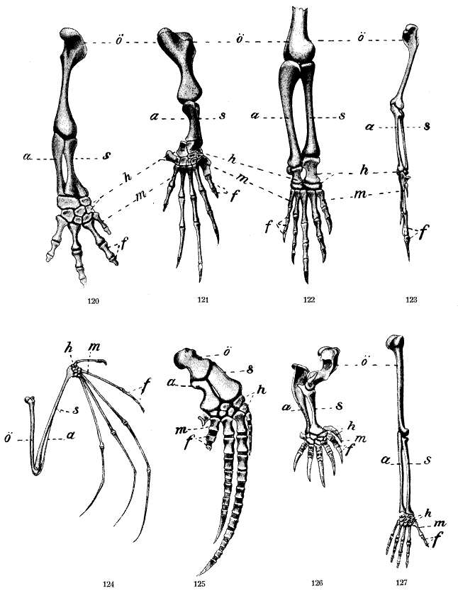
Comparative structures of the arm, Wilhelm Leche, via Wikimedia Commons, {{PD-1923}}
- Animals 124, 125, 126, and 127 in the diagram above are mammals that share a very recent common ancestor on the tree of life. What evidence and reasoning would you use to justify this claim? (on the diagram letters represent bones that are the same. Example: all the letter a’s on the diagram are the ulna bones and all the letter s’s on the diagram are radius bones, h are the carpals, m are the metacarpals, and f are the phalanges)
Extension questions
- Grasping is different than manipulating. Grasping means to seize or hold firmly, whereas manipulating means to treat or operate as with hands or mechanical means especially with a skillful manner. Primate hands have an opposable thumb that allow them to be masters at manipulating objects in addition to grabbing them. List at least 5 activities that you would be hard-pressed to accomplish without your opposable thumb.
1.

2.

3.

4.

5.

- For the animals that don’t use their “hands” for grasping or whose hands aren’t built well for grasping, what do they use their hands to do?

- If you could design the best grasping hand/limb possible what would it look like? What features would it need in order to be successful?

