Name:______________________

Date:_______________________

Circle One: Pre-test / Post-test

Fibonacci Sequence—A Handy Mathematical Approach For Looking At Evolution!
Directions: Choose the correct answer out of the options provided and write it in the space provided.

- _________ Organisms such as ____________ are most likely to have measurements of their bones that most closely align with the Fibonacci sequence.
A) reptiles
B) rodents
C) primates
D) birds
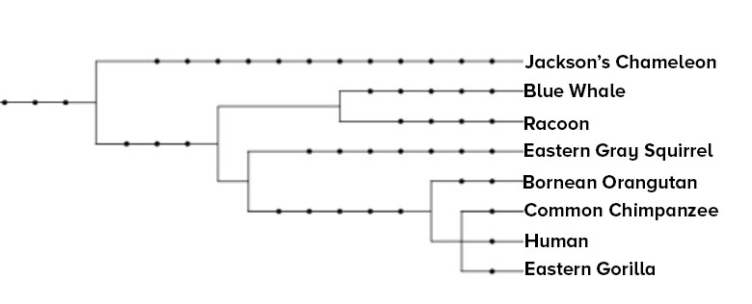
- _________ Structures like the wing of a bird, bat, and moth are considered to be _____________ because even though they have the same function they evolved independently of each other.
A) homologous
B) analogous
C) repetitious
D) numerous
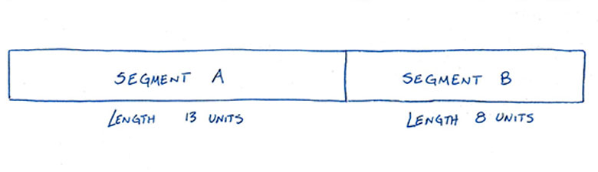
- _________ In the phylogenetic tree above, the Eastern Gorilla has the least in common genetically with the_______________
A) Jackson’s Chameleon
B) Human
C) Eastern Gray Squirrel
D) Racoon
- _________ Which of the following calculations would allow you to determine whether the ratio of the lengths of segment A and segment B matches the golden ratio?
A) Subtract A and B and then divide their difference by A
B) Add A and B and then divide their sum by A
C) Subtract A and B and then divide their difference by B
D) Add A and B and then divide their sum by B
- _________ 3, 5, 8, 13, 21, 34, X. The next number, X, in this Fibonacci sequence would be
A) 13
B) 46
C) 55
D) 66

Answer Key:
1) C
2) B
3) A
4) B
5) C

