Name:______________________

Date:____________
Run For Your Life!
Can you escape an volcanic eruption?

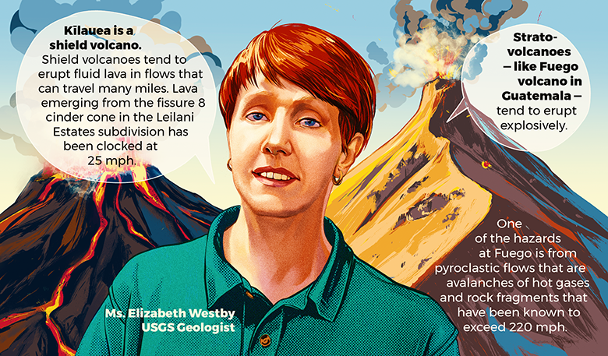
Directions: Using the information provided determine the speed of the flow resulting from each volcanic eruption, and the four other things we’ll compare them to.
Hawaii Kīlauea volcano lava flow moves at a speed of _______mph which is
__________meters per second.

A pyroclastic flow such as Guatemala’s Fuego Volcano can move at an average of
____________ mph which is __________meters per second.

Helpful Hint: The boxes below either give you the information in the video, have information in the video that you can use to calculate the speed, is given to you, or you can find by measuring yourself. The box in the upper right-hand corner has a proportion you can format to help you solve. You can also use the Google search bar to help you convert your measurements into meters per second as needed.
*Round any calculations to the nearest hundredth
Determine the speed of Bertie the world’s fastest tortoise in meters per second from the following video. | Determine Usain Bolt’s speed in meters per second from the following video.  =  m  s  m  s  100  ?  1  _____
Convert the average US Interstate speed limit of 65 mph to meters per second. | Calculate your own speed by measuring out a ten-meter distance or greater and having a friend or classmate time you.

Slope-Intercept Form
Slope-intercept form is a form of linear equation that describes the starting point of a graph based on its placement on the y-axis and the rate of change of its equation. It’s widely used and appreciated because it makes it fairly easy to graph linear functions by easily identifying the y-intercept as a point to start your graph and then using the slope to determine the next points. Each variable in the equations represents a different component of your graph the following way.
y=mx+b
Y coordinate value
X coordinate value
Slope
y-intercept
Slope-Intercept Equations
Example: A deer running from the volcanic eruption 2,000m from the volcano at 697 meters a minute would have a slope-intercept form equation of y=697x+2000.
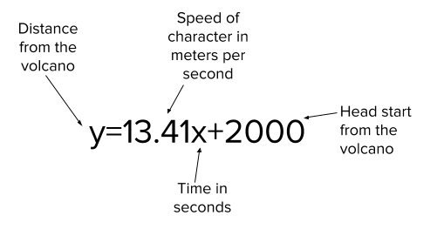
Slope-Intercept Form Equations For The Characters And Volcanoes
Kīlauea | Fuego
Slope Intercept Form Equation  y=mx+b  y=the distance from the volcano  m=the speed in meters per second  x=time, in seconds  b=starting distance from the volcano  ______=______x+______ | Slope Intercept Form Equation  y=mx+b  y=the distance from the volcano  m=the speed in meters per second  x=time, in seconds  b=starting distance from the volcano  ______=______x+______
Tortoise Equation  y=mx+b  y=the distance from the volcano  m=the speed in meters per second  x=time, in seconds  b=starting distance from the volcano  ______=______x+______ | 100m world record holder equation  y=mx+b  y=the distance from the volcano  m=the speed in meters per second  x=time, in seconds  b=starting distance from the volcano  ______=______x+______
Average Vehicle Equation  y=mx+b  y=the distance from the volcano  m=the speed in meters per second  x=time, in seconds  b=starting distance from the volcano  ______=______x+______ | YOUR Equation  y=mx+b  y=the distance from the volcano  m=the speed in meters per second  x=time, in seconds  b=starting distance from the volcano  ______=______x+______

Compare the flows:
Lava and pyroclastic flows as we know are made of different things and have a large difference in speed. Use page 1 of your graph paper to graph the slope-intercept equations of each flow to compare both rates visually.
Try this: Be sure to start from your y-intercept and then plug in the safe distance of 5,000m to calculate how long it will take each flow to reach the safe distance.

*Observation: If you were only given the graph of the two equations how would you know which one was moving faster?

*Analyze: If you expanded these graphs to a four quadrant graph the only place they would intersect would be at your point (0,0) as they do on your graph now. What does the origin in this situation represent?

Why is this the only place these two graphs will ever intersect?

Kīlauea
Using the graph paper page provided let’s determine whether or not the tortoise, Usain Bolt, a car on a US Highway, or YOU could outrun Kīlauea’s lava flow with a 1,000m head start to a safe distance 5,000m away. Graph Kīlauea’s lava flow and each of the 4 other equations you’re comparing it to on the graph paper. Be sure to use a different color or type of line for each of your equations, then label them in the key provided.
REMEMBER: Assume both you and the lava travel at the exact same speed for the entire time and would only travel in one, even, straight and uninterrupted line to the safe location 5,000m away.

*Observe: Out of the four other equations graphed, which one(s) if any were able to make it to the safety of 5,000m away before the lava flow reached there?

*Observe: Were there any that make it to the 5,000m mark on your graph paper? If so, what would it mean for that character? Why do you think this was the case? Use evidence from your graph or equation to justify your claim.

*Analyze: How were you able to interpret this from the graph?
Fuego
Using the graph paper page and some calculations let’s determine if you could make it to your safe point 5,000m away with your previous 1,000m head start. If not, we’ll find out how much of a head start you would need to reach the safe distance of 5,000m away from the volcano before Fuego’s pyroclastic flow could make it there. Graph Fuego’s pyroclastic flow and each of the 4 other equations you’re comparing it to on the graph paper. Be sure to use the same color or types of lines associated with the equation as you did on your previous graph.
REMEMBER: Assume both you and the rest of the characters as well as the pyroclastic flow travel at the exact same speed for the entire time and would only travel in one, even, straight and uninterrupted line to the safe location 5,000m away.

*Observe: Out of the four other equations graphed, which one(s) if any were able to make it to the safety of 5,000m away before the pyroclastic flow?

*Analyze: How were you able to interpret this from the graph?

Fuego Part Two
Pyroclastic flows as you’ve discovered are especially deadly. Due to their high rate of speed they’ve been known to cause some of the most well-known instances of volcanic eruptions that have resulted in the greatest loss of human life. Mount Tambora in 1815 resulted in the loss of at least 10,000 Indonesians. Krakatoa’s eruption in 1883, also in Indonesia, resulted in the loss of over 35,000 lives as a result of pyroclastic flows and accompanying tsunamis. Mount Vesuvius eruption in 79 AD, which although not the deadliest, is one of the most well-known examples of the destruction of pyroclastic flows and volcanic eruptions. Vesuvius quickly covered both the town and its victims in ash preserving the remains of both in the process.
What type of headstart would it take for our 4 characters to survive and make it to the safe distance 5,000m away?
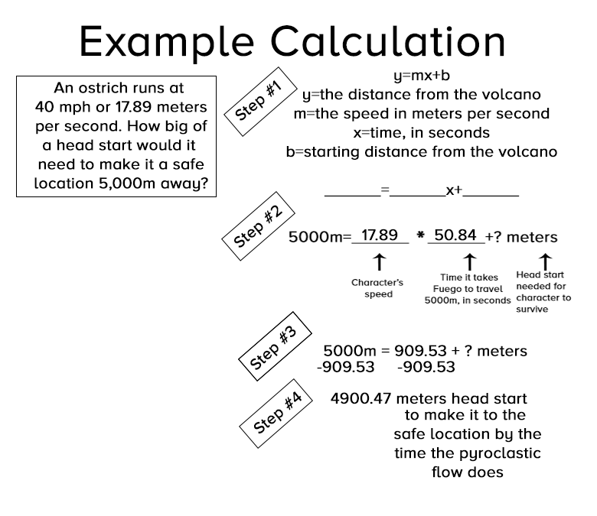

*Round all calculations to the nearest hundredth.
World’s Fastest Tortoise | Usain Bolt
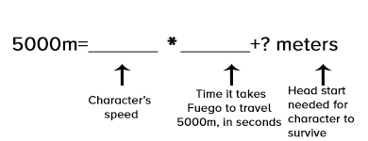

Head Start Needed: | Head Start Needed:

Average Car On The Interstate | You
Head Start Needed: | Head Start Needed:

Reflection:
- Quite a few people live in a community very close to some volcanoes. Based on what you’ve seen from these two different, but very real situations if you were in charge of these areas would you allow people to develop communities near or at the base of a volcano? Create a claim and justify your decision using the evidence from the graphs and calculations you created above.
I think that people (Circle one) SHOULD / SHOULDN’T be allowed to develop communities near the based of the volcano because...
List at least 3 pieces of evidence from the resource, graph, or your calculations from the activity above:

- Explain how each piece of evidence supports your claim below:
The Reasoning For Evidence #1

The Reasoning For Evidence #2

The Reasoning For Evidence #3

- You’re the Governor of a state that wants to develop a community on land at the base of an active volcano that hasn’t been previously developed. The law in your state says that currently, it’s illegal to build a town within 10 miles of a volcano. The developers think you should repeal the law and allow them to build due to a new “Volcano Siren” that’s been developed that will warn that says it can warn the community 15 minutes before an eruption. As governor what is your decision? Use the chart below to plan your response and then put it together in written form below on the next page.

Section | Evidence | Reasoning
Claim:
Decision
Decision (continued)

Section | 4  Distinguished | 3  Proficient | 2  Developing | 1  Beginning
Claim | The claim is clearly stated. The claim directly references the situation described. | The claim is clearly stated. Claim directly correlates to the situation described. | The claim is stated, but is not clear. The claim does not directly correlate to the situation described. | No claim is made.
Evidence | 3 or more pieces of evidence are cited from the activity in support of the claim. | 3 pieces of evidence are used from the activity and are not cited. | Less than 3 pieces of evidence are used from the activity. | Pieces of evidence are used, but they are not supportive of the claim or are not from the activity.
Reasoning | Reasoning clearly justifies the claim and clearly elaborates on all of the pieces of evidence previously provided. There are no spelling or grammar issues in the section. | Reasoning clearly justifies the claim. The reasoning elaborates on only some pieces of evidence cited. | Reasoning does not directly or clearly support the claim or the evidence stated in the | No reasoning is provided or is incoherent.

