Groundwater Simulation Instructions
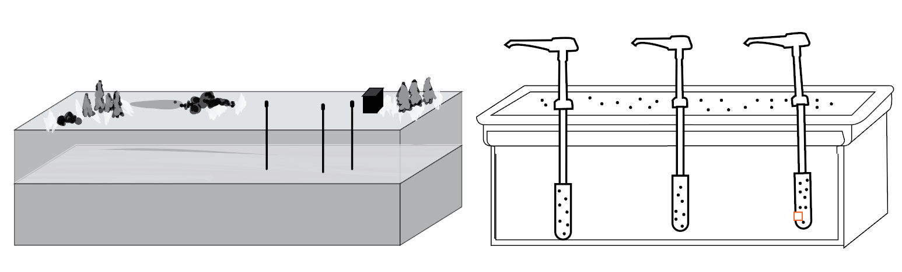
In this simulation, each month of use is represented by 60 seconds of active pumping. To maintain their quality of life, each stakeholder must pump between 90 and 100 ml of water from each well in a 60-second month. Once the month is over, no more pumping is allowed until the next month’s rainfall.

Month 1: Typical Monthly Use

- All well owners: at the start of the timer (60 seconds), begin pumping, stop as soon as your 60 seconds are up.
- Measure and record the volume of groundwater pumped in “Month 1” of the “mL Pumped” column in the {Well Monitoring Data} spreadsheet.
- Use pH paper or pH probe to test the pH of each well’s water and record the data in “Month 1” of the “pH” data table. This will be your baseline pH for the system.
- Dump the pumped water down the sink after pH has been recorded.

You’ll notice that when you add your pump volumes to the Well Monitoring Data spreadsheet, it will automatically calculate the “Amount of Surface Water for Recharge” that will be contributed to the system’s aquifer the following month. Recharge of aquifers happen when water from the surface of the earth infiltrates the pore spaces of the soil, sediments or rocks. Since monthly rainfall amounts in the simulation region are highly variable, the amount of recharge calculated each month will reflect that variability. The amount of surface water for recharge will also reflect the pumped volumes from the previous month to account for variability in the pumping efficiency of each pump and stakeholder.

Month 2: Recharge And Acid Mine Drainage Contamination Event

Owners of Well #2 and #3:
- Use tap water to fill graduated cylinders with the amount of water needed for recharge calculated by the spreadsheet.
- Slowly pour out the water to “make it rain” over each well’s parcel of land. The water should drain through the box-top’s holes.

Owner of Well #1
- Oh no! Acid mine drainage has contaminated the land and surface water that is infiltrating and recharging the aquifer under Well #1. Using the acid mine drainage simulant (citric acid), measure and fill graduated cylinder with calculated amount of water needed to recharge the land of Well #1 found in your spreadsheet, being careful not to cross-contaminate
- Slowly pour out the acid mine drainage water to “make it rain” over the parcel of land.

All Stakeholders:
Make predictions about how the acid mine drainage will affect the shared aquifer system. Be sure to address the following questions in your prediction, citing evidence to support your claim.
- What effects might the acid mine drainage have on the aquifer system, and the owners of each of the three wells over a period of four months?
- Which parcel(s) of land will be affected the most?
- How do you think the effects of the acid mine drainage will change over the course of four pumping and recharge cycles?

Some evidence to consider while making your reasoned predictions:
- The National Secondary Drinking Water Regulations (NSDWRs) considers safe drinking water to have a pH of 6.5-8.5.
- Many plants cannot survive in soils that are too acidic.
- Sand is a very porous and permeable sediment.

Month 2: Pumping
- Communities and farms that use wells #1, #2 and #3 require 90 - 100 ml of safe water each month (60 seconds) to maintain their way of life. Start a timer and begin pumping for 60 seconds for month 2.
- Record the amount of water pumped from each well in Month 2 in the data table.
- Measure and record the pumped water’s pH level in Month 2 in the data table.
- Dump the pumped water down the sink after the pH has been recorded.

Months 3-10: Huzzah! The cause of the acid mine drainage was stopped at its source!
The source of the acid mine drainage was contained, so recharge water is no longer acidic!
- Use tap water to fill graduated cylinders with the calculated amount of surface water for recharging the aquifer.
- Slowly pour water over the assigned parcels of land.
- Wait 45 seconds.
- Start a timer for 60 seconds to begin the next “month” and pump water from wells #1, #2 and #3
- Record the amount of water pumped from each well in the appropriate month row of the data table.
- Measure and record the pumped water’s pH level in the appropriate month row of the data table.
- Dump the pumped water down the sink after the pH has been recorded.
- Repeat steps 5-11 until you’ve completed 10 simulation months of recharge-pumping cycles.

Data Analysis
- Create a line-graph depicting the pH levels of all three wells over time.
To create the graph:
  - Place “pH” on the vertical axis, data range from 2 to 9
  - “Months” should be on the horizontal axis and range from 0 to 10
  - Use a different color to depict each well, and provide a key
(Example: Well 1 = red, Well 2 = blue, Well 3 = Green)
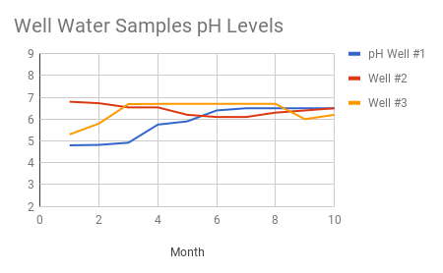
An example of a graph from a pretend run of the groundwater simulation

Simulation Inferences:
- What trends or patterns did you notice in the pH data and resulting graph?
- How did acidity change over time at each well?
- Why did the acidity of the well water change over time?
- How might the porosity and permeability of the sediments contribute to observed patterns.
- What questions do you have as a result of looking at the data and graph?

