Answer each of the following questions, annotating and incorporating diagrams in your answers.

- Why would pollution contamination of an aquifer be potentially more serious (put more people at risk) than contamination of a small surface pond? You can annotate the diagram below to support your explanation

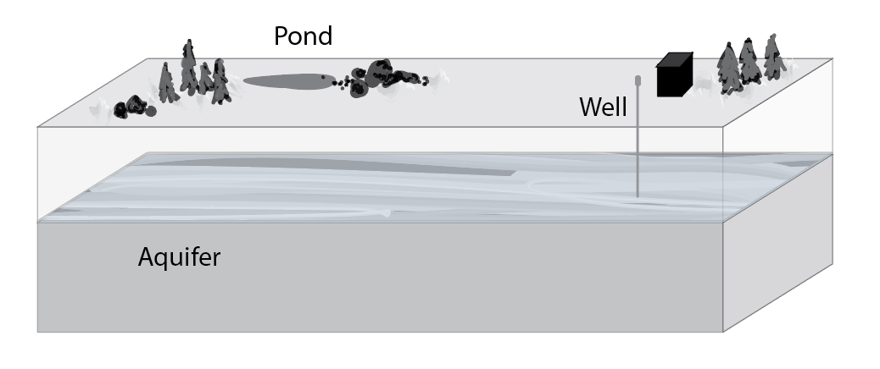

- How do you think porosity affects the amount of surface water that will be absorbed and stored as groundwater following a rain storm? Why?

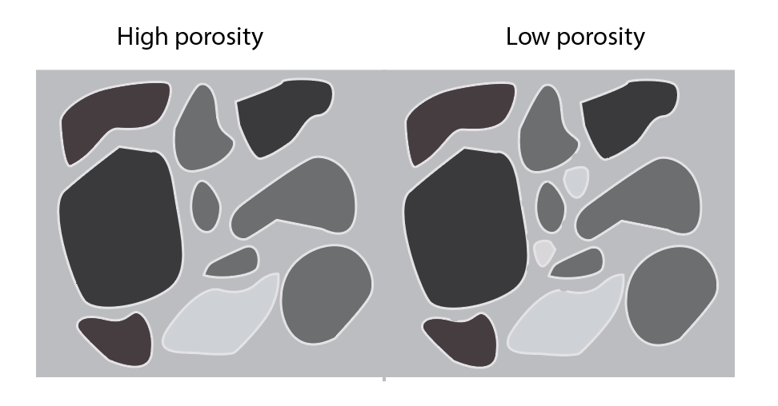

- How would a recharge event, such as a series of rainstorms, affect the direction that a pollution spill at the surface might travel if the soil was highly permeable? What if the soil had low permeability?
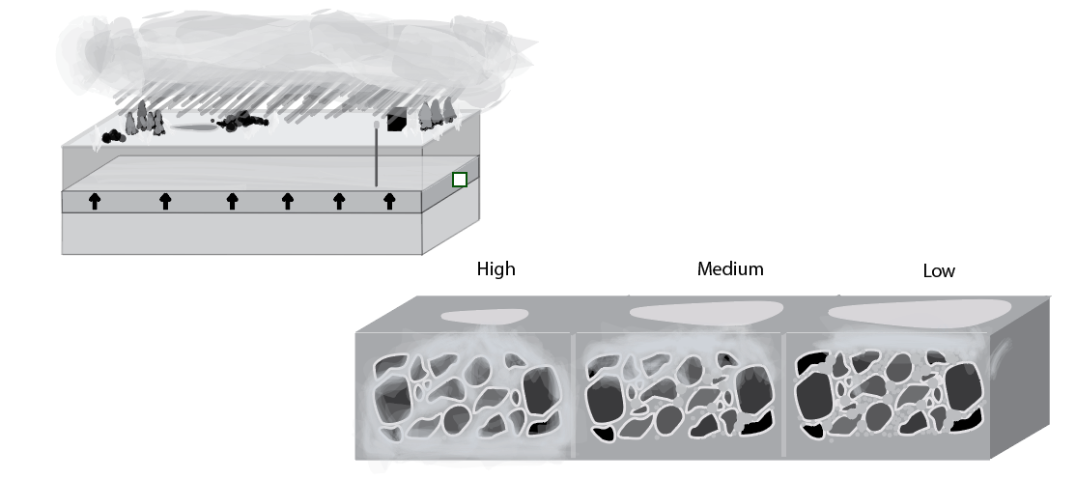

- If there is a pollution plume on one side of an aquifer, and someone pumps water from the opposite side of the aquifer, do you think the pollution plume will move towards the pump, away from it, or stay in the same place? Why?

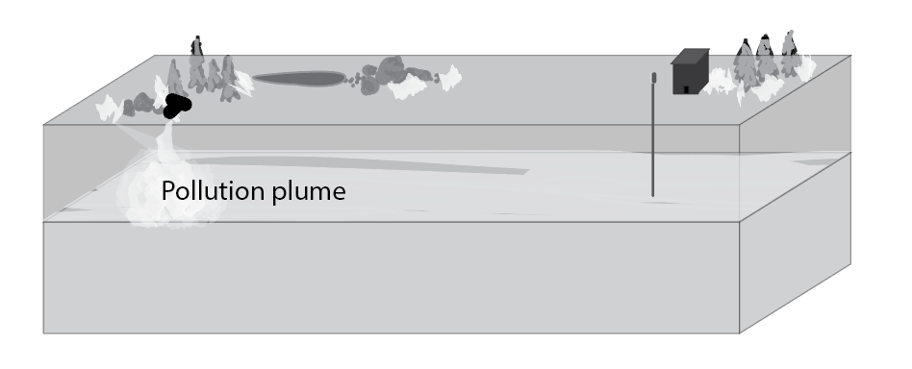

- Explain how the porosity of soil might affect its permeability. If it helps, you can annotate the diagram below as a part of your explanation.
