Cephalopod Camouflage: Beauty that’s Skin Deep Part 2
Name:________________
Activity 1: Let’s Simulate Iridophores!
Observation Sheet
Trial 1: Iridophore Only: Using color markers, draw the colors that you see through each cup.
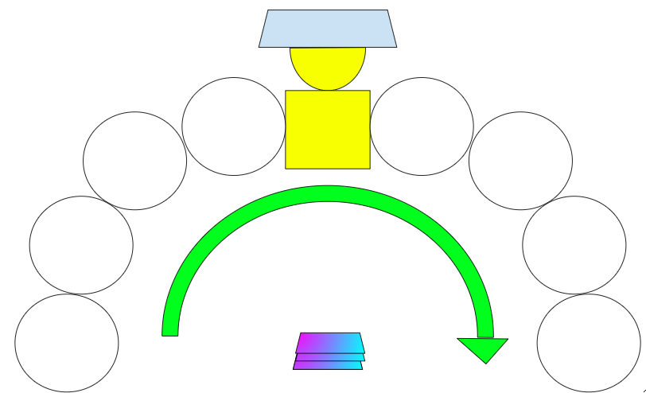

REFLECTION QUESTIONS
1) What correlations did you notice between the angles and colors that you saw?

2) Based on what you know about thin-film interference, why do you think you saw certain colors at certain angles?

3) This was a model of a set of microscopic structures in the skin of cephalopods. In what ways do you think this was a valid model? In what ways did this fail as a model? Are there any ways you could improve this model to make it more valid?

