Cephalopod Camouflage: Beauty that’s Skin Deep Part 2
Name:________________
Activity 2: Let’s Simulate Iridophores!
Observation Sheet
Without Leucophore Layer: Using color markers, draw the colors that you see through each cup.
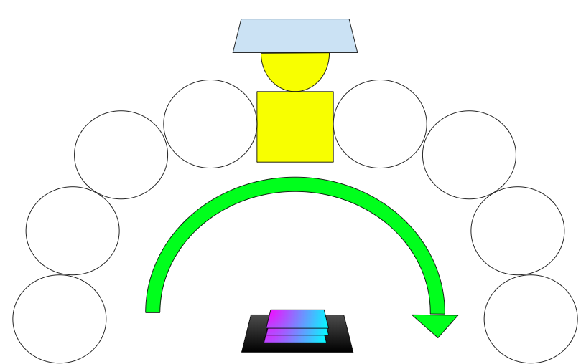

With Simulated Leucophore Layer: Using color markers, draw the colors that you see through each cup.
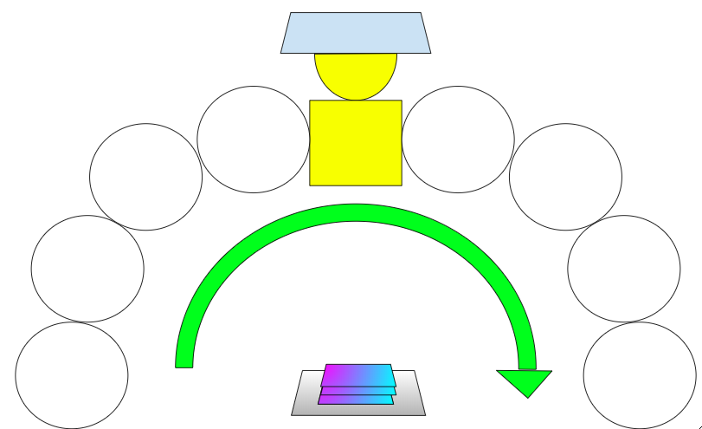

Without Leucophore Layer, Under Colored Light: Using color markers, draw the colors that you see through each cup.
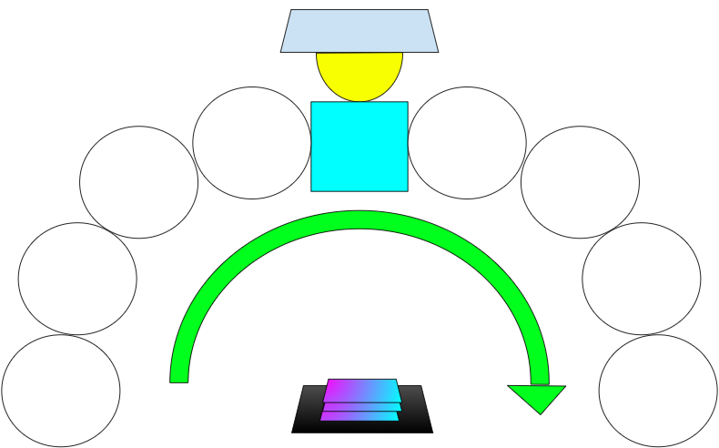

With Simulated Leucophore Layer, Under Colored Light: Using color markers, draw the colors that you see through each cup.
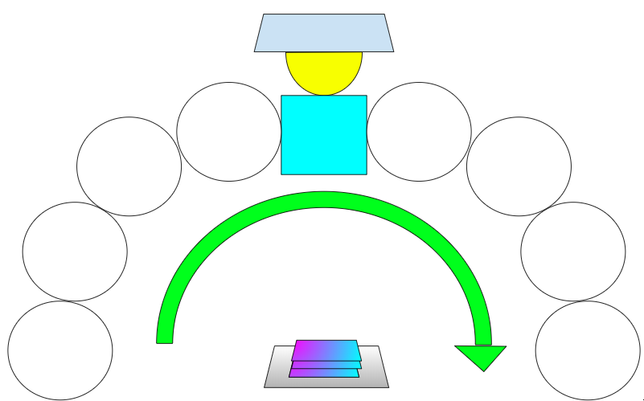

REFLECTION QUESTIONS
1) What were the differences you noticed between your observations of the Iridophores with the black construction paper and the Iridophores with the aluminum foil (Simulated Leucophore) under ordinary light?

2) How do you account for the observed differences between the Iridophores with the black construction paper and the Iridophores with the aluminum foil?

3) Under colored light, what differences did you notice between your observations of the Iridophores with the black construction paper and the Iridophores with the aluminum foil (Simulated Leucophore)?

4) How might it be beneficial for a cephalopod to have a Leucophore Layer, based on your observations?

