Cephalopod Camouflage: Beauty that’s Skin Deep Part 2
Name:________________
Activity 3: Let’s Camouflage like a Cephalopod! (Iridophore and Leucophore Layers)
Directions And Observations Sheet

Materials:
-The photographs that were taken in the previous activities uploaded to your or your teacher’s Google Drive, USB drive, or another form of digital storage.
-Computers or Chromebooks with internet access capable of using Google Draw
-A set of Undersea Backgrounds

Setting up your Palette
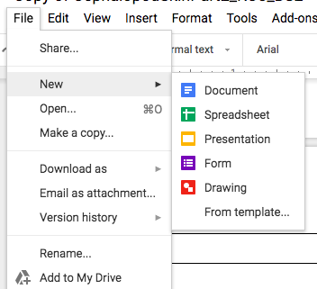 | Step 1) From any open Google document, click on File → New → Drawing. This should open up a new untitled drawing in Google Draw.
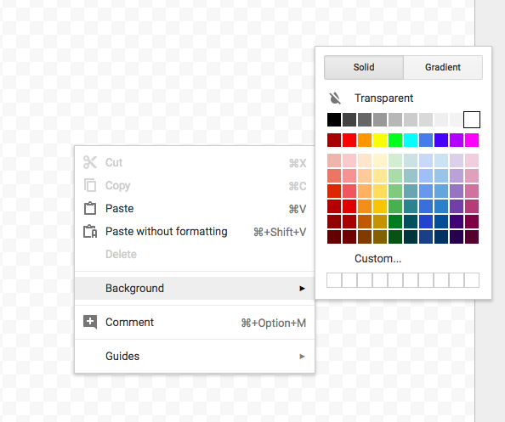 | Step 2) Right click anywhere on the checkerboard background. On the menu that appears, select Background → the color white. This will set the overall background to white.
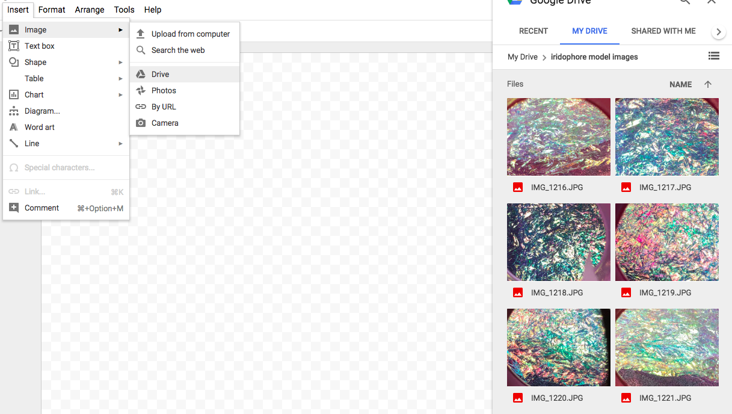 | Step 3) Click Insert → Image → Drive. Then click on a photograph from the previous activity.
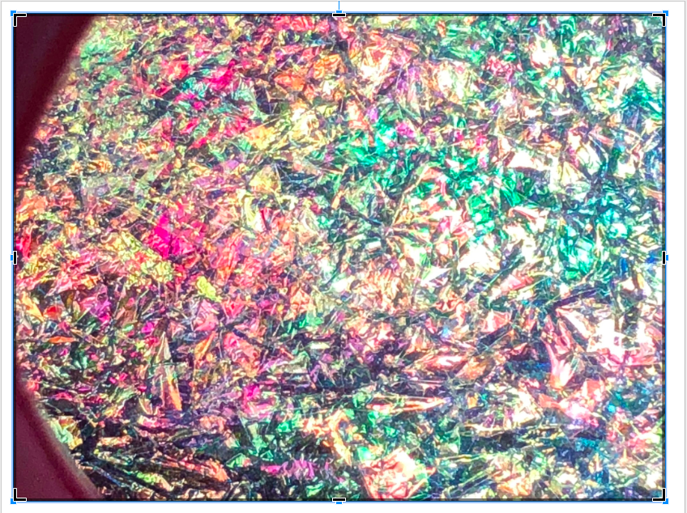 | Step 4) For EACH photograph that you insert, look for regions of specific colors. For example, in the image to the left, there is a pink area with orange flecks on the left side.
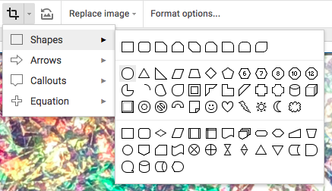 | Step 5) Look for the CROP IMAGE icon. Click on Crop Image icon first. Then, click on the drop-down arrow beside the icon (it will say “Mask Image”). Select a Shape for your mask. It is recommended that you choose a round shape.
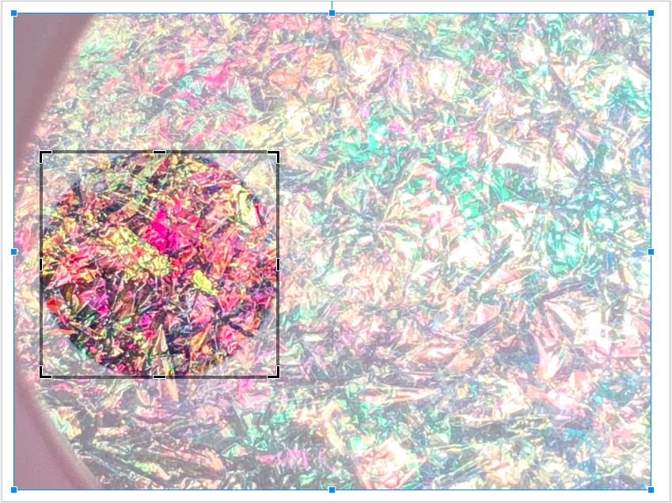 | Step 6) Resize your mask by clicking on the black handles on the edges of the mask. When you are content with the region you have focused on, then double click on it.
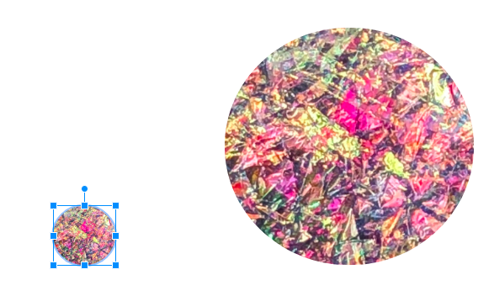 | Step 7) Resize your selected color by clicking on and dragging a CORNER of the image. Try to make your colors relatively small. A recommended size is 1/2 inch in diameter.
 | Step 8) Repeat Steps 3-7 until you have built up a palette of at least six colors. Remember that you can use the same image more than once, focusing on different regions of color. Drag your selected colors near the bottom of your background, and line them up in a way that is convenient for you.
Choosing your Background
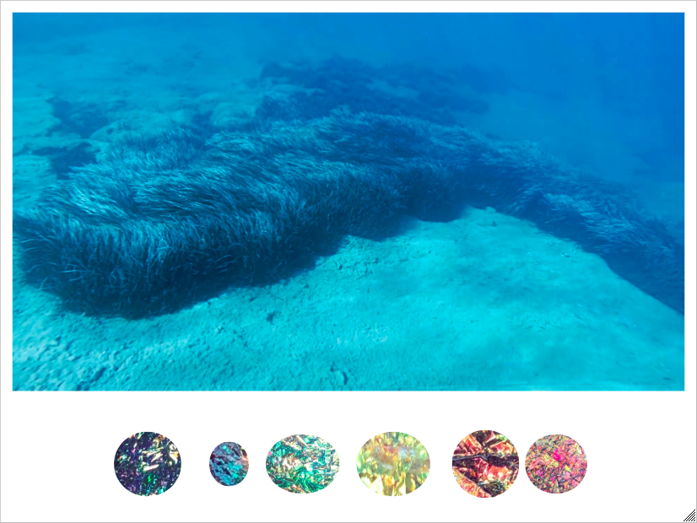 | Step 9) Students may search for real underwater backgrounds. One suggestion is these underwater landscapes by National Geographic. Once they choose an image, they can Insert it or Copy-Paste it. Then, they can resize it (by dragging on a corner of the image) so that it is an appropriate size.
Drawing your Cephalopod
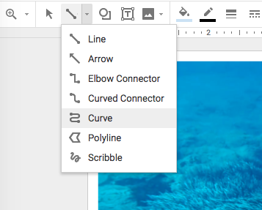 | Step 10) Select a region of the underwater background to draw your cephalopod. Then, from the Line drop-down menu, choose Curve (although it is possible to also use the Polyline setting, this tends to produce very angular shapes).
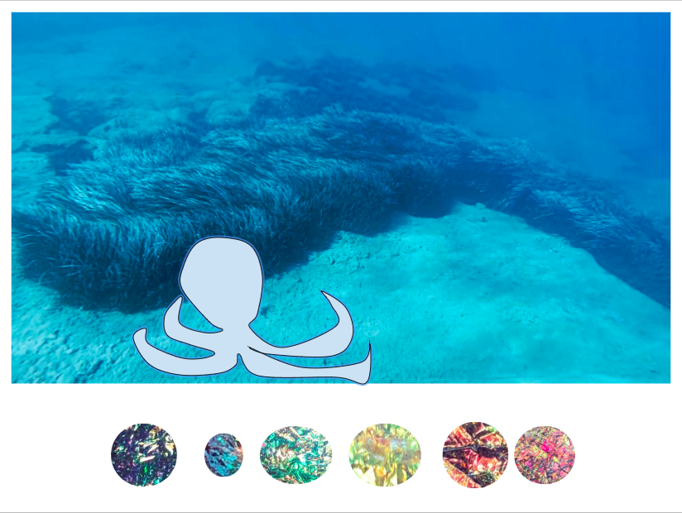 | Step 11) Draw your Cephalopod (if you need ideas, check out this sheet). It is recommended that you click frequently as you draw. Each click produces a set point on the curve. Make sure you close your shape. Once you close it, it should appear as an outline with a light blue fill color.
Camouflaging your Cephalopod
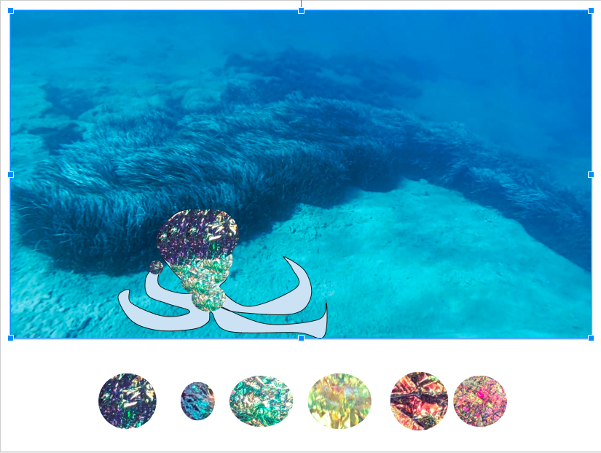 | Step 12) “Paint” your Cephalopod using the colors of your palette. Select the color you wish to use by clicking on it. Then Copy it (Command-C for Macs, and CTRL-C for Windows) and Paste it (Command-Z for Macs, and CTRL-Z for Windows). Drag your copy to the appropriate place on your Cephalopod. You can resize your color spot by clicking on a corner and dragging it. You can also adjust its angle by clicking on the handle and turning it. Repeat, using different colors, until your entire Cephalopod is covered.

Reflection Questions
1) How did using both the iridophore and leucophore help you better camouflage your cephalopod?

2) The three layers of cephalopod skin provide a wide range of colors and patterns that a cephalopod can use to camouflage itself into its environment. Why do you think having the ability to camouflage to a wide variety of colors or patterns might be more important for an organism living in a marine environment?

3) What factors do you think are the most important in a cephalopod successfully using its iridophore and leucophore layers to successfully camouflage themselves in their environment?

