Will Future Astronauts Need To Worry About Moonquakes?

The next time we go back to the moon, or better, if we ever establish a more permanent human presence on the moon, will visiting astronauts need to plan for moonquakes?

In an interview with Science Friday, NASA Administrator Jim Bridenstine conveyed NASA’s long-term vision for lunar exploration:

“Here’s the thing. We need a permanent presence at and on the moon. We need reusability. The Gateway, which is a space station in orbit around the moon—think of a very small space station–is, in essence, a reusable command and service module.”
- Jim Bridenstein, NASA Administrator, speaking on Science Friday in March 2019

On Earth, we prepare for earthquakes with earthquake-ready construction, earthquake alarms, and readiness kits in areas where earthquakes are likely to occur. If the U.S. plans a prolonged mission to the moon, will we need to make similar preparations? In this activity, you’re going to examine evidence of seismic activity on the moon. You’ll consider patterns in moonquakes measured by seismometers laid down by astronauts during the early Apollo missions, and high resolution images captured by the Lunar Reconnaissance Orbiter Camera. You’ll then use the evidence you’ve gathered to form a recommendation for NASA, the National Aeronautics and Space Administration, to consider in their planning of the next manned missions to the surface of the moon.

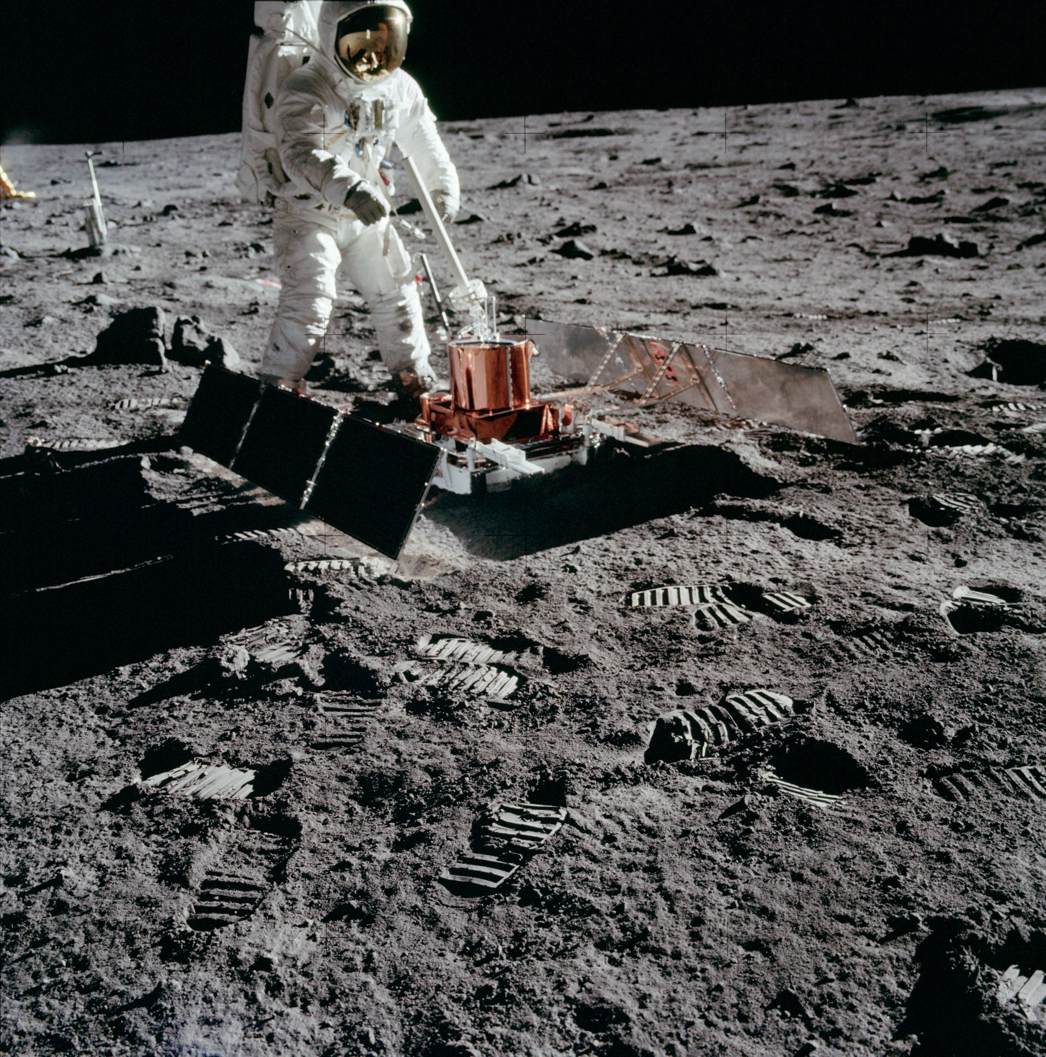

Apollo 11 astronaut Buzz Aldrin installs seismic monitoring equipment on the moon. This was the first seismometer placed on the moon’s surface. The Apollo Passive Seismic Experiment detected lunar "moonquakes" and provided information about the internal structure of the moon. Photo credit: NASA

The Moon Has Moonquakes?
Background reading and reflection questions

Our cold, cratered little moon, just a fraction of Earth’s size, completes a circular path around our planet every 28 days—it’s the most-studied object in the night sky. And although it was first mapped hundreds of years ago, has been orbited by multiple satellites, and is the only other object in our solar system that humans have visited, there is so much that we still don’t know about the moon. One of the first surprise discoveries? Moonquakes.

During the first-ever crewed-mission to the surface of the moon in July 1969, astronaut Buzz Aldrin installed a seismometer on the lunar surface as part of the Apollo 11 mission. Seismometers measure vibrations in the ground, and the seismometer installed by Aldrin was the first of five seismic stations installed and maintained by subsequent Apollo missions to monitor lunar ground vibrations, called lunar seismic activity. Of the original five seismic stations, four (from Apollo missions 12, 14, 15, and 16) continued functioning long enough to measure seismic activity on the moon for eight years from 1969 to 1977 and beam the data back to Earth after the astronauts had left. The network of stations, called the lunar seismic network, revealed that in spite of the cold, apparently stable nature of the moon, it was seismically active. Very seismically active.

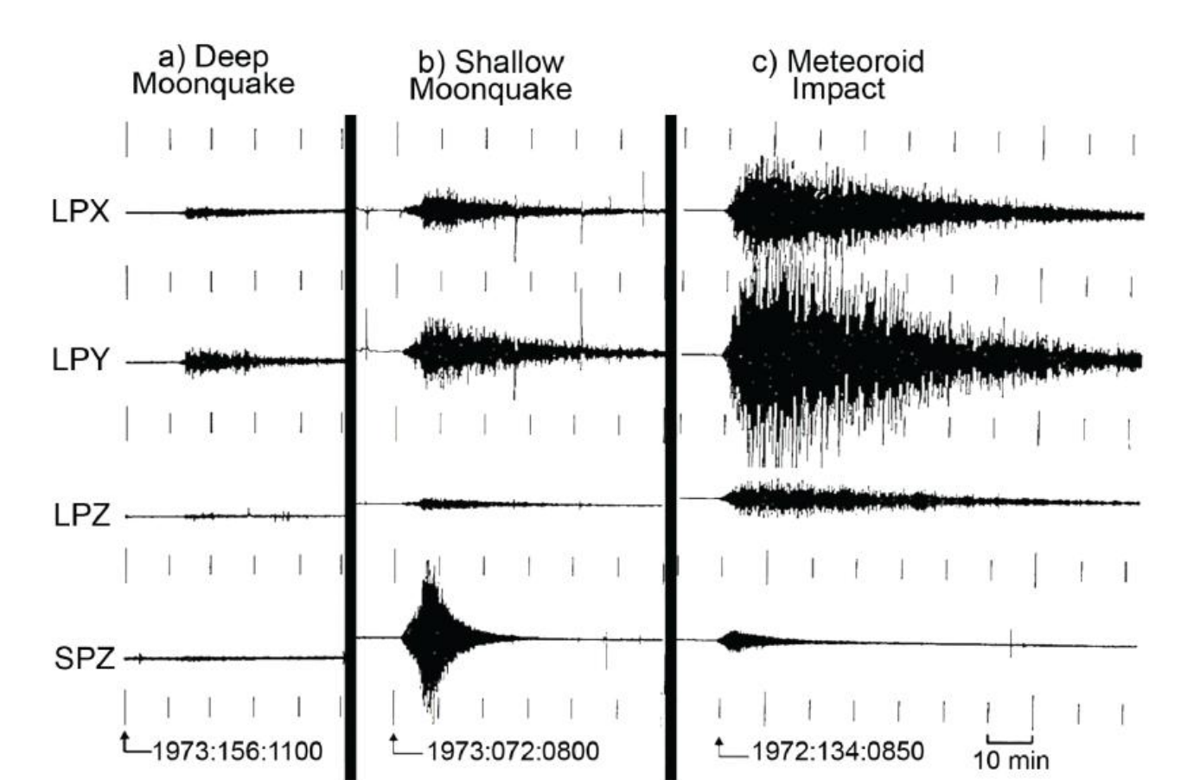
Seismograms from three different seismic events as detected by the Apollo 16 station. The left seismogram shows a deep moonquake that occurred June 1973, the center shows a shallow moonquake detected March 1973, and the right shows a meteor impact from May 1972. From Nakamura, Y., Dorman, J., Duennebier, F., Ewing, M, Lammlein, D., & Latham, G.. (1974). High-frequency lunar teleseismic events. In Lunar and Planetary Science Conference Proceedings (Vol. 5, pp. 2883-2890).

What was causing all of those moonquakes? On Earth, earthquakes are the result of plate tectonics. Plate tectonics is the idea that the surface of a planet (or in this case a moon) is made up of a crust broken into large rigid slabs that split, rub, collide with, and slide past one another. All of these slips and slides occur along cracks between plates, called faults. On Earth, the movement of tectonic plates along faults can lead to earthquakes, give way to volcanoes, and generate mountain ranges and canyons. All of that tectonic activity on Earth is made possible in part by a hot, molten layer beneath Earth’s crust, called the mantle, that allows Earth’s tectonic plates to slide around. (For a refresher, browse through this free ebook chapter on plate tectonics from CK-12.)

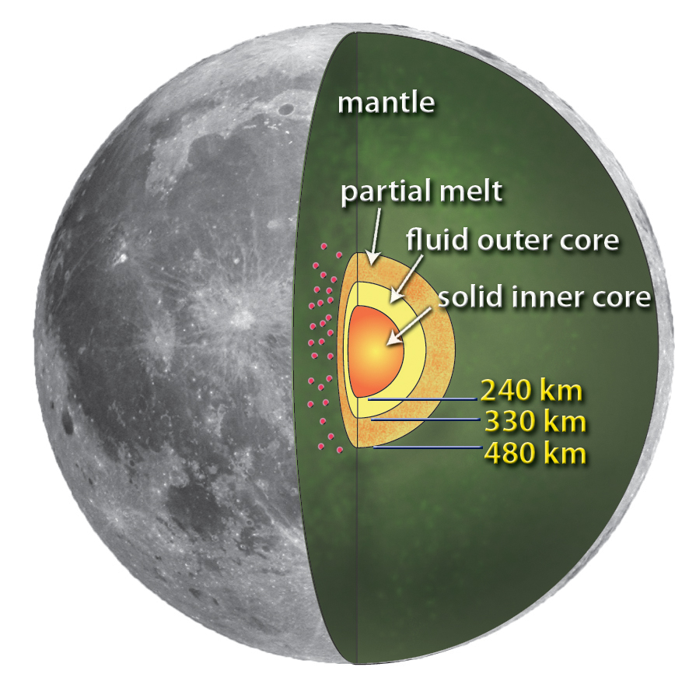
← An artist's rendering of the lunar core revealed as revealed by analysis of the Apollo Passive Seismic Experiment seismic data (NASA/MSFC/Renee Weber)

The moon’s structure is different from Earth in a number of ways, and so is its seismic activity. Though it has layers made of different materials like Earth, the moon is generally cooler and more solidified than Earth, which means there are no active volcanoes, and there is little evidence that tectonic plates drift or collide in the way that they do on Earth. Without a magnetic field or atmosphere to shield it, the moon gets bombarded frequently by meteors (which have given the moon the cratered appearance we know and love). Lastly, the moon is cooling and becoming more solid since its birth as a molten hot fluid mass. As it has cooled, ever so slowly, it has been shrinking like a raisin! The moon also experiences short term thermal expansion (when an object gets larger as it gets hotter) and thermal contraction (when an object shrinks as it cools) as it is warmed unevenly by the sun or shaded from its rays by the Earth.

Decades of analysis of the seismic data collected by the lunar seismic network revealed that vibrations on the moon mostly fall into four types, each with a distinct cause rooted in the moon’s structure and its position in our solar system:

- Deep moonquakes, quakes originating deep (over 700 kilometers deep) within the moon, caused by the stretching and relaxing of the gravitational pull between the Earth and the moon, the same force that drives our ocean tides!
- Shallow moonquakes, quakes at the surface of the moon (20-30 kilometers deep), likely caused when the moon’s crust slips and cracks due to the gradual shrinking or “raisining” of the moon as it cools.
- Meteor impacts, vibrations caused when meteors crash into the surface of the moon.
- Thermal quakes, quakes caused by the short-term thermal expansion and contraction of materials on the surface of the moon as it is warmed by, and shaded from the rays of the sun.
- Bonus! Mission “quakes”, caused by the force of the later Apollo mission landings on the moon’s surface, were helpful for making sure the measurements of the first seismic stations were accurate!

The moonquakes observed by the lunar seismic network between 1969 and 1977 varied in where, how often, and how severely they shook the moon. Researchers are still discovering new things about the moon’s structure and how it is changing by analyzing seismic data that was collected the Apollo Passive Seismic Experiment from 1969-1977. The lasting value of lunar seismic observations from the Apollo missions suggests that future missions to the moon will likely carry with them a new, updated class of seismic monitoring equipment.

Reflection questions
- Why do you the vibrations caused by later Apollo missions be helpful for making sure that the first lunar seismometers installed by astronauts were working properly?
- What are two differences between the composition of the moon and the Earth, and how do they lead to differences in the causes of seismic activity between the moon and the Earth?
- How does the sun contribute to seismic activity on the moon?
- How does the Earth contribute to seismic activity on the moon?
- Based on the causes of each of the different types of moonquakes, which type of moonquake would you predict occurs the most frequently, which type do you think occurs the most rarely? Why?

Task 1: Which types of moonquakes are most common? How powerful are they?
Look at the following summary of seismic events observed by the lunar seismic network. Based on these data, which type of moonquakes appear to be the most common?
Seismic event categories observed by the Apollo Passive Seismic Experiment from 1969-1977 | Number of events
Shallow moonquakes | 28
Deep moonquakes | ~7200
Meteor impacts | ~1700
Thermal quakes | ~1160
Artificial (human) impacts | 9
From: Lammlein, D. R. (1977). Lunar seismicity and tectonics. Physics of the Earth and Planetary Interiors, 14(3), 224-273; Neal, C. R., Banerdt, W. B., Chenet, H., Gagnepain-Beyneix, J., Hood, L., Jolliff, B., ... & Mendell, W. (2004, March). The lunar seismic network: Mission update. In Lunar and Planetary Science Conference (Vol. 35).

Further analysis of lunar seismic data revealed that shallow moonquakes were the most high-energy seismic events on the moon. Shallow moonquakes lasted a long time, and compared to deep moonquakes or thermal quakes, they generated much more powerful vibrations. Consider the following map created by Weber and colleagues (2017) showing the magnitudes of shallow moonquakes observed by the seismic network:
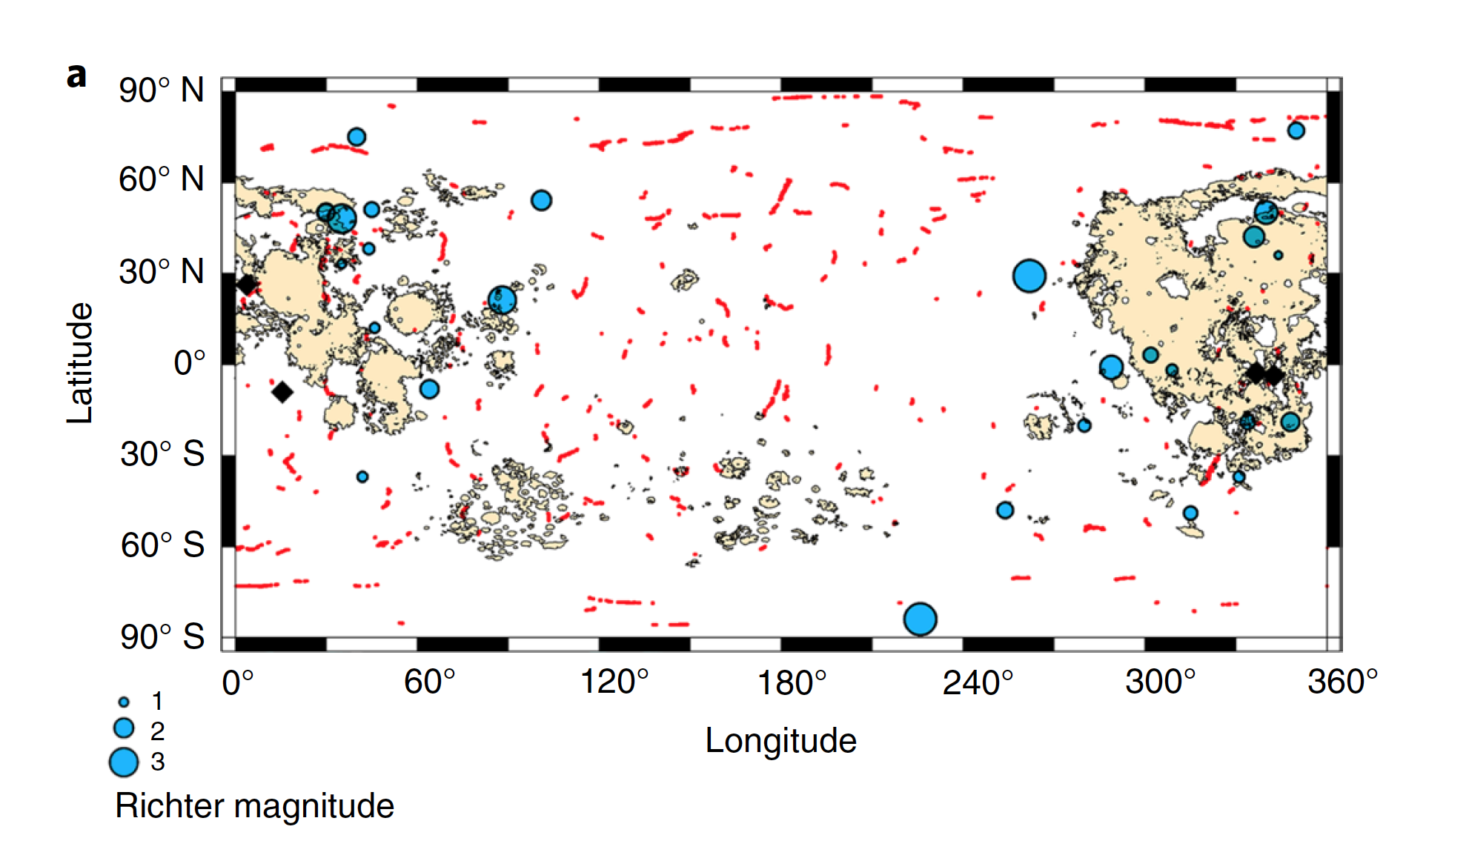
The map shows the locations of places where lunar faults may exist (called scarps), estimates of the epicenters of shallow moonquakes (blue dots) and locations of the Apollo Seismic Network seismometers (black diamonds). The moonquake symbol size is scaled by the estimated Richter magnitude (see key). From Watters et al 2019 (Fig 2a), reproduced for non-commercial educational use with permission from the publisher.

- Based on this data, how powerful are “most” shallow moonquakes, as measured on the Richter scale?

Task 2: Where do shallow moonquakes occur?
In 2017, researchers reported new, more precise estimates about where shallow moonquakes were coming from. All quakes, on Earth and on the moon, usually start at a single location, called an epicenter. Researchers found that many shallow quake epicenters were located near places where the moon’s crust was splitting and shifting—faults—similar to where most quakes occur on earth. Look at the map that the researchers generated and highlight areas where shallow moonquakes seem more common. What areas of the moon (using latitude and longitude areas) would you tell future missions to avoid if they wanted to avoid shallow moonquakes? Based on this map, do you think it is likely that shallow moonquakes are caused by lunar plate tectonics, similar to how earthquakes are caused by plate tectonics on earth? Why?

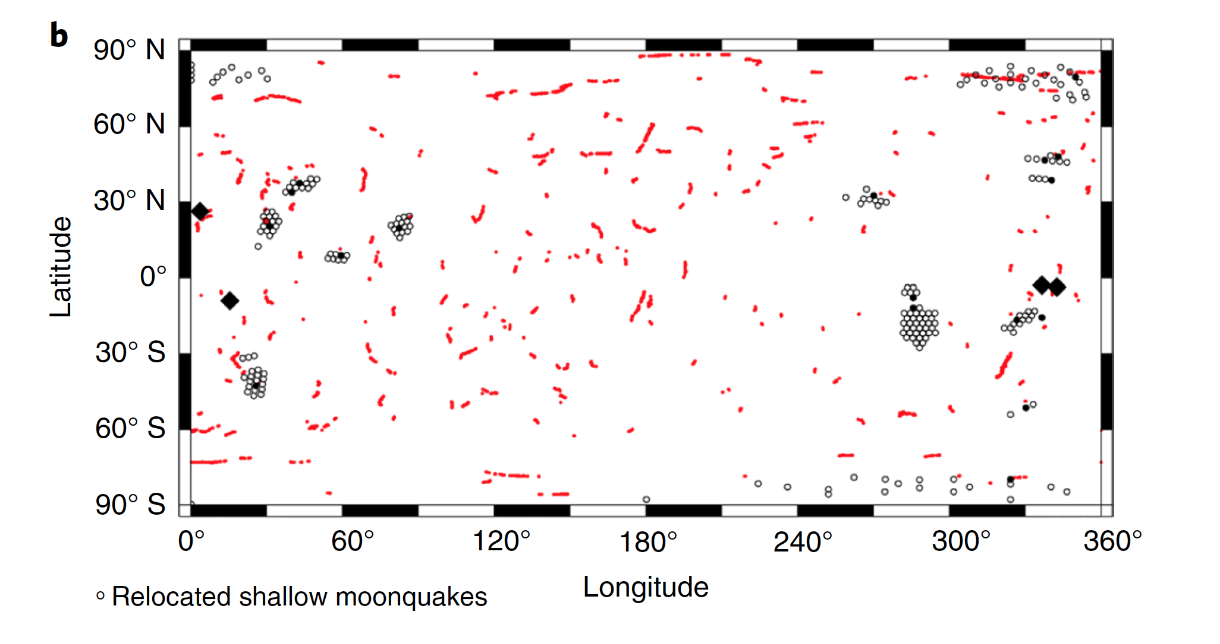
A map showing the locations of suspected faults on the moon (red lines, indicating fault scarps) and revised epicenters of shallow moonquakes (dark circles surrounded by clusters of open circles), and Apollo Seismic Network seismometer locations (black diamonds). From Watters et al 2019 (Fig 2b) reproduced for non-commercial educational use with permission from the publisher.

Task 3: When do shallow moonquakes occur most often?
The gravity of the Earth pulls on the moon, and the gravity of the moon pulls on the Earth. Gravitational force isn’t minor either—the gravitational pull of the moon (and the sun) is strong enough to move the Earth’s oceans to make tides! Similarly, the gravitational pull of the Earth on the moon appears to be enough to cause more slipping of the moon’s crust along faults, and it changes as the moon orbits the Earth. The moon’s orbit, just like the orbit of the Earth around the sun, isn’t a perfect circle, but is more elliptical, and it isn’t centered, it is asymmetrical around the Earth. That means that instead of being the same distance from the Earth all the time, the moon moves between being close to the Earth and far away from it. The position of the moon in its orbit where it is closest to the Earth is called the perigee, the position farthest away is called the apogee.

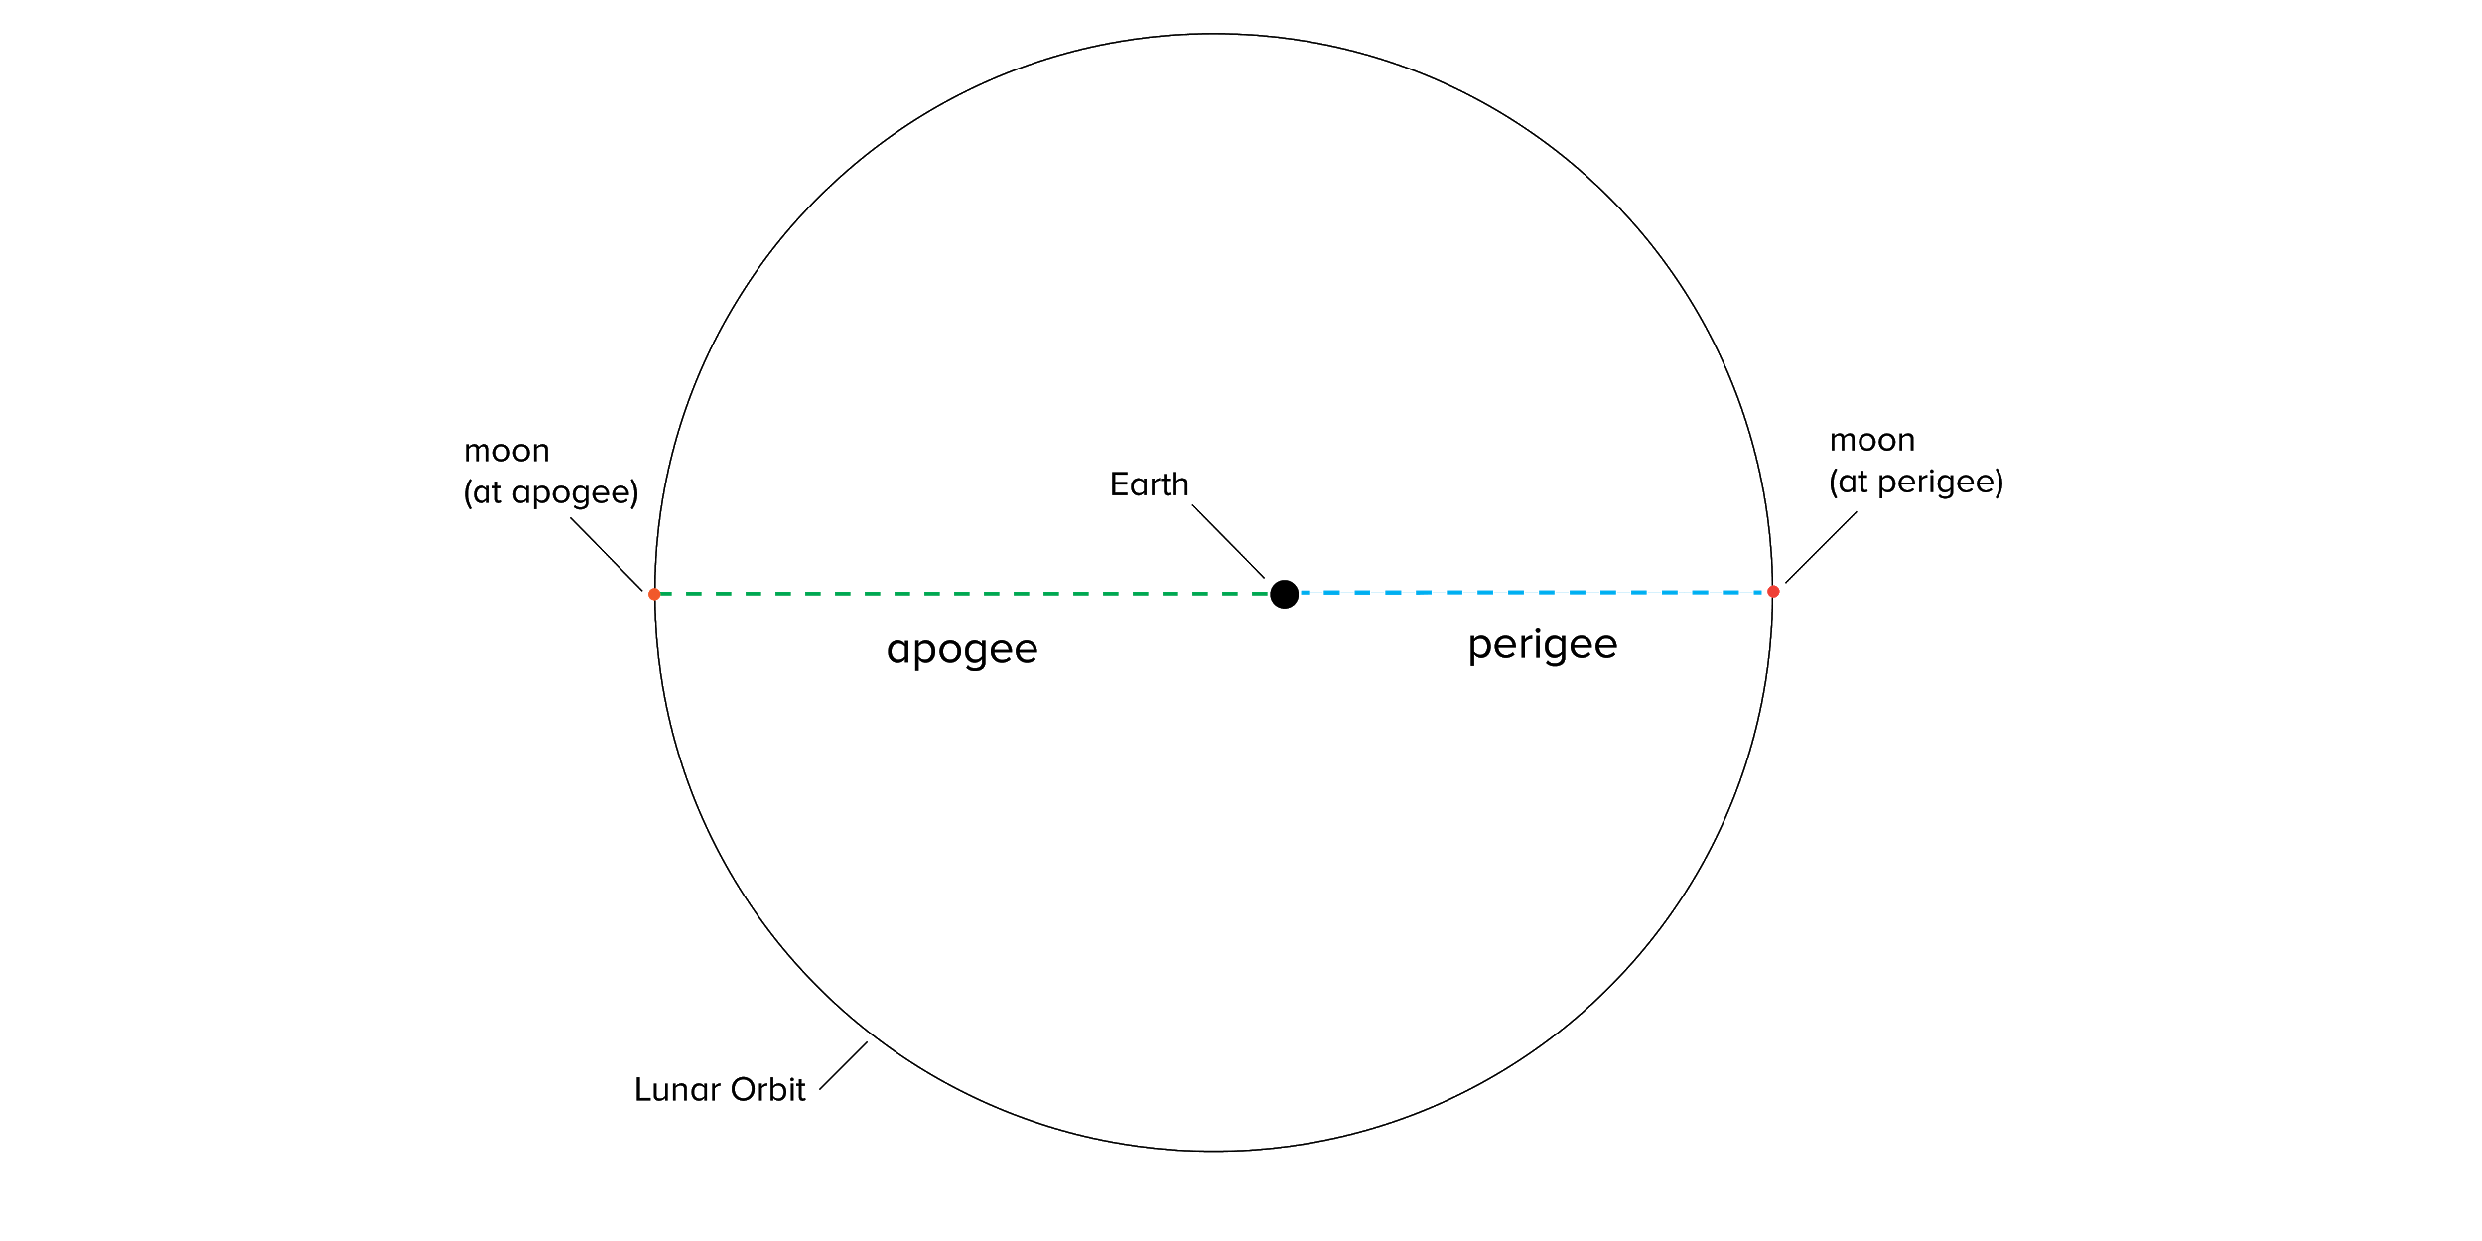
Illustration by A. Zych

Scientists looked at when shallow moonquakes occurred relative to the position of the moon in its orbit around Earth, and saw a pattern that suggested moonquakes might be more common during certain positions in the moon’s orbit around the Earth. Look at the following chart of shallow moonquakes plotted against how far away the moon was from the Earth (EMD, which means Earth-moon distance). Dots mark shallow moonquakes, the x-axis shows when the quakes occurred, and the y-axis shows how far away the moon was from Earth when each quake occurred. Dots closer to the top of the graph (farthest from Earth) occurred when the moon was near its apogee, dots closer to the bottom of the graph (nearest to Earth) occurred when the moon was near its perigee.

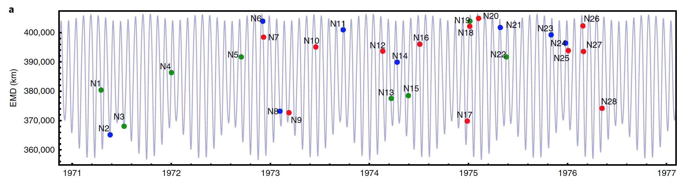
A plot of shallow moonquakes, time, and the distance between Earth and the moon in kilometers (EMD). →

Dots mark shallow moonquakes, the x-axis shows when the quakes occurred, and the y-axis shows how far away the moon was from Earth when each quake occurred. Dots closer to the top of the graph (farthest from Earth) occurred when the moon was near its apogee, dots closer to the bottom of the graph (nearest to Earth) occurred when the moon was near its perigee. In addition to monthly EMD variation (smaller ups and downs), a longer 206-day stretch in the distance between the earth and the moon is caused by the sun’s gravitational pull on the moon (larger wave-like pattern). From Watters et al 2019 (Fig 4a) reproduced for non-commercial educational use with permission from the publisher.

- Where in the moon’s orbit do they appear to be the most common?
- Based on this observation, when in the moon’s orbit would you recommend that missions to the moon be scheduled–when the moon is near its perigee, its apogee, or when it is traveling between the two?

Task 4: Is there geologic evidence of moonquakes on the lunar surface?
The surface of the moon is covered by silt, mountains, valleys, and of course, craters. Dust on the surface of the moon, called regolith, gets darker and less reflective (called “low-albedo” regolith) the longer it sits undisturbed. Fresh, reflective regolith can be exposed by meteor impacts, faults that have thrust up to form ridges (called fault scarps), and moonquakes that shake up old regolith. Light, reflective regolith (regolith with a “high albedo”) on the surface of the moon, particularly around ridges or bumps, is therefore good evidence that seismic activity has occurred nearby.

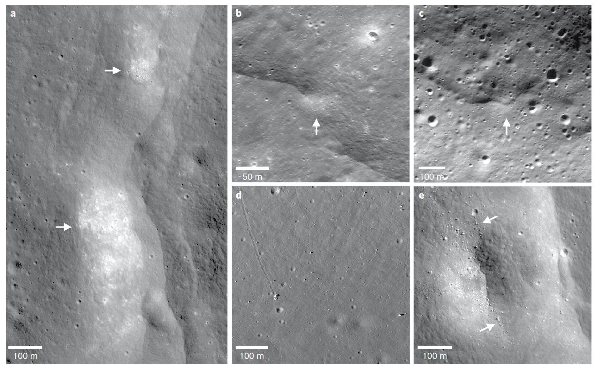
Possible evidence of recent activity on fault scarps near relocated shallow moonquakes, indicated by white arrows (information in parentheses indicates LROC NAC image frames). a, A prominent lobate scarp and boulder fields (M190844037LR). b, A bright white lobate scarp (124449632R). c, Albedo feature on a scarp face (M1119172889L). d, Boulders and boulder tracks on the slopes of North Massif, the large boulder is the Apollo 17 Station 6 boulder (M134991788R). e, Boulders in about a 300 m diameter degraded crater (M190844037L).From Watters et al 2019 (Fig 6) reproduced for non-commercial educational use with permission from the publisher.

The Lunar Reconnaissance Orbiter (LRO) is a satellite that the United States launched in 2009 to orbit the moon. It has been capturing beautiful, high-resolution images of the lunar surface ever since in addition to measurements of the moon’s surface temperature, reflectivity, topography, radiation, and other environmental observations.
- Visit the LRO Camera image gallery (http://lroc.sese.asu.edu/images) and search the images using the term “high albedo.”
- Select one or more of the resulting images.
- Print or copy the image into illustration software and highlight any examples you see of fresh regolith (bright white boulders, lumps, scarps, or landslides) that might suggest the moon’s surface is still seismically active.
- Describe the features you highlighted in the space below, and explain why you think they may represent seismic activity

Task 5: What do lunar experts think about the risk of lunar seismic activity?

There is a global community of thousands (OK, more like tens of thousands!) of experts who study the moon and its interactions with other objects in the solar system. What do they think about the risk that moonquakes might pose to future manned missions to the moon?
- Read one of the following interviews with lunar experts as they discuss moonquakes and future missions to the moon.
- Select a quote from the interview you selected that you think illustrates how your chosen expert views moonquake risk.

Moonquakes Rattle the Moon as It Shrinks Like a Raisin (Space.com, 2019)
Shrinking Moon May Be Generating Moonquakes (NASA Press Release, 2019)
Re-analysis of Apollo seismic data indicates Moon still active (Astronomy Now, 2019)
How the Moon Got its Fault Scarps: Moonquakes and the Lunar Surface (PhysicsCentral, 2019)
Faces Of The Moon (Science Friday, 2016)

- Based on the quote you selected, do you think future missions will need to plan or prepare for moonquakes?

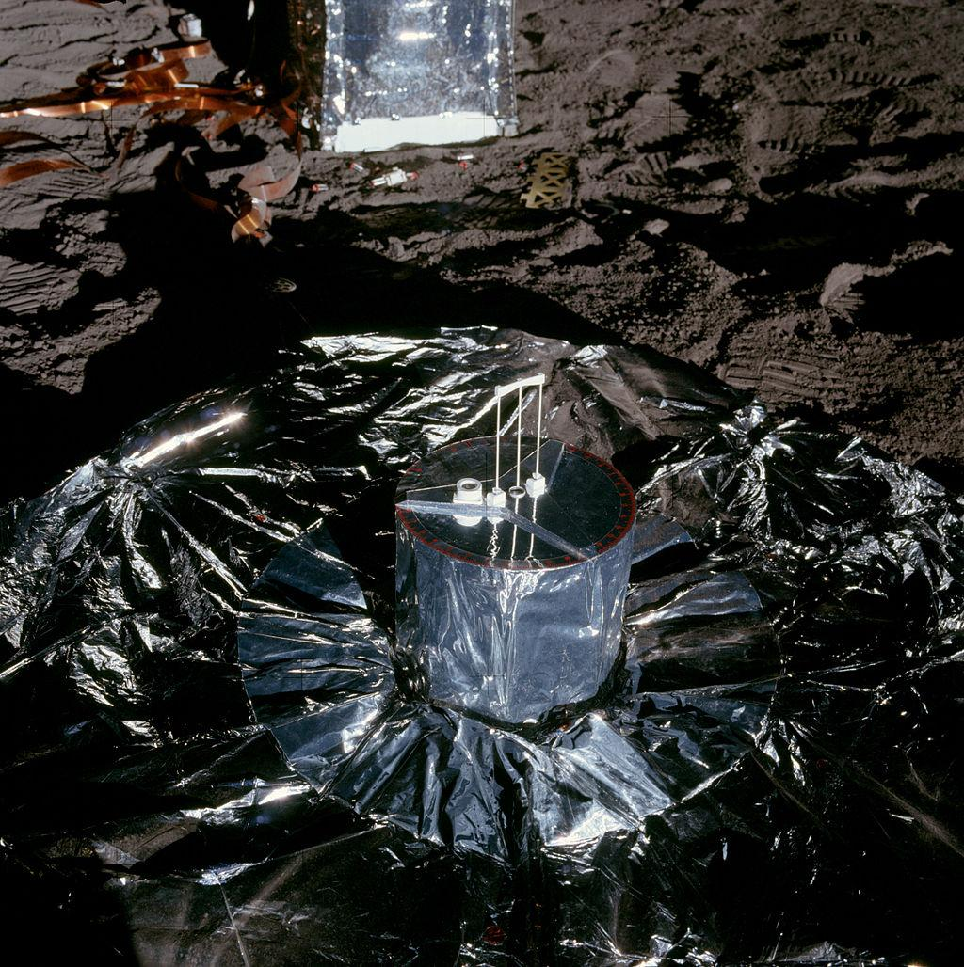
Apollo 12's Passive Seismic Experiment, NASA

Use Evidence To Make A Recommendation For Future Lunar Explorers

You’ve now considered multiple lines of evidence detailing the location, timing, recency, and severity of moonquakes. Drawing on the evidence you’ve gathered, and your initial conclusions, make a written recommendation to NASA, the National Aeronautics and Space Administration, that answers the following question:

Could moonquakes pose a threat to future manned missions to the surface of the moon, and if so, how could missions be planned to minimize those risks?

Make sure your recommendation describes the severity of moonquakes as well as where and when a mission should land in order to best avoid them, citing evidence from your research. Here’s a writing rubric to guide you as you construct your response by making a claim, providing supporting evidence, and reasoning to explain how the evidence supports your claim.

