Part 1: Representing Adaptations Through Dance
Adaptation: an inherited characteristic that helps an organism survive and reproduce in its environment
- Physical Adaptations: body process or structural feature of an organism (ex. differences between bird beaks)
- Behavioral Adaptations: action/response made by the organism (ex. birds migrating south in winter)
Anishnabe Fish Dance
- Identify two adaptations of the fish that the dancers are representing.

- Identify each adaptation you noted above as behavioral or physical.
Anishnabe Swan Dance
- Identify two adaptations of fish are the dancers representing.

- Identify each adaptation you noted above as behavioral or physical.
Honey Bee Waggle
- After watching the video explaining the phenomenon, gather materials from your teacher and set them up on the floor to match the diagram below.
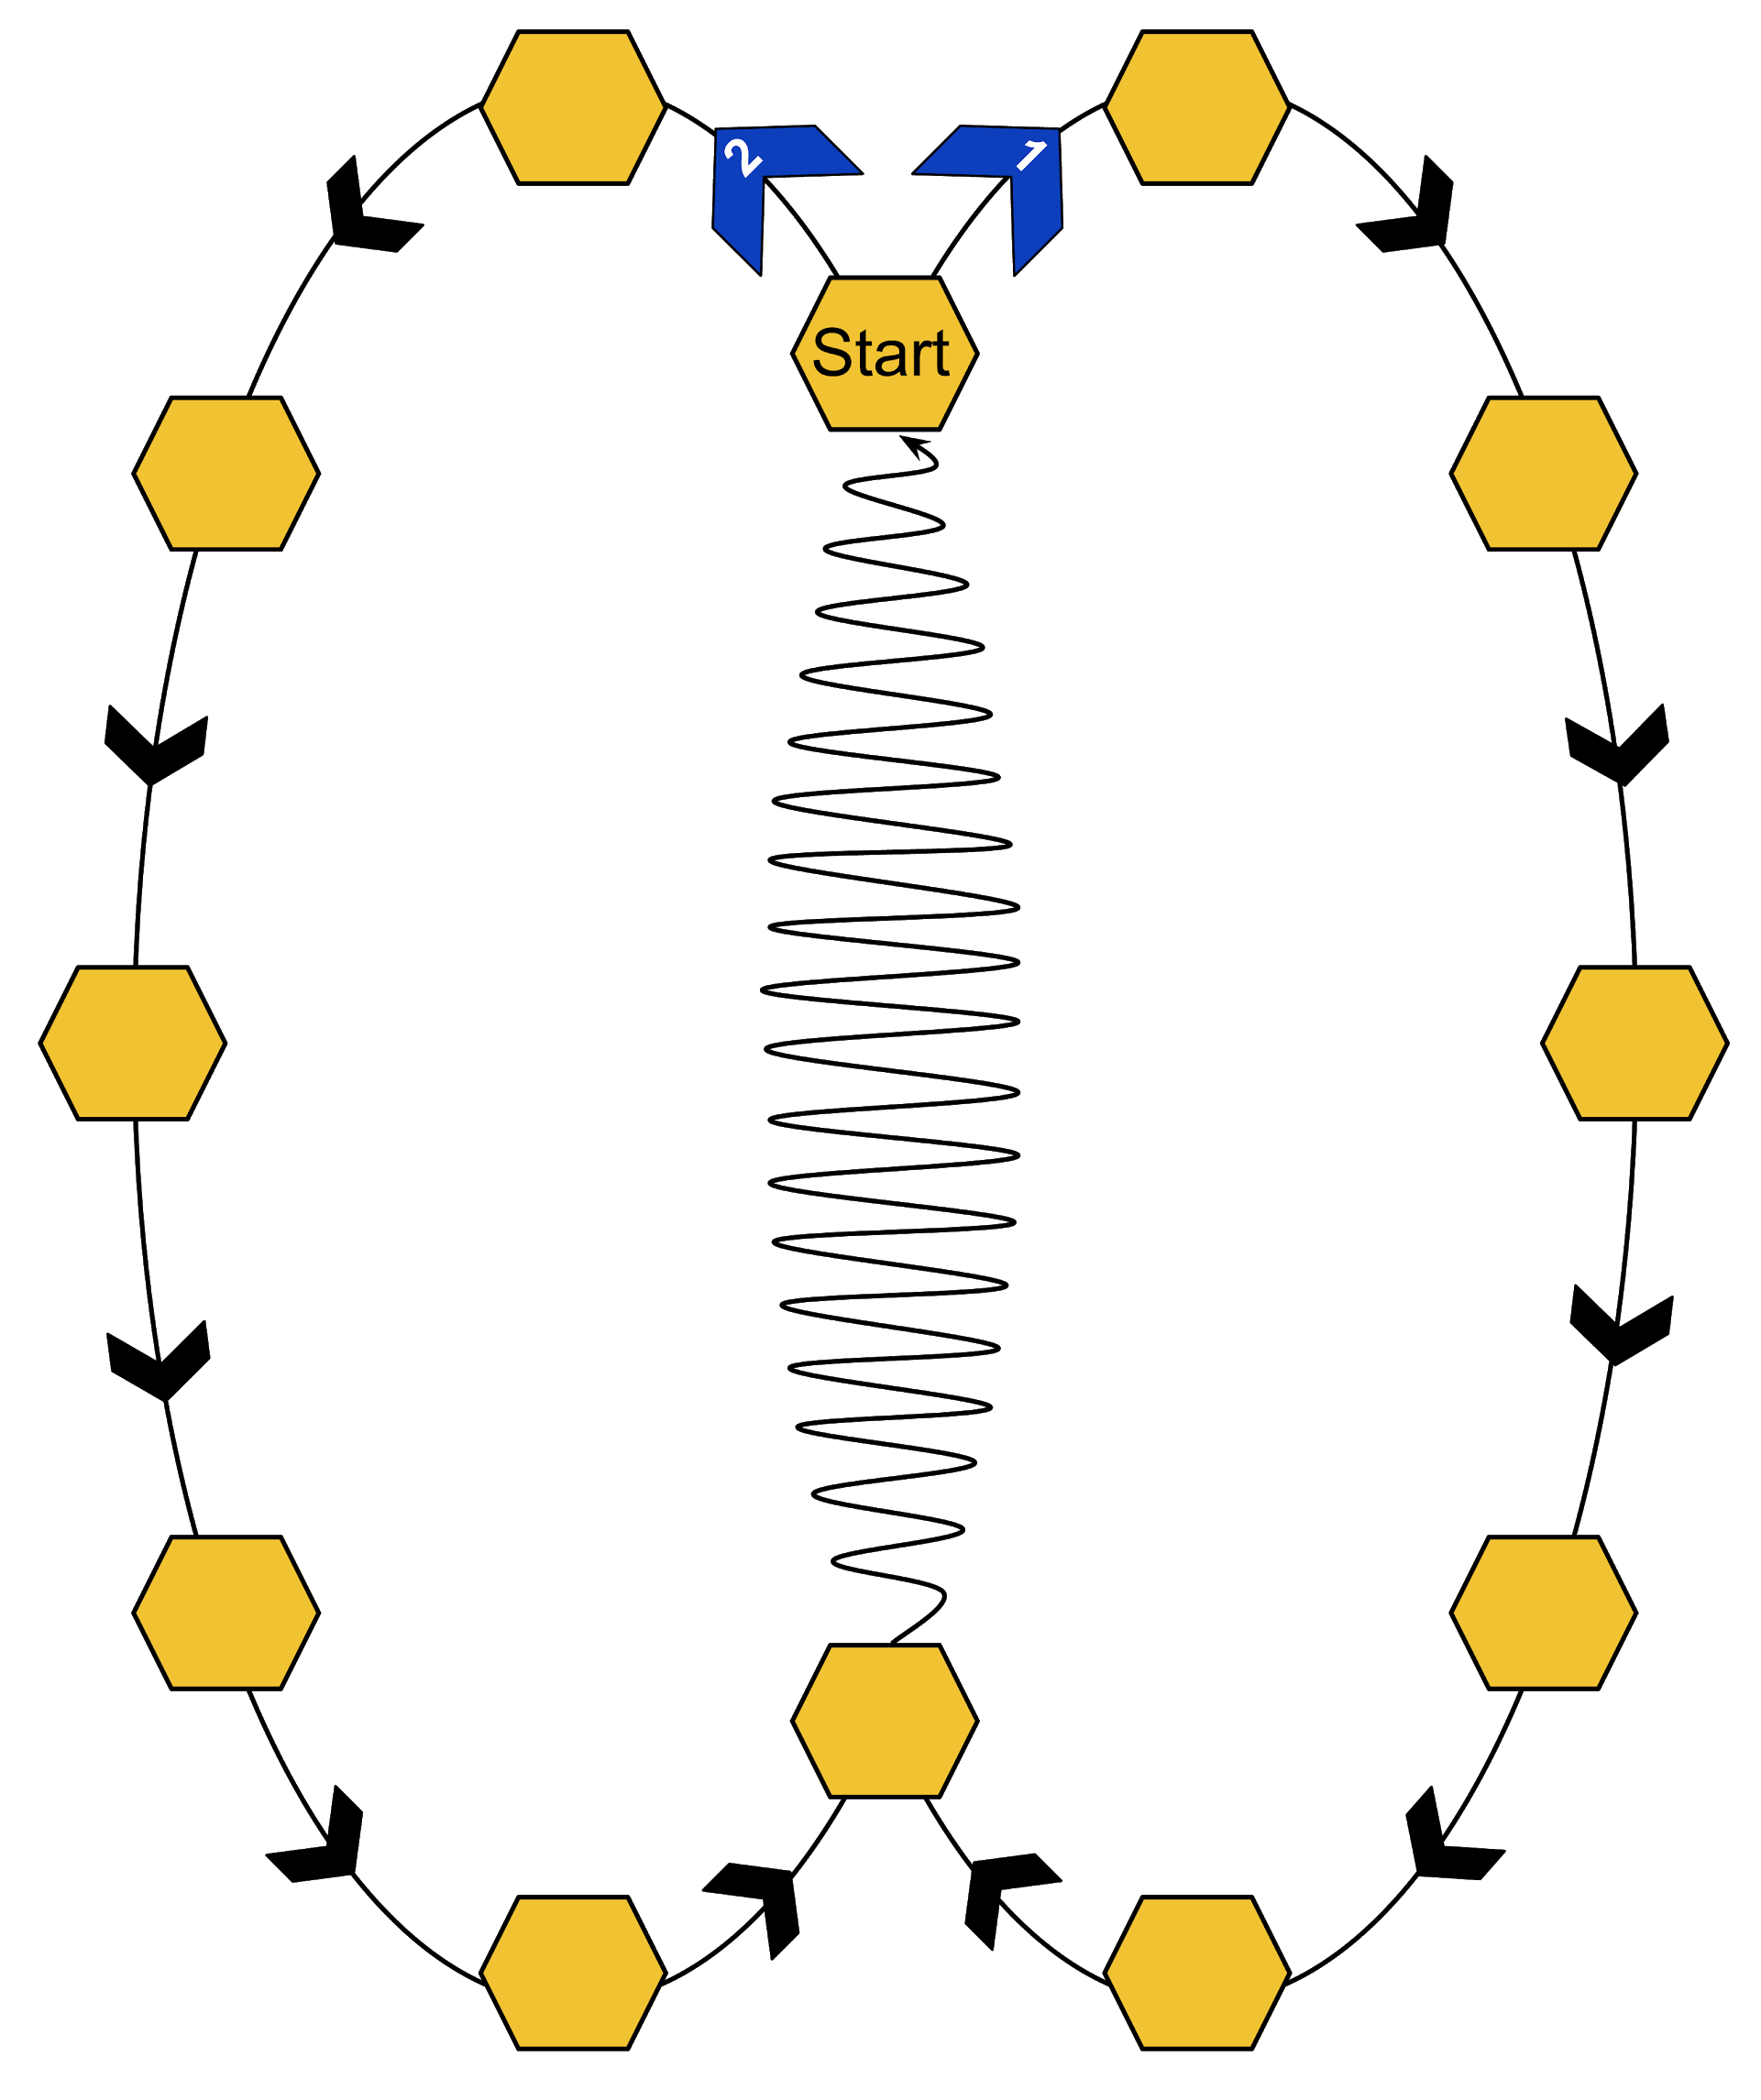
- Practice the honey bee waggle by following the numbered shapes. After you think you’ve mastered the dance, try it without the guide!
- Determine if your dance move represents a physical or behavioral adaptation. Justify your answer. *Is your dance move representing a physical feature or an act of the organism?

- Explain how this adaptation helps the organism survive in its environment.

Elephant Trunk
- Decide how to represent the trunk of an elephant in a dance move.
- Determine if your dance move represents a physical or behavioral adaptation. Justify your answer. *Hint: Is your dance representing a physical feature or an act of the organism?

- Explain how this adaptation helps the organism survive in its environment.

- Be prepared to share your dance move and the type of adaptation with the class.
Grizzly Bear
- Decide how to represent an adaptation of a grizzly bear. *Your dance can be more than one step.
- Determine the part of your dance move that represents a physical adaptation and the part that represents a behavioral adaptation. Justify your answer.

- Explain how these adaptations help the organism survive in its environment.

- Be prepared to share your dance move and explain how it represents the adaptations you chose with the class.

Part 2: Representing Ecological Interactions Through Dance
Predation - an interaction in which one organism kills another for food or nutrients; the predator does the eating, and the prey gets eaten
- List two organisms that interact to show predation in your local environment.
- Predator:
- Prey:
- Describe an adaptation of each of the organisms that is related to the relationship.

- Explain how each organism’s adaptation affects their survival.

- Develop a dance move for each of the adaptations you describe. *One person can represent an adaptation, or your group can work together to represent an adaption. For example, one person could represent a heron slowly stalking a fish through the water, then grabbing a fish with their beak (arm and hand) in a swooping motion OR you could choose to break this up into parts. In the heron example, one person could stalk the fish, another represents the swooping motion, and a final person could represent the snapping of the beak.
- Determine how your developed dance moves work together to represent the interaction between these organisms.

Competition - an interaction in which two organisms attempt to use the same resources in the same place at the same time
- List two organisms that interact to show competition in your local environment. *Your organisms should all be in the same ecosystem (forest for example).

- Describe an adaptation of each of the organisms that is related to the relationship.

- Explain how each organism’s adaptation affects their survival.

- Develop a dance move for each of the adaptations you describe.
- Determine how your developed dance moves work together to represent the interaction between these organisms.

Mutualism - an interaction in which both organisms involved benefit
- List two organisms that interact to show mutualism in your local environment. *Your organisms should all be in the same ecosystem (forest for example).

- Describe an adaptation of each of the organisms that is related to the relationship.

- Explain how each organism’s adaptation affects their survival.

- Develop a dance move for each of the adaptations you describe.
- Determine how your developed dance moves work together to represent the interaction between these organisms.

Commensalism - an interaction in which one organism benefits and the other is neither benefited or harmed
- List two organisms that interact to show commensalism in your local environment. *Your organisms should all be in the same ecosystem (forest for example).

- Describe an adaptation of each of the organisms that is related to the relationship.

- Explain how each organism’s adaptation affects their survival.

- Develop a dance move for each of the adaptations you describe.
- Determine how your developed dance moves work together to represent the interaction between these organisms.

Parasitism - an interaction in which one organism benefits by living with, on, or inside another organism that is harmed
- List two organisms that interact to show each type of interaction in your local environment. *Your organisms should all be in the same ecosystem (forest for example).
- Parasite:
- Host:
- Describe an adaptation of each of the organisms that is related to the relationship.

- Explain how each organism’s adaptation affects their survival.

- Develop a dance move for each of the adaptations you describe.
- Determine how your developed dance moves work together to represent the interaction between these organisms.

Part 3: Representing an Ecosystem Through Dance
- Determine how the organisms you chose to represent each type of interaction (predation, competition, mutualism, commensalism, parasitism) are related within your chosen ecosystem. *It might be helpful to draw a diagram or web to show these relationships.

- Determine how to combine your dances into one cohesive dance. Practice your dance to prepare for a performance.
- Along with performing your dance (live or recorded), your group must submit a description of how your dance represents your local ecosystem. Your writing should include the type of interactions in which each organism is involved, and the adaptations represented that help them survive.
  - Describe the interactions that connect all the organisms in your represented ecosystem.
  - Describe the adaptations (physical/behavioral) that help each organism survive.
  - Describe what would happen if one of the organisms was removed from the ecosystem.

