Where Will You Purchase Land For Your Grandchildren?

A long-lost great aunt of yours passed away recently and you were given $75,000 from her will. In contemplating what you would do with this, you felt it may be a good investment in your family’s long-term future to purchase a plot of land in a region that can withstand the coming climate changes.

You will research and identify a location that you feel has appropriate resources such as fresh water, farmable land, protection, and its proximity to cities or metropolitan areas. But these resources and safety will need to be present in the year 2063, when your grandchildren may possibly need to live in a place less impacted by the changing climate.

Learning Target: Students will select a plot of land to purchase that would have a high likelihood of shielding their family from negative climate change impacts and provide an environment that could independently sustain habitation.

Activity 1: Climate Change Background Knowledge
Before you decide on where you are going to buy land in order to weather climate change, you’ll need to make sure you understand what climate change is, why it is occurring, and how it may ultimately impact the world. Several impacts of climate change are already apparent:
- Increased frequency and intensity of severe weather events such as hurricanes, typhoons, tornadoes, etc.
- Coastal flooding
- Watershed flooding in rivers, streams, and other waterways
- Increased frequency and intensity of abnormal or extreme weather patterns, such as heat waves or the Polar Vortex
- Impact on growing seasons and growing capacity due to over saturation or drought

Start by bringing yourself up to speed with the following readings and activities:
- Read the Climate Change Impacts background information on pages 2-3.
- Watch this TED-Ed video: Climate Change: Earth's Giant Game Of Tetris
  - Explore further with TED-Ed’s Our Changing Climate series
- Follow the directions on pages 4-5 below to use experiment with this greenhouse gas simulation to see how temperature changes as you add carbon dioxide to the atmosphere. Follow the instructions below and respond to the reflection questions.

STEP I: Background Information Reading — Climate Change Impacts

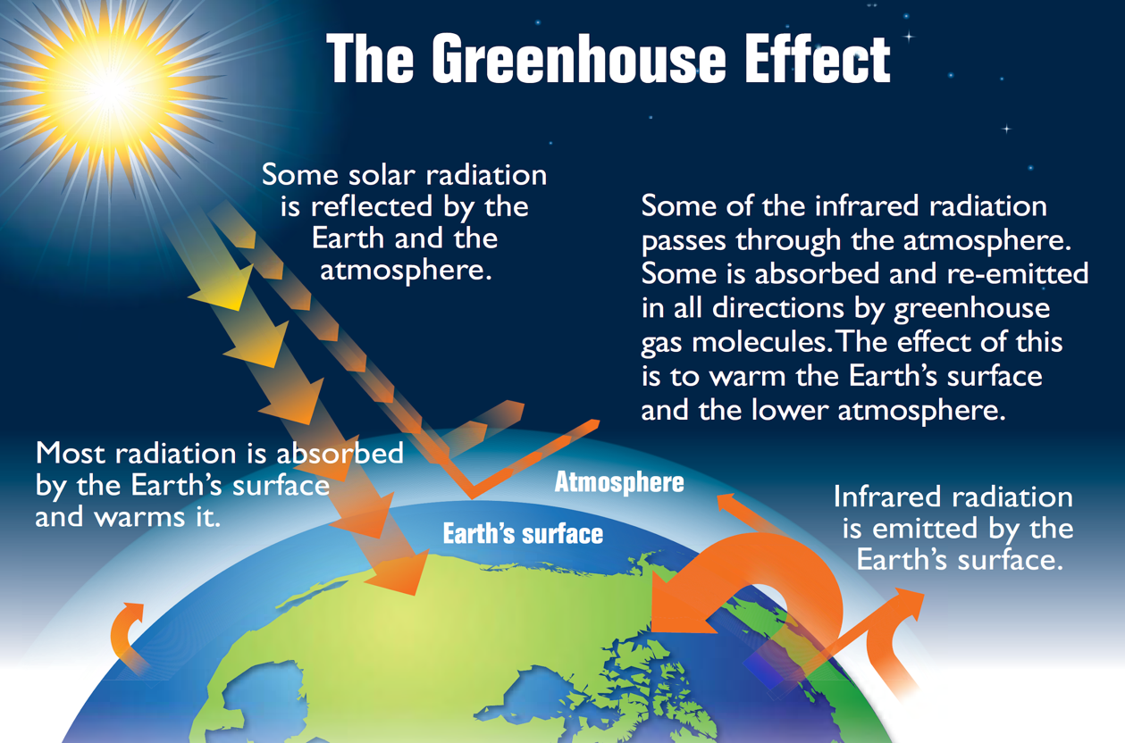
Earth's greenhouse effect (US EPA, 2012, Wikimedia Commons, public domain)

Most of our harnessed energy has come from the burning of fossil fuels, which has caused an increase in the concentration of carbon dioxide in our atmosphere (CO2). Methane (CH4) concentration has also risen from our world’s cattle population (because they fart methane), although methane does come from other sources as well, like wetlands, and the production of oil and gas. Natural gas is approximately 90% methane. Carbon dioxide and methane are two gases known as “greenhouse” gases. Our reliance on these methane- and carbon-dioxide-producing resources has created a scenario where these ‘greenhouse’ gases trap heat in our atmosphere, causing a rise in overall global temperatures. This affects many systems on our planet and changes the global climate.

The rise in global temperature has a domino effect. As the global temperature increases, the surface temperature of the ocean will also warm, causing evaporation to occur much more easily. These evaporating waters drive the global precipitation cycle. An increase in the amount of water that evaporates into the atmosphere will mean that the stabilized ‘normal’ precipitation patterns will be disrupted and there will be an increasing amount of strange precipitation events, which will cause more severe flooding events.

Melting Glaciers & Impact on Water Cycle

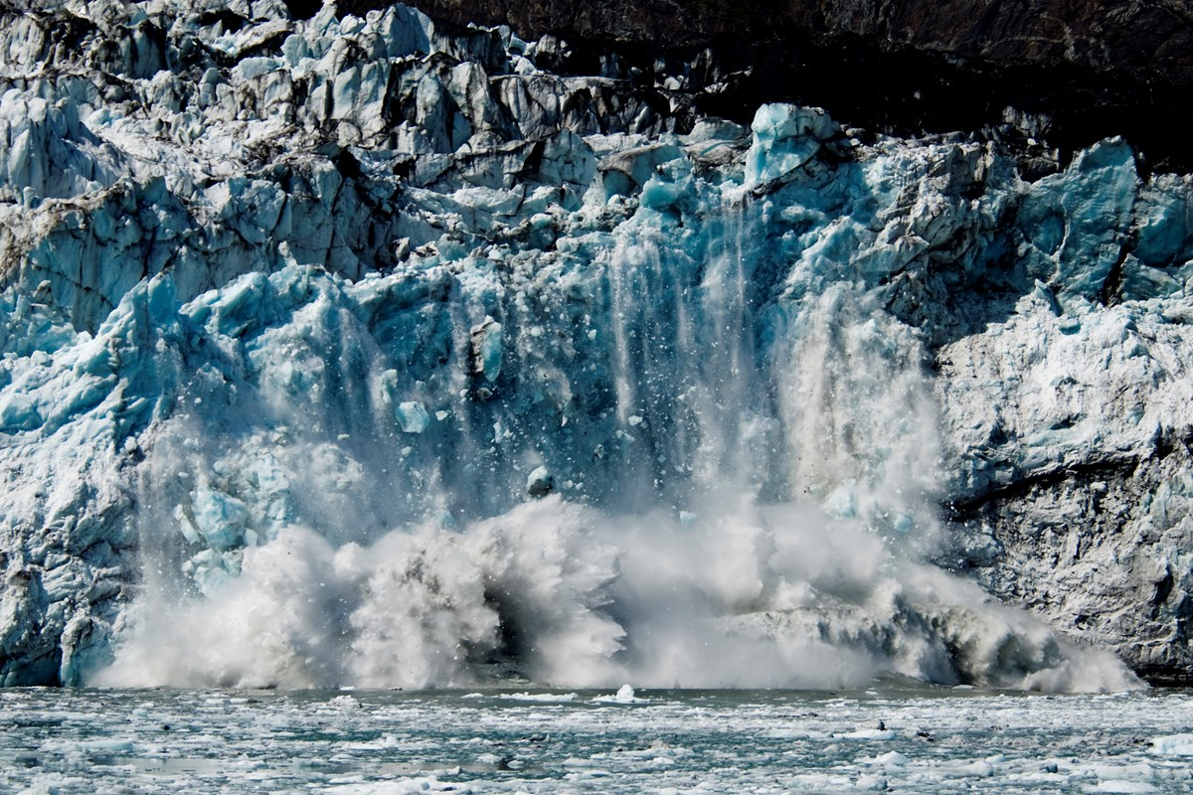
Rising global temperatures are causing the ice caps, glaciers, and alpine snow reserves to melt. This issue is actually occurring at an exponential rate. As portions of these regions melt, more of the underlying surface area of ice and snow is exposed, which means a greater surface area is impacted by the sun at a time, causing, even more, to melt on the next round! These are vast volumes of water that are entering the oceans, causing the sea level to rise around the globe. As the ocean level increases, coastal regions are at risk of flooding. This risk is even higher for small island nations such as the Marshall Islands, which boasts a high elevation of seven feet.

The freshwater in glaciers, ice caps, and alpine reserves were once part of the water cycle in the form of precipitation. The ocean is salt water and salinity is the measure of how salty the water is. The amount of salinity must exist in a specific and delicate range. Any changes in salinity could have major effects on global weather. Waters in certain regions have warm water, while others have a cold. This difference causes the ocean currents which bring warm water from the equatorial regions towards the poles. These ‘conveyor belts’ as they are called, help to drive global weather. In an arctic region, water freezes, leaving higher amounts of salt in the surrounding water. This extra salt causes it to become more dense and the water sinks. Ocean water circulates via these belts due to the dense water sinking and less dense water replacing it.

Currently, as polar region ice is melting at an accelerating pace, more and more freshwater will be present in those regions, reducing the density, and therefore the amount of sinking water, which drives the conveyor belts. If the salinity of the ocean continues to change, these conveyor belts are at risk. For example, if the conveyor belt that brings warm water to North America is slowed or stops, the United States could face a colder climate, even though the Earth is warming overall. If this occurs, there could be major climate impacts that are felt on a global scale for generations.

STEP 2: Greenhouse Effect Simulation

Follow the directions below to experiment with this greenhouse gas simulation to see how temperature changes as you add carbon dioxide to the atmosphere. Respond to the reflection questions as you move through the simulation.

Start by visiting this simulation from the Concord Consortium to see what happens to air temperatures as you add carbon dioxide to the atmosphere.

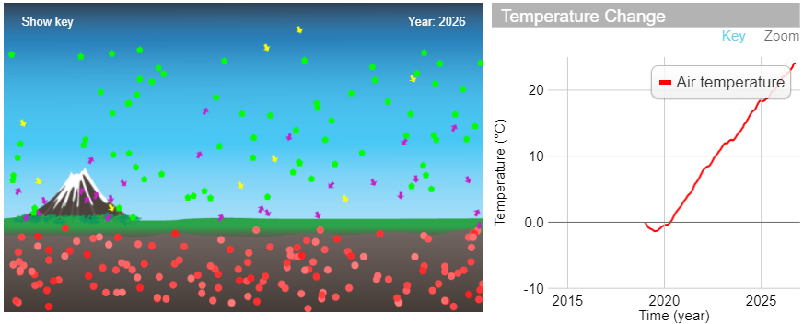

- What happens to the temperature when you add carbon dioxide to the atmosphere?

- What happens to the temperature when you slowly remove carbon dioxide from the atmosphere?

Here is an advanced version of the same simulation that you can explore to see what happens to the ocean and ice levels:
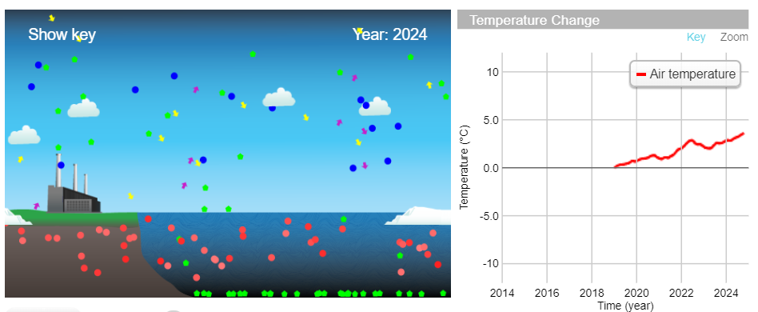

- What happens to the ice as the amount of atmospheric carbon dioxide increase?

OVERALL REFLECTION: Based on the background reading, TED-Ed videos, and your exploration of the simulations, what are three impacts of climate change that you feel are the most dangerous for humanity?

Activity 2: Identify Property Needs
Now that you have increased your climate change IQ, let’s get you ready to find a property! Before even deciding which part of the country would be the best to buy property in, what should that property have that would allow you or your descendants to potentially live “off the grid” without relying on others for food, water, shelter, and electricity? How much land should you buy?

Core requirements for your property search:
- Clean, dependable source of freshwater
- Natural building materials such as trees, rock, or clay
- A property located in a climate that includes a growing season for growing crops to eat
- Low probability of extreme weather events (hurricanes, tornadoes, etc)
- A place with few temperature extremes
- Enough space for growing food (plants and livestock), collecting water, and generating electricity. For a family of four you will need at least 2.5 acres of land with stable soil for planting crops

Based on your research, explain why each of the core requirements is a “must-have” and create a list of “nice to haves” for your ideal property, making sure to justify your selections. Use the graphic organizer below to guide you as you answer these questions:
- Why are the core requirements “must haves” for your property?
- What features are “nice to haves” for your property? Why?
- What size parcel of land do you feel would be necessary for you and your family?

Property Features “Must-Haves” & “Would-Be-Nice-to-Haves”
Property features may include freshwater sources (lake, streams, etc.), fields, forests, rocky features, tall-grass prairie, desert. In making your lists below, be as specific as possible.

OUR PROPERTY’S “MUST-HAVES”
Property feature | Why is this feature a “must-have?”
Clean, dependable source of freshwater

Natural building materials.

A climate that includes a growing season for crops

Low probability of extreme weather events

A place with few temperature extremes

Enough space for growing food (plants and livestock), collecting water, and generating electricity.

OUR PROPERTY’S “NICE-TO-HAVES”
Property feature | Why is this feature “nice-to-have?”

Activity 3: Regional Climate Information
The first major decision you’ll need to make as you begin to narrow down your target property is where in the country you want to buy a property. The search for this activity is limited to the continental United States, but between the Atlantic and Pacific Oceans lies a diverse landscape. There are a multitude of different environments in the various regions in the United States, each with their own pros and cons. So how will you ever decide?

In 2018, the Fourth National Climate Assessment was released. This is a scientific report outlining predictions and models for various regions in the United States. Another powerful summary of risk is the Climate Resilience Screening Summary and Framework, created by the Environmental Protection Agency. This report outlines the risk posed to every county in the United States for localized meteorological events, certain natural hazards, and the resilience to those hazards, and the increasing risks posed by climate change. Contained in the report are the five factors considered in creating the index and a region by region assessment of resilience. These findings are shown as maps, graphs of multiple types, and data tables.

Directions
- Use the Regional Information Graphic Organizer on the next page to organize your findings from the following sources (links in the Regional Climate Model Resources document) and begin to narrow your property search to a particular region:
  - Fourth National Climate Assessment Regional Summaries
  - The EPA Climate Resilience Screening Index Summary
  - Your choice! Pick a third reliable source that forecasts regional climate change impacts.
- Summarize your findings on each of the regions in the Regional Information Graphic Organizer and narrow your search to one or two regions before starting the next activity. Note in your Climate Future Student Guide about the reason for your choices.

Regional Climate Model Graphic Organizer

SOURCE: Fourth National Climate Assessment (NCA)
Region or State(s) | Pros | Cons | Comments

SOURCE: Climate Resilience Screening Index (CRSI) - EPA
Region or State(s) | Pros | Cons | Comments

SOURCE: _____________________________________________
Use this table to collect information for a reputable climate change resource you selected.
Region or State(s) | Pros | Cons | Comments

Activity 4: Property Search
Now that you’ve done some research on how the various regions and environments may be impacted by climate change, and narrowed your search down to a smaller region, you’re ready to start looking at some properties. Remember the following constraints as you begin your search:

- You only have $75,000 to spend and you must spend it all at once, no mortgages.
- You do not need to worry about taxes, property insurance, or other fees, for this exercise, your only concern is the list price. Although bargaining on list price is a real part of real estate, for simplification reasons, it will not be allowed in this activity.
- You cannot buy a property that has any structure on it that people could currently live in (no houses, apartments, yurts, etc.). On every real estate website there are search filter drop-down menus; deselect all property types EXCEPT for land to speed up your search.
- You must select your property from actual real estate listings. Try using Zillow.com, Realtor.com, or Trulia.com to begin your search.

Using the Property & Climate Information Organizer (print or digital), find and organize information for 5-8 different properties by following the directions below:
- Record each property you find in Tab/Table 1 “Log of Properties.” You don’t need to fill out the whole grid for each property, but this is a good way to track your search, which you can narrow down to 5-8 properties.
- The rightmost column gives a place to link to the listing, you should do this, so you can easily get back to properties you’ve looked at later.
- Remove any properties that you don’t like or that don’t meet any of your core criteria. After this step, you should end up with 5-8 properties for deeper analysis.
- Switch to Tab/Table 2. If you are using the electronic version of this document, the address of each property will be automatically copied from Tab 1 to Tab 2.
- Add the following climate information about the properties you’ve selected in the appropriate column:
  - Predicted temperatures for region
  - Risk of severe weather events
  - Predicted precipitation patterns
  - Fresh water or well on property.
- There are two extra columns track other “must-haves” for your property.
- Once you’ve completed your search, discuss with your group which property you should buy, and record the property information below. Going Once...Going Twice…SOLD!!

Table 1: Log of Possible Properties
Address of Property (Street, City, State) | Price ($) | Acres | Price per Acre | Features of Property (i.e. water, topography, environment) | Comments

Table 2: Regional Climate Information
Address of Property (Street, City, State) | Predicted Temperatures for Region | Risk of Severe Weather Events | Predicted Precipitation Patterns | Fresh Water or Well on Property? | “Must-Haves”

Final Property Selection

Address
Price ($) | Acres | Price per Acre
Description of Property

Activity 5 - Conclusion and Presentation
Now that you have chosen which property to purchase, it's time to put all the information you used to make that decision into a professional, fact-based argument for why you chose the property you did. There were many factors that you considered in making your decision. This is your time to formalize those thoughts and share them with others in a presentation.

As a group, please answer the following questions to help organize your thoughts to prepare for the creation of your property presentation.

- Write a 90-second elevator speech about why you chose this property (an elevator speech is what you would tell a person in the time it takes to ride an elevator, approximately 90 seconds). Don’t forget to include the climate change factors that informed your decision.

- Why is the region surrounding your property a safe bet for long-term climate adaptation?

- Why would your property allow for sustainable, off-grid living, even in 2063, when changes in the climate may be more apparent?

Property Presentation Guidelines

Your presentation should include.
- A clear selection of a property that meets the guidelines for purchase ($75,000 or less, no living structures currently on the property, in the Continental United States)
- A generalized summary of predicted climate in that region in the mid-21st century with references that cite specific scientific models and/or reports
- A clear connection between the predicted climate in the region around the property you selected, and the risks, costs, hazards, and discomforts that you are avoiding by purchasing property in that region.

You may present the information in any presentation format that you would like. You should produce something using a format comfortable to you, and be sure to cite quality information and deliver a professional presentation. Below is a list of possible presentation formats and some basic criteria for each.

Presentation Type | Basic Criteria
PowerPoint Presentation | 10-12 slides with text, images/gifs/videos, with a logical progression of slides and transitions between them. Use APA, MLA, or Chicago style for citations.
Oral Speech (Video) | 4-5 minutes that includes a clearly articulated position and supporting evidence. All members of the group must speak in equal proportions. Group members speak to the audience, not just reading off paper or notecards. Include a bibliographic document using APA, MLA, or Chicago style.
Newspaper Article | 1-2 pages of column text that includes justification for selection and contains connected images throughout the text (as in print/online articles). Include a bibliographic document using APA, MLA, or Chicago style.
Traditional Paper | 3-5 pages, double-spaced with appropriate in-text citations using APA, MLA, or Chicago styles.
Interactive Website | The website has a professional feel to it, all of the links work, and has easily navigated interface. Include a bibliographic section using APA, MLA, or Chicago style.
Poster | Large, encompassing poster that contains, in a visually appealing fashion, all of your information including justifications for purchasing the property. Include a bibliographic section using APA, MLA, or Chicago style.

