How Often Do 100-Year Floods Actually Occur?
Activity 1
- If you were to roll a 10-sided die 30 times, how many 7’s (floods) would you expect to see in the 30 “years”? Hint: Exactly three floods (3 is 10% of 30) is a correct answer, but is it the only one? Remember that the roll of the die is random. Could rolling two 7’s or “floods” be one of the possible outcomes? Five Floods?

Record your random numbers below, and shade in each “year” in which you generated the number 7 to represent a year with a flood.

1 | 2 | 3 | 4 | 5 | 6 | 7 | 8 | 9 | 10 | 11 | 12 | 13 | 14 | 15 | 16 | 17 | 18 | 19 | 20 | 21 | 22 | 23 | 24 | 25 | 26 | 27 | 28 | 29 | 30 | 31 | 32 | 33 | 34 | 35 | 36 | 37 | 38 | 39 | 40

41 | 42 | 43 | 44 | 45 | 46 | 47 | 48 | 49 | 50 | 51 | 52 | 53 | 54 | 55 | 56 | 57 | 58 | 59 | 60 | 61 | 62 | 63 | 64 | 65 | 66 | 67 | 68 | 69 | 70 | 71 | 72 | 73 | 74 | 75 | 76 | 77 | 78 | 79 | 80

81 | 82 | 83 | 84 | 85 | 86 | 87 | 88 | 89 | 90 | 91 | 92 | 93 | 94 | 95 | 96 | 97 | 98 | 99 | 100

- What do you notice about your results for 30 and 100 years? What do you wonder?

- Other students have generated their own random sequences. What do you wonder about their results?

The number of floods in 30 years among the other students in the class will likely range between 0 and 8. Is this reflected in the class data?

Activity 2
Record the number of students who had each number of floods in 30 years for use back in the classroom using the chart below.

# of floods in 30 years | Zero | One | Two | Three | Four | Five | Six | Seven | EIght | Nine and up
# of students

Activity 3
- What was your class’ experimental probability of experiencing exactly 3 floods? Of 4 or more?

- After examining the class distribution, and the distributions provided, how might you refine your previous answer to Q1: “How many times would you expect a flood over the course of 30 years?”

- What else do you notice or wonder about the class results, as displayed in the bar graph?
Write An Article
Imagine you are a writer for the news media or a public organization. You would like to write an article to educate the public about the chances of experiencing such a flood. In a separate document, write a draft of this article, making sure to address the following questions:

- How can experimental probability help us anticipate (but not predict) the future chances of a flood when a neighborhood has a 1 in 10 chance of a flood each year?
- How can looking at a distribution of data based on a simulation help us understand what to expect in the future?
- How many floods should a neighborhood with a 1 in 10 chance of a flood each year expect to see in the course of 30 years? How certain can residents be that no more than the theoretical number of floods will occur?

Extension: How Often Do 100-Year Floods Occur?
- What do you notice in the class distribution of recurrence intervals? What do you wonder?

- On the next page you will see a distribution of the recurrence intervals between “rolls of a 7” constructed from 500 people who rolled a 10-sided die 100 times. Again thinking of rolls of a 7 as “a year with a flood,” you can see that one year between floods is the most likely outcome! Does this surprise you? Why?

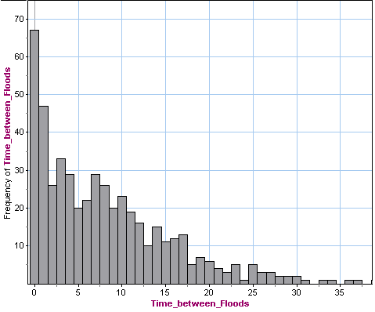

The distribution of 500 recurrence intervals for a flood with a 1 in 10 chance of occurring each year:
Zero | One | Two | Three | Four | Five | Six | Seven | Eight | Nine | Ten
67 | 47 | 26 | 33 | 29 | 20 | 22 | 29 | 26 | 20 | 23

- In the above example, there is a 67/500, or 12.3%, experimental probability of a floor occurring one year after the previous one. What is the class’ experimental probability of this outcome?

- Use the example to calculate the experimental probability that you will wait less than 10 years for our next flood. What is the class’ experimental probability of less than 10 years between floods?

Return to your news article educating the public about their chances of experiencing a flood. Add to your article by addressing recurrence intervals. Note that some believe that after they experience a “10-year flood,” a flood will not occur again for another 10 years. What does the distribution of recurrence intervals tell us about this belief?

