Nautilus measurement worksheet

What makes a spiral golden?
A golden spiral is based on the golden ratio, usually represented by the Greek letter phi, or 𝜙.

𝜙 = 1.618

The golden ratio appears when the ratio of a longer measurement to a shorter measurement is approximately 1.618. It is also connected to the Fibonacci sequence where each number is found by adding the two before it.

1, 1, 2, 3, 5, 8, 13, 21, 34, 55…

Find the Golden Ratio
- Calculate each ratio in the table below. Divide the larger Fibonacci number by the smaller Fibonacci number, as shown.
- Round your answer to three decimal places.

Fibonacci numbers | Ratio | Result
2 and 3 | 3 / 2 | 1.500
3 and 5 | 5 / 3
5 and 8 | 8 / 5
8 and 13 | 13 / 8
13 and 21 | 21 / 13
21 and 34 | 34 / 21
34 and 55 | 55 / 34

What happens to the ratios as the Fibonacci numbers get larger?

Investigate the shells
- Before measuring, examine each shell image. Predict whether its proportions will be close to the golden ratio, 1.618.
- Measure the shell’s greatest length from front to back. Record the measurement in millimeters.
- Measure the shell’s greatest height from top to bottom. Record the measurement in millimeters.
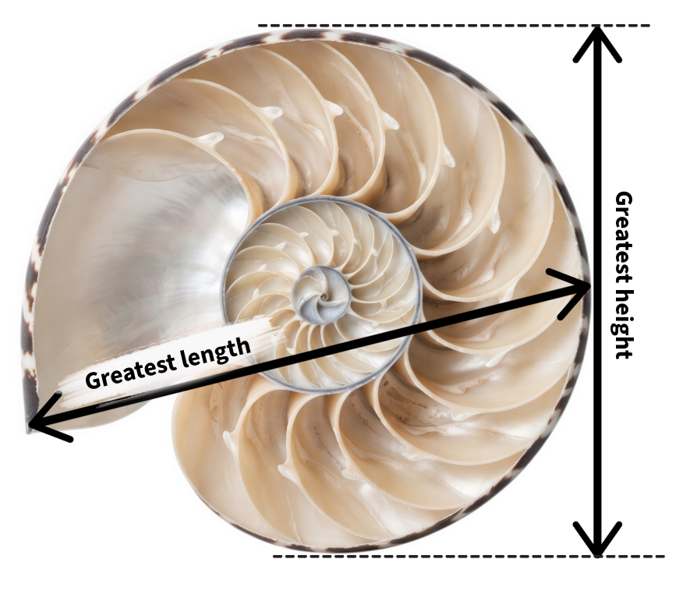
- Divide the length by the height: Shell ratio = length / height
- Repeat the process for each shell image.
- Calculate the mean ratio for all the shells: Mean = sum of the shell ratios / number of shells.
- Calculate the absolute value of the difference between your mean measured ratio and the golden ratio: Difference = ꘡ shell ratio - 1.618 ꘡

Nautilus | Length (mm) | Height (mm) | Length / height (ratio) | Difference from 1.618
A
B
C
D
E
MEAN

Issue your myth verdict!
Use your measurements to complete one of these statements:
- Our evidence supports the claim that nautilus shells have golden proportions because…
- Our evidence does not support the claim because…
- Our results are inconclusive because…

Support your verdict with at least two pieces of numerical evidence.

Questions to ask
- Did every shell have the same ratio? Why might real shells vary?

- Was your mean closer to 1.618 or 1.31?
- How could cropping, image angle, or measurement error affect your results?
- How many shells would you need to measure before feeling confident in your conclusion? Explain your reasoning.
- What is the difference between finding a pattern and proving that the pattern exists?

- Can two shapes look similar without having the same mathematical proportions?

Extension activity
The percent difference (or percentage difference) compares two ratios of similar things. Using the data from your experiment, calculate the percent difference between your calculated mean ratio and the golden ratio.

Percent difference = (꘡ mean shell ratio ﹣ 1.618 ꘡ / 1.618) x 100

Then use the same formula to calculate the percent difference between your calculated mean and Bartlett’s proposed ratio of 1.31. (Hint: Replace 1.618 with 1.31 in the formula above.)

Based on the evidence you collected, which ratio is more accurate for nautilus shells, Bartlett’s ratio or the golden ratio? Explain your reasoning.

NAUTILUS A

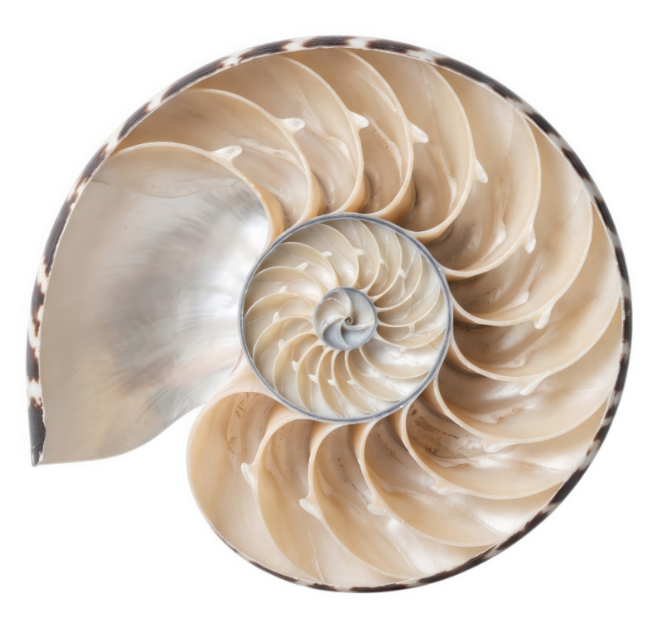

By: Zakir
Source: Adobe Stock
Asset ID#: 2154395362

NAUTILUS B
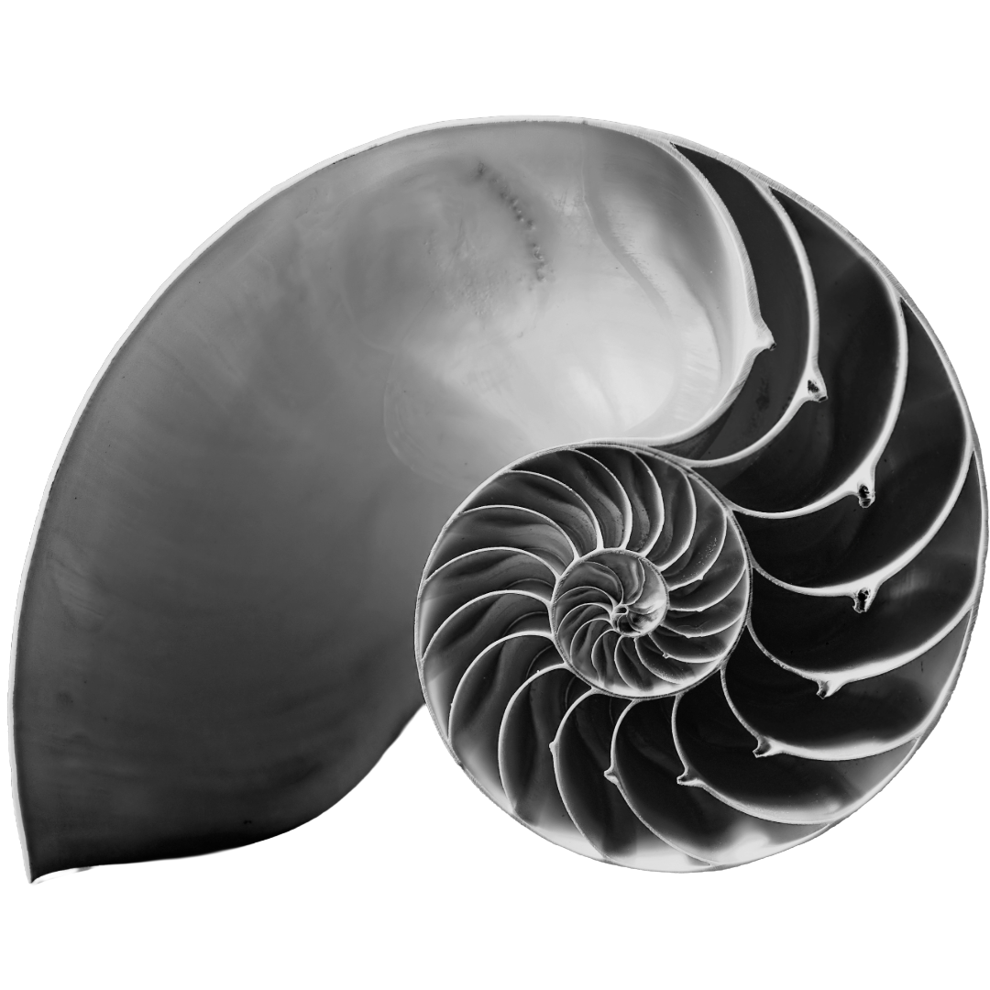

By: barneyboogles
Source: Adobe Stock
Asset ID#: 27136534

NAUTILUS C

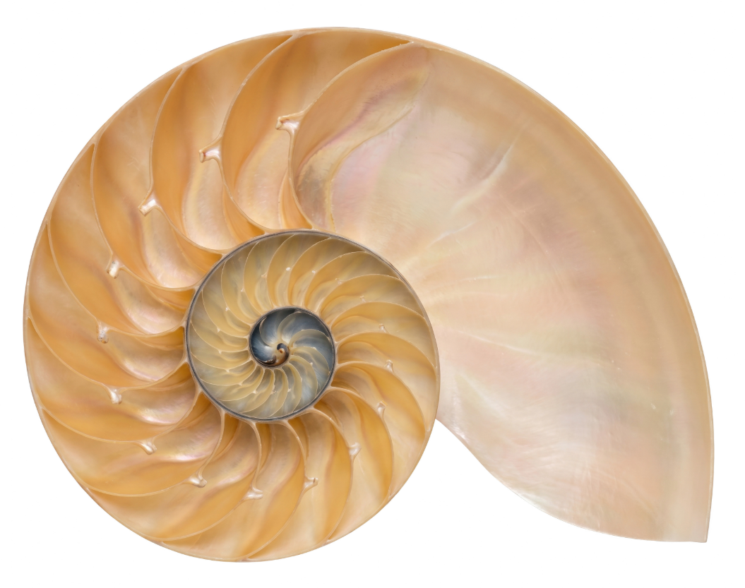

By: Tania
Source: Adobe Stock
Asset ID#: 2102096185

NAUTILUS D

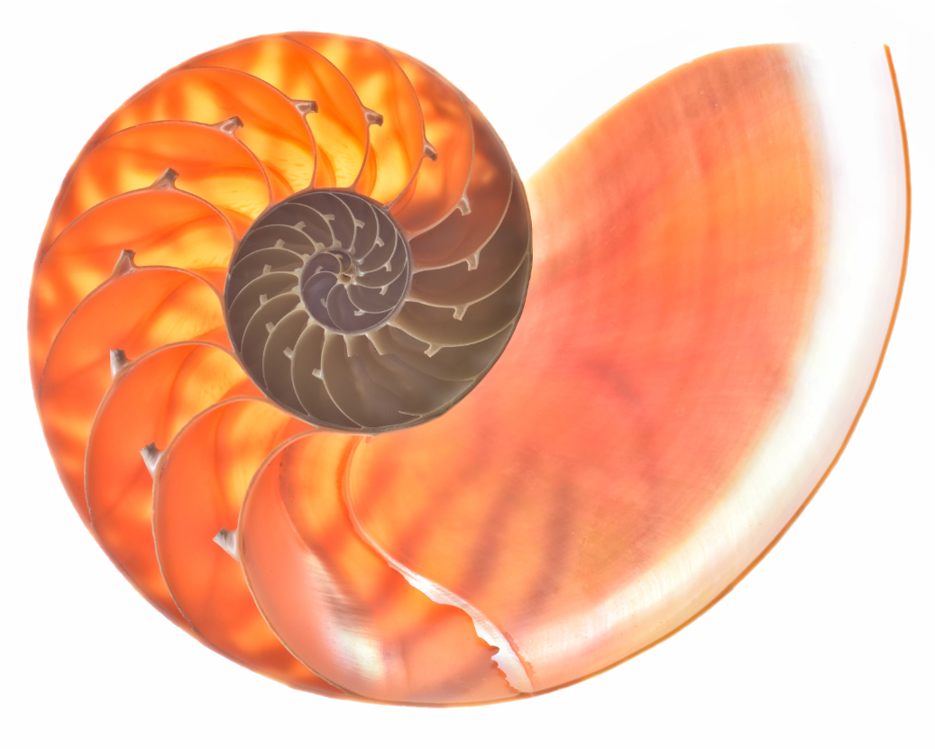

By: Aurelian Nedelcu
Source: Adobe Stock
Asset ID#: 98211602

NAUTILUS E

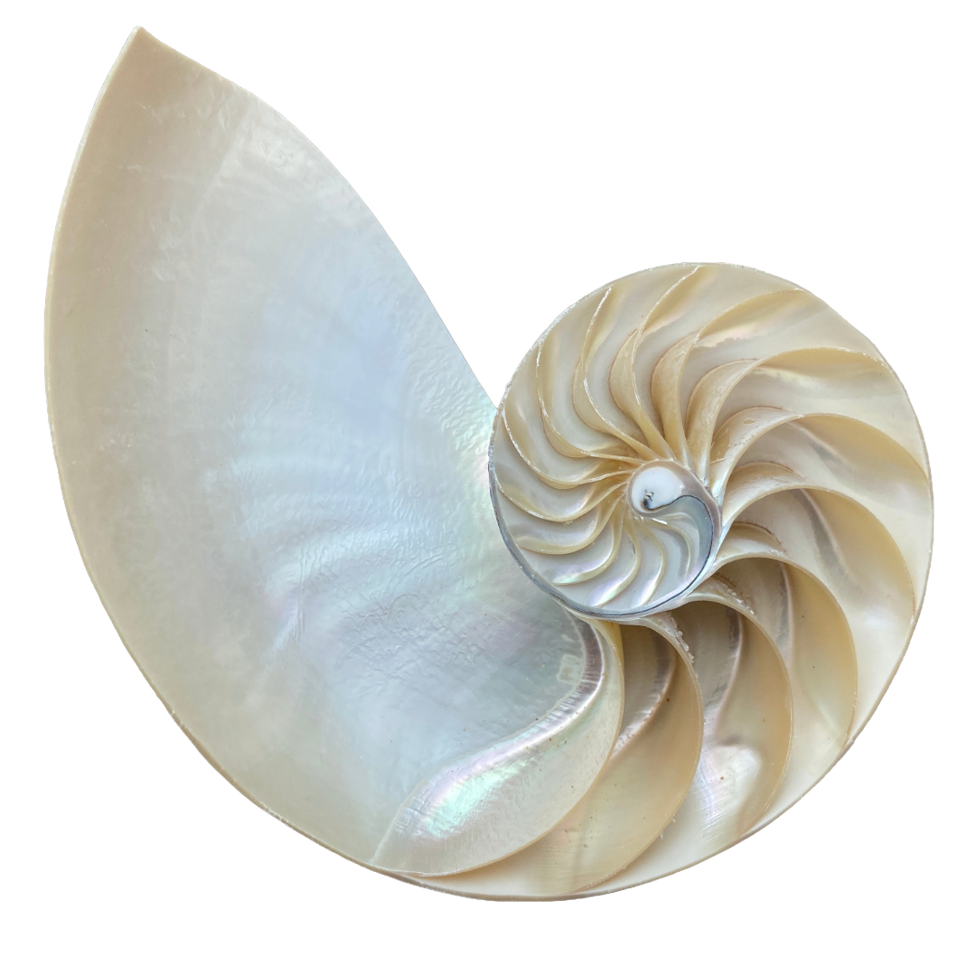

By: cheekylorns
Source: Adobe Stock
Asset ID#: 473618813

