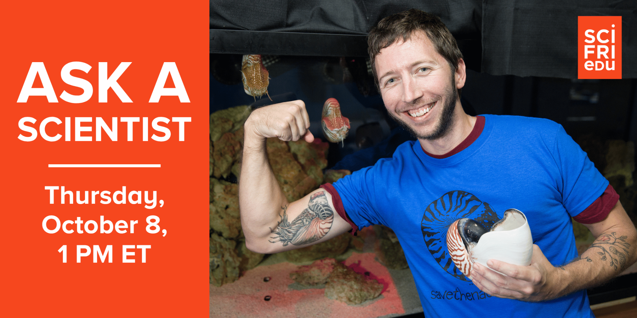

Educator’s Guide
Cephalopod Week 2026: Ask a Scientist
“Discover the chambered nautilus
with Dr. Gregory J. Barord”
Livestreamed Q&A with SciFri Educate
October 8, 2026

Science Friday  160 Varick St., 7th Floor  New York, NY 10013  212-840-2244  sciencefriday.com | 

Welcome To Science Friday Cephalopod Week 2026

Every year, Science Friday hosts Cephalopod Week, a celebration of the incredible animals that squirt ink, change colors, solve puzzles, and continue to surprise scientists. Cephalopod Week is the perfect time to explore the watery world of marine mollusks like octopuses, squids, cuttlefish, and nautiluses. This year, the fun kicks off Monday, October 5! We’ll learn about our favorite smart marine invertebrates through reported stories and interactive activities for all ages.

Plus, you can join Science Friday Educate on October 8 at 1 pm EDT / 10 am PDT for a 45-minute livestreamed Ask a Scientist Q&A event on YouTube where we’ll meet Dr. Gregory J. Barord, a marine biologist, chambered nautilus expert, and Director of Science and Outreach for Save the Nautilus. Come with your curiosity. We’ll be taking your questions in the chat. It’s free, and learners of every age are welcome! Just RSVP for updates and reminders.

The chambered nautilus may not be as famous as its octopus and squid relatives, but it’s just as remarkable. These ancient animals have survived for hundreds of millions of years, navigating the ocean with buoyant, spiral-shaped shells. Today, they face growing threats from overharvesting, habitat disruption, and a changing ocean. At our Ask a Scientist event, you’ll learn more about Dr. Barord’s work to raise awareness about the nautilus, its precarious future, and the research needed to help protect the species at Save the Nautilus.

This event will be presented with live English closed captioning. Need help? Send us an email at educate@sciencefriday.com.

Welcome To Science Friday Cephalopod Week 2026 2
How to prepare for the event 3
Register and log in 3
Introduce the chambered nautilus 3
About Dr. Gregory Jeff Barord 4
Designing great questions to ask scientists 5
After the event 8
Write a letter to protect the nautilus 8
Check your knowledge 9
Discover other cephalopods 14
Stay connected 14
Join the SciFri Learning Lab 14
Receive the SciFri Educate Newsletter 14

How to prepare for the event

Register and log in
- RSVP for the event to receive updates and reminders: https://www.eventbrite.com/e/1999225158266
- Tune in on October 8 at 1 pm EDT / 10 am PDT for the livestream on the Science Friday YouTube channel at https://youtube.com/live/O4X5kdvUj-g.
- Make sure you are logged into YouTube to participate. Enter your questions in the chat to the right or at the bottom of your screen. We'll answer as many of them as we are able in the time we have.
- Live English closed captions will be provided at https://www.sciencefriday.com/askascientistcc. Keep the site open in a second browser window.

Introduce the chambered nautilus
- Visit Save the Nautilus to learn more about the organization and the endangered chambered nautilus. The nonprofit was started by 11-year-old Josiah Utsch and his friend Ridgely Kelly to raise awareness about the nautilus and fund research to better understand this 500-million-year-old creature.
- Watch Science Friday’s video, “Teaching Ancient Nautilus New Tricks” (4 minutes 47 seconds), in which a series of experiments by evolutionary biologists Dr. Jennifer Basil and Robyn Crook involving fish juice, blue lights, and mazes dispels the notion that this ancient species is incapable of basic learning and throws into question the origins of cephalopods' intellectual prowess.
- Read and discuss the activity “Can a living fossil learn new tricks? Meet the nautilus!” (Grades 6-8). With poor eyesight, the chambered nautilus hunts by smell. Explore how a blue-light experiment revealed mysteries of the cephalopod’s memory.
- Watch Ocean Media Institute’s video “Expedition Nautilus: Fiji” (30 minutes). It features Dr. Barord and others as they take to the seas in a search for the chambered nautilus.
- Explore the educational activity, “Myth or math? Is the nautilus shell’s golden ratio real?” (Grades 6-12). Grab a ruler, crunch the length-to-height ratios, and use the Fibonacci sequence to test whether this famous spiral is truly golden.
- Solve a cephalopod puzzle to win this escape room-style game, “Endangered Rescue: Chambered Nautilus” (Ages 10+).
- Discover tips for gaming with learners with the educational resource, “Play this game to build critical thinking and science literacy” (Grades 3-12).

About Dr. Gregory Jeff Barord
Director of Science and Outreach for Save the Nautilus
Dr. Gregory Jeff Barord was born in Katy, Texas, but grew up in Phoenix, AZ. Like all people who grow up in a desert, Greg wanted to be a marine biologist. At age 4, he told his Dad he wanted a PhD to study squid.

He attended Texas A&M University at Galveston (2001-2005), where he earned his B.S. in Marine Biology and minored in Chemistry. In Galveston, he also worked at the renowned National Resource Center for Cephalopods (2003-2008) and in the Quarantine Facility at Moody Gardens Aquarium (2006-2008). After his time in Texas, he traveled up to Alaska and worked aboard fishing vessels in the Bering Sea (2008-2010), collecting data for the National Marine Fisheries Service to monitor fisheries. While on a boat, he received a call (thankfully, there was cell phone service) that he had been accepted into the doctoral program at City University of New York – Graduate Center. There, Greg received his M.Phil. in Biology and completed his dissertation titled, “On the Biology, Behavior, and Conservation of the Chambered Nautilus, Nautilus sp.” Greg is currently a Conservation Biologist for Save the Nautilus and the Marine Biology Instructor at Central Campus High School in Des Moines, Iowa.

Greg has worked with a variety of species in different settings throughout his career, but his passion is helping preserve one of Earth’s oldest lineages: nautiluses. He has traveled to many places, including the Philippines, Australia, and Fiji, to learn more about nautiluses and understand the current state of nautilus populations. Greg presents the work of their research team at multiple professional conferences and public venues around the country and internationally. The work of Greg and his colleagues has also been featured by various media outlets.
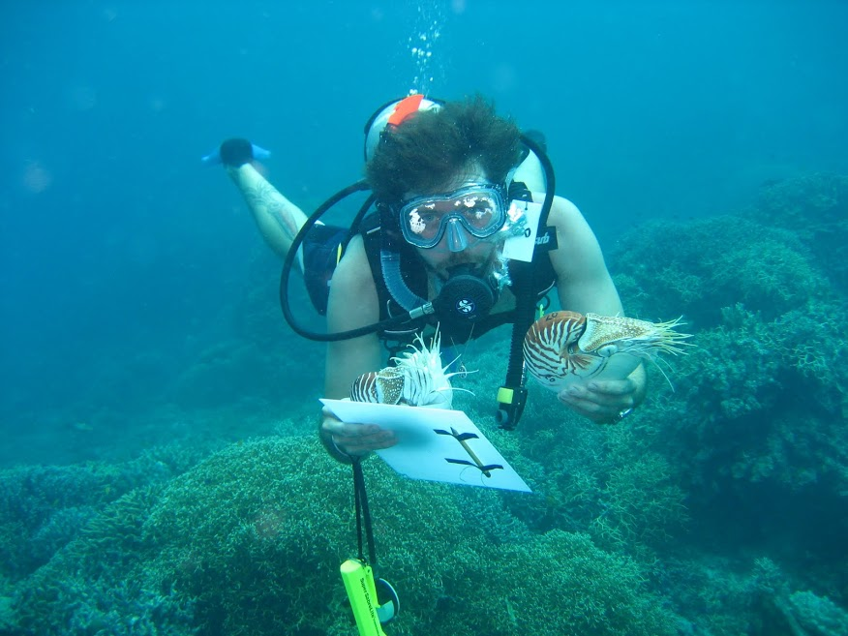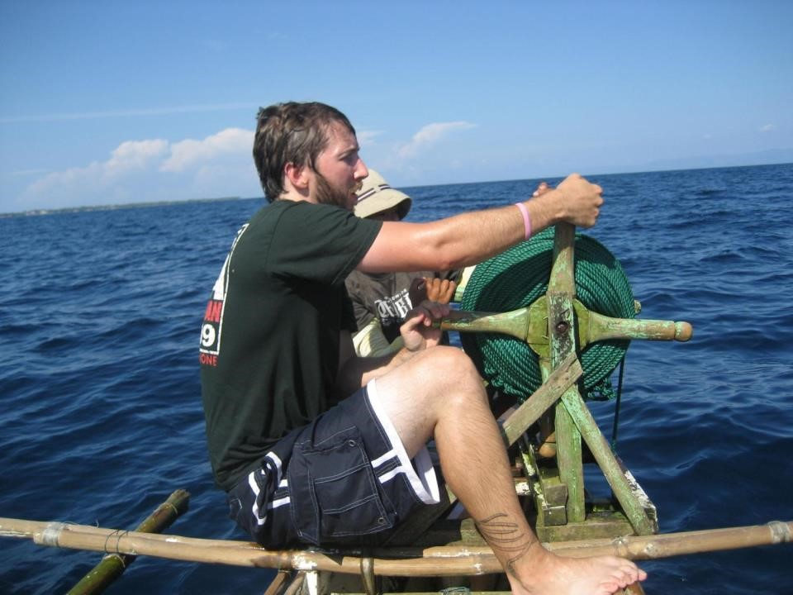

Designing great questions to ask scientists

Science Friday livestreams go quickly! Each question-and-answer session is 30-45 minutes long, and our experts will only have time to answer 12 to 15 questions. How can we make the most of our time with these scientists? How can you create a great question for our scientists to answer?

With the tips below, you’ll design your own questions, refine them, and work with friends to select the best ones. Journalists, like the writers and producers at Science Friday, usually start with “The Five W’s”: who, what, when, where, and why. They then craft open-ended questions for guests to answer. An open-ended question is a question that cannot be answered with a simple "yes" or "no" and instead requires a detailed, thoughtful answer, often including opinions, experiences, and perspectives. Take a look at the examples below.

 | MAIN IDEA | EXAMPLE QUESTION
Who? | Asks about the person or people involved. | Who first discovered and classified the Giant Pacific Octopus?
What? | Asks about the event, action, or thing in question. | What kinds of research take place on the International Space Station?
When? | Asks about the time or date something happened. | When do monarch butterflies migrate in North America?
Where? | Asks about the location of something. | Where do scientists use remotely operated vehicles to study the geology of the ocean floor?
Why? | Asks about the reason or cause behind something. | Why do some smells trigger strong memories?

- Review the questions below. Do you think these would be good questions to ask a scientist during a livestream? Why or why not? How can you make them better? Revise and share out your edits!
  - Does water boil in space?
  - Is it ok to use ChatGPT for my homework?
  - Can the brain create new connections between neurons?
  - Is the Giant Pacific Octopus the largest animal on Earth?
  - What do I need to do to prepare for a career in environmental biology?
- Research the topic of the livestream using Science Friday resources or other trusted sources. Consider what you already know and what you want to learn more about. Generate a list of first-draft questions based on your research. Evaluate questions using the examples above and revise as needed. Write each question on a sticky note with your name and start organizing and forming categories or connections. What are your favorite questions?
- Once you have finished brainstorming, join your family, group, or class to review and prioritize the questions. Ask yourself:
  - How did the research and brainstorming process go?
  - What categories did you come up with earlier?
  - Did others in the group have the same question?
- Put the questions on a whiteboard or large piece of chart or butcher paper. Take turns sharing questions. Add post-its to your group mind map, forming categories to help group together common questions and themes. Label post-its with students’ names. Group together any duplicates!
- Finally, evaluate the group’s questions. Choose group favorites and eliminate others (making sure to discuss the reasoning for each decision). Edit the list until you have your final group of questions.
- During the livestream, take notes. Was your question answered? Did participating in the livestream spark new questions? Did you learn something new? Use our Scientist Q&A Graphic Organizer to record your thoughts. Where can you find answers to questions that weren’t discussed in the livestream?

First draft questions:

Finalized question for scientist:

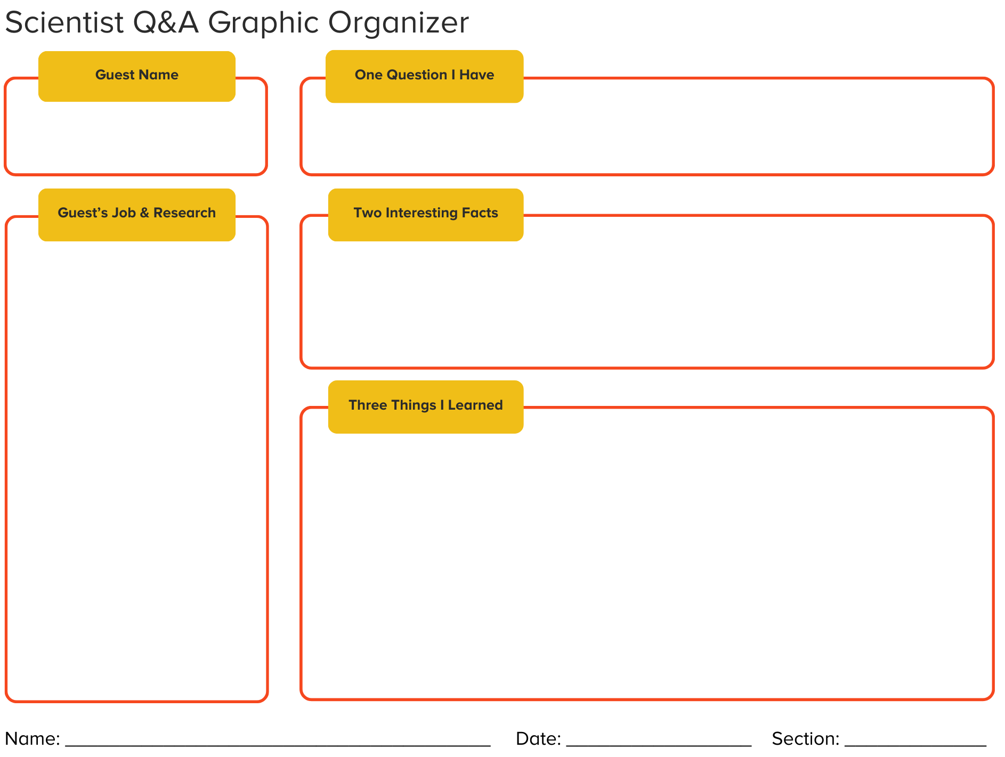

After the event
Learning doesn’t have to stop when the event ends! Here are some activities you can use to continue your discovery of the chambered nautilus.

Write a letter to protect the nautilus
One of the biggest threats to the nautilus is overfishing. People often use the shells for jewelry, clothing, and home decor. Chambered nautiluses grow slowly and reproduce infrequently, so widespread fishing can significantly damage their populations. Despite international protections, thousands are still sold each year.
Learners who want to help protect the nautilus can take action. Save the Nautilus encourages people to write letters to retailers like eBay, Amazon, and Etsy, asking them to stop selling nautilus shells.

Help players craft their messages using persuasive writing guides for young students and older learners. Start by having them gather facts using what they learned at the event and through other resources included in this guide. As learners work on their letters, have them consider the following tips:
- Make sure you state your opinion clearly near the beginning of the letter.
- Craft an introduction with a “hook” that grabs the reader’s attention.
- Explain why the company should trust you.
- Give several reasons why the company should stop selling the shells, each backed by a fact.
- Show you understand the company's point of view and provide your counterargument. You should try to anticipate potential objections to your opinion.
- Tell the reader exactly what you want them to do.
- Help the reader feel something about the nautilus. Appeal to their emotions.
- Use transition words to connect your ideas clearly.
- Write a strong conclusion that summarizes your points and restate your opinion in new words at the end of the letter.

Learners in grades 3-5 may benefit by working together in small groups. Aim for two reasons and a simple call to action. Learners in grades 6–8 may want to outline their letter first. Then have a peer review a draft of the letter and offer ways to strengthen their arguments.

Check your knowledge
Try our chambered nautilus trivia with your learners. Download a Google Slides presentation, use the printable version, or copy the questions below in whatever format works for you.

1. The chambered nautilus is a type of cephalopod. Which animal below is NOT a cephalopod?
A. Cuttlefish
B. Starfish
C. Squid
D. Octopus
2. Cephalopods usually have highly developed senses, a large brain, and…
A. A backbone
B. Tentacles
C. Scales
D. A prominent head
3. The nautilus lives 1,000 to 2,000 feet underwater. What is that environment like?
A. Extremely dark
B. Many plants
C. Warm water
D. Many predators
4. True or false: Nautiluses don’t occupy the entirety of their shells.
A. True
B. False
5. About how big is the largest known chambered nautilus shell?
A. About 1 inch
B. About 12 inches
C. About 3 feet
D. About 6 feet
6. How many tentacles can a chambered nautilus have?
A. Fewer than 10
B. Up to 30
C. About 60
D. As many as 90
7. True or false: The spiral of a nautilus shell is a perfect example of the golden ratio.
A. True
B. False
8. Nautiluses have a sensory structure called a rhinophore. What does it help them do?
A. See
B. Hear
C. Smell
D. Touch
9. Which foods would a chambered nautilus use its tentacles and rhinophores to find?
A. Algae and seaweed
B. Large, fresh fish
C. Clams and oysters
D. Decaying animals
10. Some call the nautilus a “living fossil.” How long has the nautilus lineage existed?
A. 2,000 years
B. 100,000 years
C. 30 million years
D. 500 million years
11. How long can a nautilus hold information in its long-term memory?
A. About 5 minutes
B. Almost 1 hour
C. Up to 24 hours
D. About 1 week
12. Experiments show nautiluses have spatial memory. What do they use it for?
A. Recognizing faces
B. Navigating familiar places
C. Changing shell color
D. Remembering sounds
13. Scientists can’t tell a grown nautilus’s exact age, but some believe nautiluses can live up to how long?
A. Less than 1 year
B. Up to 5 years
C. About 10 years
D. 50 years or more
14. What is the main reason the chambered nautilus is threatened in many ocean regions?
A. Warming waters
B. Loud boat noise
C. Too little food
D. Overfishing
15. Why is slow reproduction such a serious problem when nautilus populations are overfished?
A. More predators
B. Eggs are destroyed
C. Only live a short time
D. Cannot replace losses

Answer Key
1. B. Starfish
Cephalopods are ocean animals with arms or tentacles around their mouths, such as the octopus, squid, cuttlefish, and nautilus. Starfish are not part of this group.
2. D. A prominent head
Cephalopods are known for their prominent heads, highly developed senses, and large brains. They are curious creatures that are good at exploring and solving problems.
3. A. Extremely dark
At these depths the ocean is extremely dark, which helps keep the nautilus safe because predators are less likely to spot it. Recreational divers only go about 100 feet down.
4. A. True
The nautilus lives in only part of its spiral shell. When threatened, it can retract its full body into the shell.
5. B. About 12 inches
A nautilus shell usually ranges from 4.5 to 10 inches. The largest known nautilus shell specimen is about 12 inches in diameter.
6. D. As many as 90
A chambered nautilus typically has 90-94 tentacles, which it uses to find food and to find a mate. Other species of nautilus may have between 50 to over 90.
7. B. False
Close, but not quite! The nautilus’s distinctive spiral shell is almost, but not exactly, an example of the golden ratio. Test it yourself: Myth or math? Is the nautilus shell’s golden ratio real?
8. C. Smell
The rhinophore is a body part that helps a nautilus sense chemicals in the water, much like smelling. Along with its tentacles, the nautilus uses it to search out food.
9. D. Decaying animals
Though nautiluses occasionally hunt for small fish, shrimp, or crabs, they don't have great eyesight, so they mostly search out decaying food items dropped by other animals. They're like the ocean's little janitors!
10. D. 500 million years
The chambered nautilus lineage has existed with very little change to its anatomy for the last 500 million years.
11. C. Up to 24 hours
Drs. Jennifer Basil, Robyn Crook, and Gregory Barord found that nautiluses have a biphasic memory curve: short-term memory for up to an hour and long-term memory for up to 24 hours. Dig deeper: Can a living fossil learn new tricks? Meet the nautilus!
12. B. Navigating familiar places
Spatial memory means remembering where things are and how to move through a place. Nautiluses use it to navigate familiar areas more efficiently, including mazes they have been through before.
13. D. 50 years or more
A nautilus can generally live more than 20 years, and some scientists believe it may live up to and beyond 50 years. Its lifecycle is much longer and slower than other cephalopods’.
14. D. Overfishing
Overfishing means catching animals faster than their populations can replace them. Nautilus shells are sold for jewelry and décor. Despite CITES protection since 2017, over 10,000 were openly used in traded goods in 2024.
15. D. Cannot replace losses
Nautiluses don’t lay eggs until they mature at about age 10, and the eggs take at least a year to hatch. Populations are being depleted much faster than they can recover.

Discover other cephalopods
The chambered nautilus is just one of the amazing members of the cephalopod family, which includes octopuses, squid, and cuttlefish.
- “The Ink-Credible STEAM Adventure Toolkit” features tons of book suggestions, videos, educational activities, party ideas, and more. It’s a one-stop shop for activities suited to every age.
- The Cephalopod Week Spotlight includes over ten years of fantastic stories featured on Science Friday. Listen to the stories of amazing discoveries and dedicated scientists.
- Discover The Mysteries Of Octopuses! Dive into marine biology with this “Many Things Under A Rock” interactive book club guide for young readers.
- Play “What Cephalopod Are You? Take The Quiz!” Are you an old soul? A giant genius? Answer these 8 questions to find out which cephalopod is most like you.
- We’re suckers for a good coloring book page. If you are too, try our all-ages cephalopod coloring pages.

Stay connected

Join the SciFri Learning Lab
The SciFri Learning Lab is a space for anyone engaged in science learning—classroom teachers, informal educators, homeschool families, community science facilitators, and lifelong learners—to connect around the science stories, discoveries, and teaching practices that excite us. This free community on Mighty Networks is a great place to ask questions, share resources, and connect with others. It only takes a moment to join at https://scifricommunity.mn.co/

Receive the SciFri Educate Newsletter
Get free science activities, event updates, and more delivered to your mailbox once a month with our SciFri Educate newsletter. Be sure to explore other Sciecne Friday newsletters, like our flagship Week in Science, too!

